UNITED STATES
SECURITIES AND EXCHANGE COMMISSION
Washington, D.C. 20549
___________________________________
FORM 8-K
___________________________________
CURRENT REPORT
Pursuant to Section 13 or 15(d)
of the Securities Exchange Act of 1934

Date of Report (Date of earliest event reported): March 19, 2026
___________________________________
Gemini Space Station, Inc.
(Exact name of registrant as specified in its charter)
___________________________________

Nevada  (State or other jurisdiction of  incorporation or organization) |  |  | 001-42836  (Commission File Number) |  |  | 33-3263417  (I.R.S. Employer Identification Number)
600 Third Avenue, 2nd Floor
New York, NY 100161
(Address of principal executive offices) (Zip code)
(646) 751-4401
(Registrant's telephone number, including area code)
 |  |  | Not Applicable
(Former name or former address, if changed since last report)
___________________________________
Check the appropriate box below if the Form 8-K filing is intended to simultaneously satisfy the filing obligation of the registrant under any of the following provisions:

☐ |  |  | Written communications pursuant to Rule 425 under the Securities Act (17 CFR 230.425)
☐ |  |  | Soliciting material pursuant to Rule 14a-12 under the Exchange Act (17 CFR 240.14a-12)
☐ |  |  | Pre-commencement communications pursuant to Rule 14d-2(b) under the Exchange Act (17 CFR 240.14d-2(b))
☐ |  |  | Pre-commencement communications pursuant to Rule 13e-4(c) under the Exchange Act (17 CFR 240.13e-4(c))
Securities registered pursuant to Section 12(b) of the Act:
Title of each class |  |  | Trading Symbol |  |  | Name of each exchange on which registered
Class A common stock, $0.001 par value per share |  |  | GEMI |  |  | The Nasdaq Stock Market LLC
Indicate by check mark whether the registrant is an emerging growth company as defined in Rule 12b-2 of the Exchange Act.
Emerging growth company ☒
If an emerging growth company, indicate by check mark if the registrant has elected not to use the extended transition period for complying with any new or revised financial accounting standards provided pursuant to Section 13(a) of the Exchange Act. ☐
1 We use this address for receiving mail and correspondence to our principal executive office located in New York, NY.

Item 2.02 – Results of Operations and Financial Condition
On March 19, 2026, Gemini Space Station, Inc. (“Gemini,” the “Company,” “we,” or “us”) issued a shareholder letter (the “Shareholder Letter”) and supplemental materials (the “2025 Earnings Presentation”) announcing its financial results for the three and twelve months ended December 31, 2025. Copies of the Shareholder Letter and 2025 Earnings Presentation are furnished as Exhibit 99.1 and Exhibit 99.2, respectively, to this Current Report on Form 8-K. As previously announced, Gemini will hold an earnings conference call on March 20, 2026 at 8:30 a.m. ET.

The information furnished with Item 2.02, including Exhibit 99.1 and Exhibit 99.2, shall not be deemed “filed” for purposes of Section 18 of the Securities Exchange Act of 1934, as amended (the “Exchange Act”), or otherwise subject to the liabilities of that section, nor shall it be deemed incorporated by reference into any other filing under the Securities Act of 1933, as amended, or the Exchange Act, except as expressly set forth by specific reference in such filing.

Item 9.01 – Financial Statements and Exhibits
(d) Exhibits

Exhibit No. |  |  |  |  |  | Description
99.1 |  |  |  |  |  | Shareholder Letter, dated March 19, 2026.
99.2 |  |  |  |  |  | 2025 Earnings Presentation, dated March 19, 2026.
104 |  |  |  |  |  | Cover Page Interactive Data File (embedded within the Inline XBRL document)

SIGNATURE

Pursuant to the requirements of the Securities Exchange Act of 1934, as amended, the Registrant has duly caused this report to be signed on its behalf by the undersigned hereunto duly authorized.

 |  |  |  |  |  | GEMINI SPACE STATION, INC.
Date: |  |  | March 19, 2026
 |  |  |  |  |  | By: |  |  | /s/ Danijela Stojanovic
 |  |  |  |  |  | Name: |  |  | Danijela Stojanovic
 |  |  |  |  |  | Title: |  |  | Interim Chief Financial Officer



March 2026 Q4 and Full Year 2025 A Letter to Shareholders 9:41 Featured Live Trending Sports Crypto Politics Economics Culture Politics Will Crude Oil (CL) hit by end of March? Fed Fed decision in April? e fore 22? e fore une 22? 1.1x 11.1x 94% 9% Will crypto market structure regulation become law? 66% 38%Yes No $100 → $151 $100 → $256 Fed maintains rate Cut 25bps 1.1x 11.1x 94% 9% Bitcoin price today at 12:30pm ET? Current: $73,982.45 $73,750 or below 1.2x 66% $73,250 or below 4.2x 21% Show 4 more $1.3M vol 0 1 2 3 4 5 6 7 8 9 0 0 1 2 3 4 5 6 7 8 9 0 0 1 2 3 4 5 6 7 8 9 0 Will Netflix close Warner Bros. deal by end of 2026? Home Predict Invest Card Activity0 1 2 3 4 5 6 7 8 9 0 0 1 2 3 4 5 6 7 8 9 0 0 1 2 3 4 5 6 7 8 9 0 % $100 → $714 $100 → $116 $1,398,473 vol Pisburgh Pro Football enver Yes . No . % Live 1.4x 44 1.1x $288m vol Home Predict Invest Card Activity 1

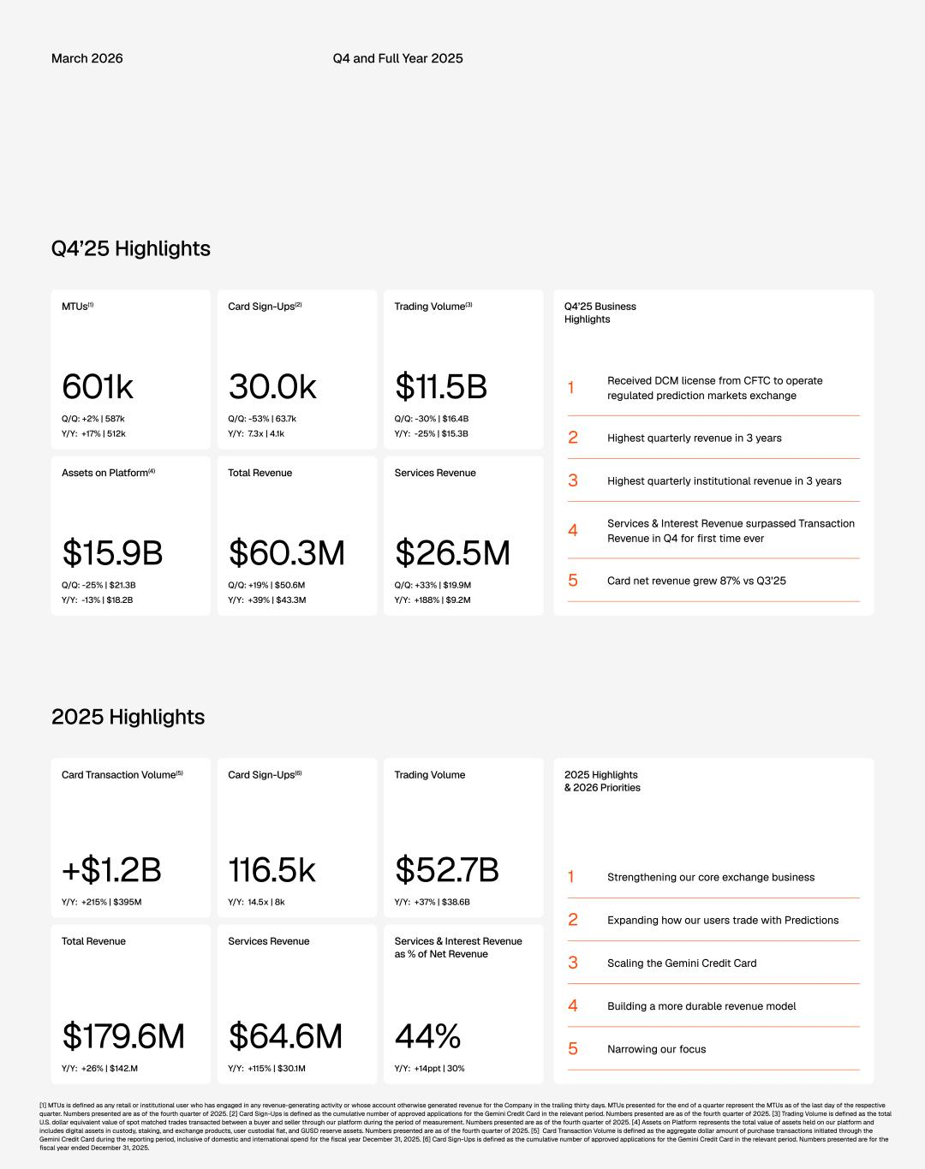
March 2026 Q4 and Full Year 2025 Q4’25 Highlights Q4’25 Business Highlights MTUs(1) Card Sign-Ups(2) Trading Volume(3) 601k 30.0k $11.5B Received DCM license from CFTC to operate regulated prediction markets exchange1 Q/Q: +2% | 587k Q/Q: -53% | 63.7k Q/Q: -30% | $16.4B Y/Y: +17% | 512k Y/Y: 7.3x | 4.1k Y/Y: -25% | $15.3B 2 Highest quarterly revenue in 3 years Assets on Platform(4) Total Revenue Services Revenue 3 Highest quarterly institutional revenue in 3 years Services & Interest Revenue surpassed Transaction Revenue in Q4 for first time ever4 $15.9B $60.3M $26.5M 5 Card net revenue grew 87% vs Q3’25Q/Q: -25% | $21.3B Q/Q: +19% | $50.6M Q/Q: +33% | $19.9M Y/Y: -13% | $18.2B Y/Y: +39% | $43.3M Y/Y: +188% | $9.2M 2025 Highlights 2025 Highlights & 2026 Priorities Card Transaction Volume(5) Card Sign-Ups(6) Trading Volume +$1.2B 116.5k $52.7B 1 Strengthening our core exchange business Y/Y: +215% | $395M Y/Y: 14.5x | 8k Y/Y: +37% | $38.6B 2 Expanding how our users trade with Predictions Total Revenue Services Revenue Services & Interest Revenue as % of Net Revenue 3 Scaling the Gemini Credit Card 4 Building a more durable revenue model $179.6M $64.6M 44% 5 Narrowing our focus Y/Y: +26% | $142.M Y/Y: +115% | $30.1M Y/Y: +14ppt | 30% [1] MTUs is defined as any retail or institutional user who has engaged in any revenue-generating activity or whose account otherwise generated revenue for the Company in the trailing thirty days. MTUs presented for the end of a quarter represent the MTUs as of the last day of the respective quarter. Numbers presented are as of the fourth quarter of 2025. [2] Card Sign-Ups is defined as the cumulative number of approved applications for the Gemini Credit Card in the relevant period. Numbers presented are as of the fourth quarter of 2025. [3] Trading Volume is defined as the total U.S. dollar equivalent value of spot matched trades transacted between a buyer and seller through our platform during the period of measurement. Numbers presented are as of the fourth quarter of 2025. [4] Assets on Platform represents the total value of assets held on our platform and includes digital assets in custody, staking, and exchange products, user custodial fiat, and GUSD reserve assets. Numbers presented are as of the fourth quarter of 2025. [5] Card Transaction Volume is defined as the aggregate dollar amount of purchase transactions initiated through the Gemini Credit Card during the reporting period, inclusive of domestic and international spend for the fiscal year December 31, 2025. [6] Card Sign-Ups is defined as the cumulative number of approved applications for the Gemini Credit Card in the relevant period. Numbers presented are for the fiscal year ended December 31, 2025.

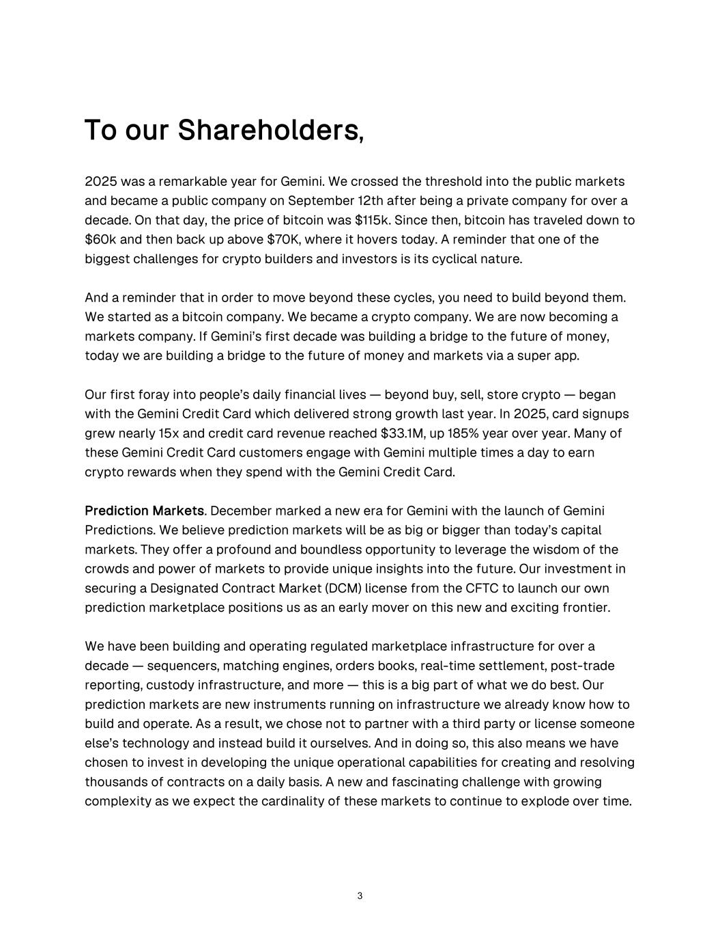
To our Shareholders, 2025 was a remarkable year for Gemini. We crossed the threshold into the public markets and became a public company on September 12th after being a private company for over a decade. On that day, the price of bitcoin was $115k. Since then, bitcoin has traveled down to $60k and then back up above $70K, where it hovers today. A reminder that one of the biggest challenges for crypto builders and investors is its cyclical nature. And a reminder that in order to move beyond these cycles, you need to build beyond them. We started as a bitcoin company. We became a crypto company. We are now becoming a markets company. If Gemini’s first decade was building a bridge to the future of money, today we are building a bridge to the future of money and markets via a super app. Our first foray into people’s daily financial lives — beyond buy, sell, store crypto — began with the Gemini Credit Card which delivered strong growth last year. In 2025, card signups grew nearly 15x and credit card revenue reached $33.1M, up 185% year over year. Many of these Gemini Credit Card customers engage with Gemini multiple times a day to earn crypto rewards when they spend with the Gemini Credit Card. Prediction Markets. December marked a new era for Gemini with the launch of Gemini Predictions. We believe prediction markets will be as big or bigger than today’s capital markets. They offer a profound and boundless opportunity to leverage the wisdom of the crowds and power of markets to provide unique insights into the future. Our investment in securing a Designated Contract Market (DCM) license from the CFTC to launch our own prediction marketplace positions us as an early mover on this new and exciting frontier. We have been building and operating regulated marketplace infrastructure for over a decade — sequencers, matching engines, orders books, real-time settlement, post-trade reporting, custody infrastructure, and more — this is a big part of what we do best. Our prediction markets are new instruments running on infrastructure we already know how to build and operate. As a result, we chose not to partner with a third party or license someone else’s technology and instead build it ourselves. And in doing so, this also means we have chosen to invest in developing the unique operational capabilities for creating and resolving thousands of contracts on a daily basis. A new and fascinating challenge with growing complexity as we expect the cardinality of these markets to continue to explode over time. 3

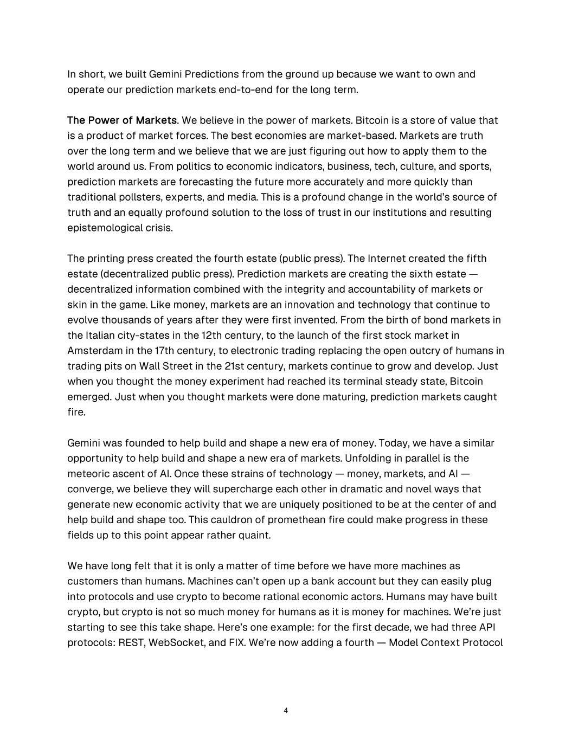
In short, we built Gemini Predictions from the ground up because we want to own and operate our prediction markets end-to-end for the long term. The Power of Markets. We believe in the power of markets. Bitcoin is a store of value that is a product of market forces. The best economies are market-based. Markets are truth over the long term and we believe that we are just figuring out how to apply them to the world around us. From politics to economic indicators, business, tech, culture, and sports, prediction markets are forecasting the future more accurately and more quickly than traditional pollsters, experts, and media. This is a profound change in the world’s source of truth and an equally profound solution to the loss of trust in our institutions and resulting epistemological crisis. The printing press created the fourth estate (public press). The Internet created the fifth estate (decentralized public press). Prediction markets are creating the sixth estate — decentralized information combined with the integrity and accountability of markets or skin in the game. Like money, markets are an innovation and technology that continue to evolve thousands of years after they were first invented. From the birth of bond markets in the Italian city-states in the 12th century, to the launch of the first stock market in Amsterdam in the 17th century, to electronic trading replacing the open outcry of humans in trading pits on Wall Street in the 21st century, markets continue to grow and develop. Just when you thought the money experiment had reached its terminal steady state, Bitcoin emerged. Just when you thought markets were done maturing, prediction markets caught fire. Gemini was founded to help build and shape a new era of money. Today, we have a similar opportunity to help build and shape a new era of markets. Unfolding in parallel is the meteoric ascent of AI. Once these strains of technology — money, markets, and AI — converge, we believe they will supercharge each other in dramatic and novel ways that generate new economic activity that we are uniquely positioned to be at the center of and help build and shape too. This cauldron of promethean fire could make progress in these fields up to this point appear rather quaint. We have long felt that it is only a matter of time before we have more machines as customers than humans. Machines can’t open up a bank account but they can easily plug into protocols and use crypto to become rational economic actors. Humans may have built crypto, but crypto is not so much money for humans as it is money for machines. We’re just starting to see this take shape. Here’s one example: for the first decade, we had three API protocols: REST, WebSocket, and FIX. We’re now adding a fourth — Model Context Protocol 4

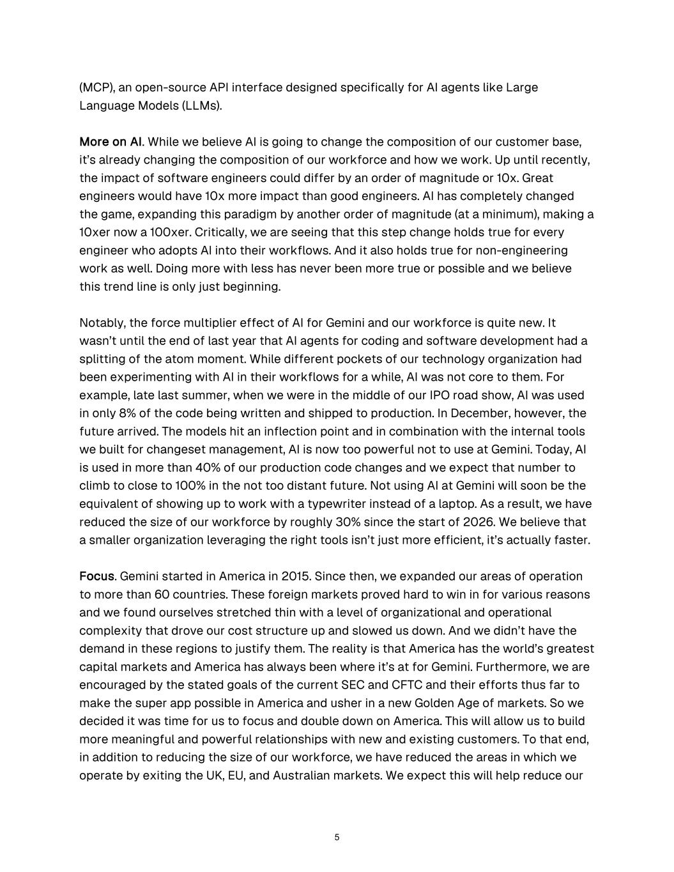
(MCP), an open-source API interface designed specifically for AI agents like Large Language Models (LLMs). More on AI. While we believe AI is going to change the composition of our customer base, it’s already changing the composition of our workforce and how we work. Up until recently, the impact of software engineers could differ by an order of magnitude or 10x. Great engineers would have 10x more impact than good engineers. AI has completely changed the game, expanding this paradigm by another order of magnitude (at a minimum), making a 10xer now a 100xer. Critically, we are seeing that this step change holds true for every engineer who adopts AI into their workflows. And it also holds true for non-engineering work as well. Doing more with less has never been more true or possible and we believe this trend line is only just beginning. Notably, the force multiplier effect of AI for Gemini and our workforce is quite new. It wasn’t until the end of last year that AI agents for coding and software development had a splitting of the atom moment. While different pockets of our technology organization had been experimenting with AI in their workflows for a while, AI was not core to them. For example, late last summer, when we were in the middle of our IPO road show, AI was used in only 8% of the code being written and shipped to production. In December, however, the future arrived. The models hit an inflection point and in combination with the internal tools we built for changeset management, AI is now too powerful not to use at Gemini. Today, AI is used in more than 40% of our production code changes and we expect that number to climb to close to 100% in the not too distant future. Not using AI at Gemini will soon be the equivalent of showing up to work with a typewriter instead of a laptop. As a result, we have reduced the size of our workforce by roughly 30% since the start of 2026. We believe that a smaller organization leveraging the right tools isn’t just more efficient, it’s actually faster. Focus. Gemini started in America in 2015. Since then, we expanded our areas of operation to more than 60 countries. These foreign markets proved hard to win in for various reasons and we found ourselves stretched thin with a level of organizational and operational complexity that drove our cost structure up and slowed us down. And we didn’t have the demand in these regions to justify them. The reality is that America has the world’s greatest capital markets and America has always been where it’s at for Gemini. Furthermore, we are encouraged by the stated goals of the current SEC and CFTC and their efforts thus far to make the super app possible in America and usher in a new Golden Age of markets. So we decided it was time for us to focus and double down on America. This will allow us to build more meaningful and powerful relationships with new and existing customers. To that end, in addition to reducing the size of our workforce, we have reduced the areas in which we operate by exiting the UK, EU, and Australian markets. We expect this will help reduce our 5

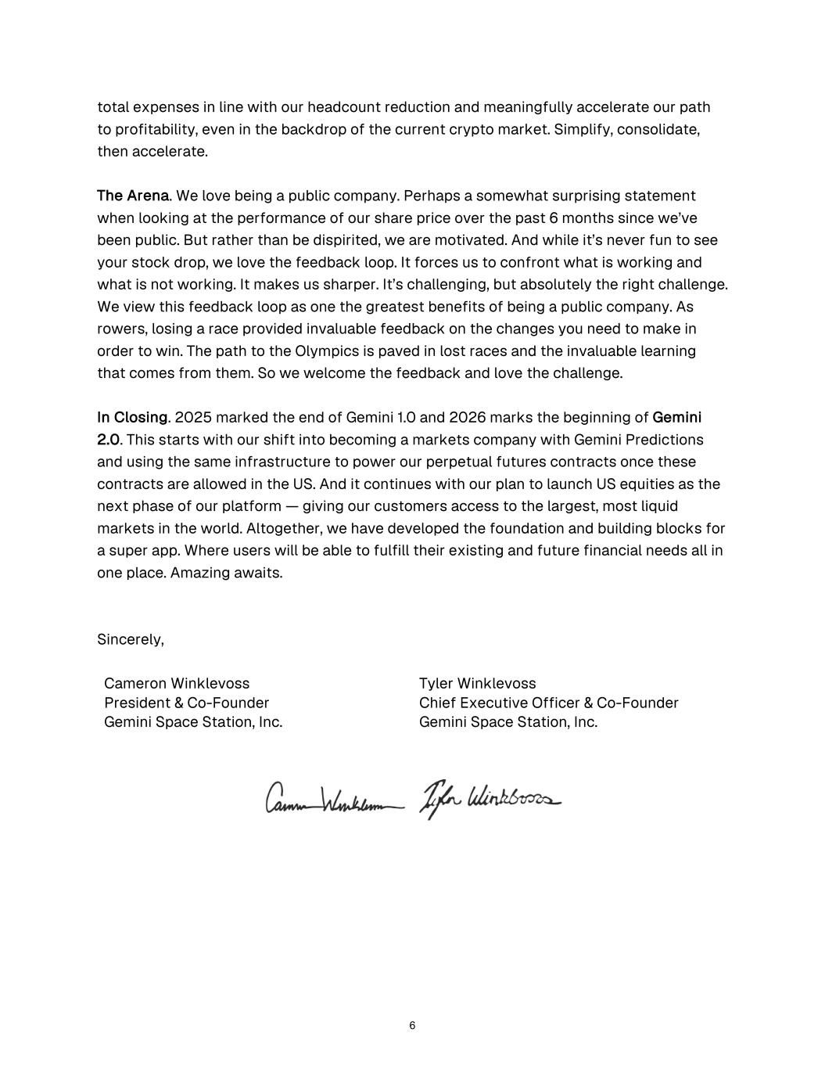
total expenses in line with our headcount reduction and meaningfully accelerate our path to profitability, even in the backdrop of the current crypto market. Simplify, consolidate, then accelerate. The Arena. We love being a public company. Perhaps a somewhat surprising statement when looking at the performance of our share price over the past 6 months since we’ve been public. But rather than be dispirited, we are motivated. And while it’s never fun to see your stock drop, we love the feedback loop. It forces us to confront what is working and what is not working. It makes us sharper. It’s challenging, but absolutely the right challenge. We view this feedback loop as one the greatest benefits of being a public company. As rowers, losing a race provided invaluable feedback on the changes you need to make in order to win. The path to the Olympics is paved in lost races and the invaluable learning that comes from them. So we welcome the feedback and love the challenge. In Closing. 2025 marked the end of Gemini 1.0 and 2026 marks the beginning of Gemini 2.0. This starts with our shift into becoming a markets company with Gemini Predictions and using the same infrastructure to power our perpetual futures contracts once these contracts are allowed in the US. And it continues with our plan to launch US equities as the next phase of our platform — giving our customers access to the largest, most liquid markets in the world. Altogether, we have developed the foundation and building blocks for a super app. Where users will be able to fulfill their existing and future financial needs all in one place. Amazing awaits. Sincerely, Cameron Winklevoss Tyler Winklevoss President & Co-Founder Chief Executive Officer & Co-Founder Gemini Space Station, Inc. Gemini Space Station, Inc. 6

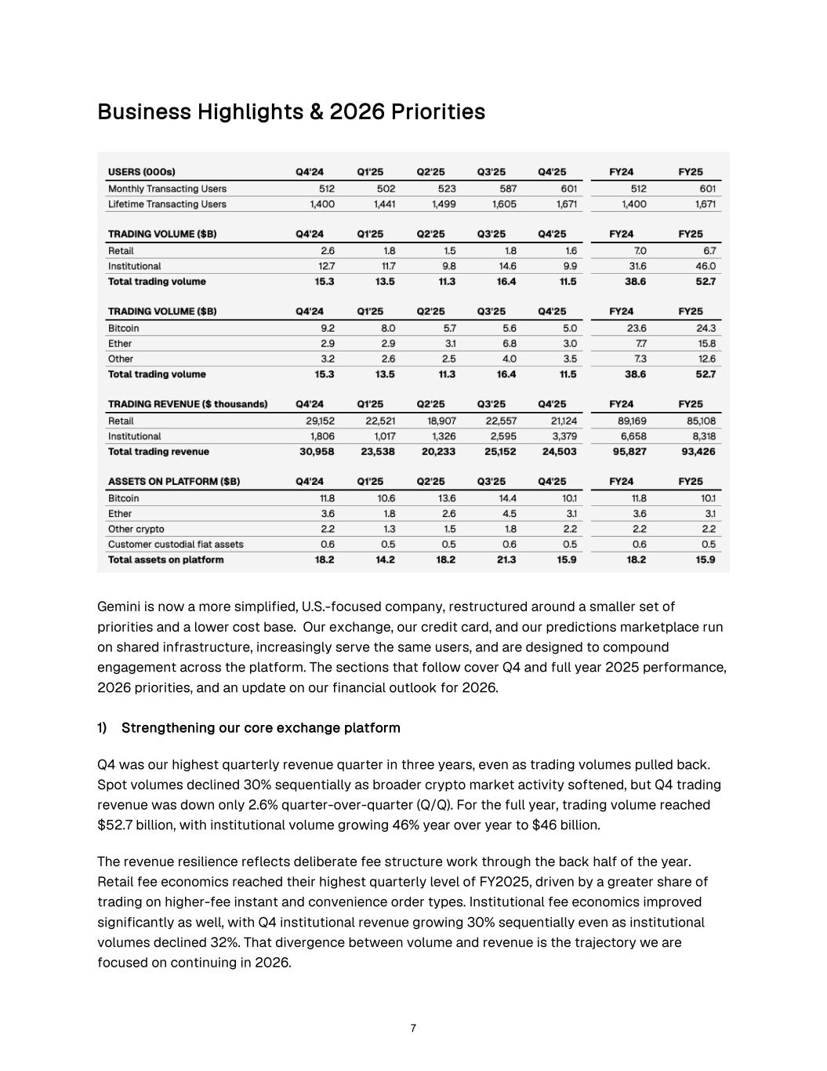
Business Highlights & 2026 Priorities Gemini is now a more simplified, U.S.-focused company, restructured around a smaller set of priorities and a lower cost base. Our exchange, our credit card, and our predictions marketplace run on shared infrastructure, increasingly serve the same users, and are designed to compound engagement across the platform. The sections that follow cover Q4 and full year 2025 performance, 2026 priorities, and an update on our financial outlook for 2026. 1) Strengthening our core exchange platform Q4 was our highest quarterly revenue quarter in three years, even as trading volumes pulled back. Spot volumes declined 30% sequentially as broader crypto market activity softened, but Q4 trading revenue was down only 2.6% quarter-over-quarter (Q/Q). For the full year, trading volume reached $52.7 billion, with institutional volume growing 46% year over year to $46 billion. The revenue resilience reflects deliberate fee structure work through the back half of the year. Retail fee economics reached their highest quarterly level of FY2025, driven by a greater share of trading on higher-fee instant and convenience order types. Institutional fee economics improved significantly as well, with Q4 institutional revenue growing 30% sequentially even as institutional volumes declined 32%. That divergence between volume and revenue is the trajectory we are focused on continuing in 2026. 7

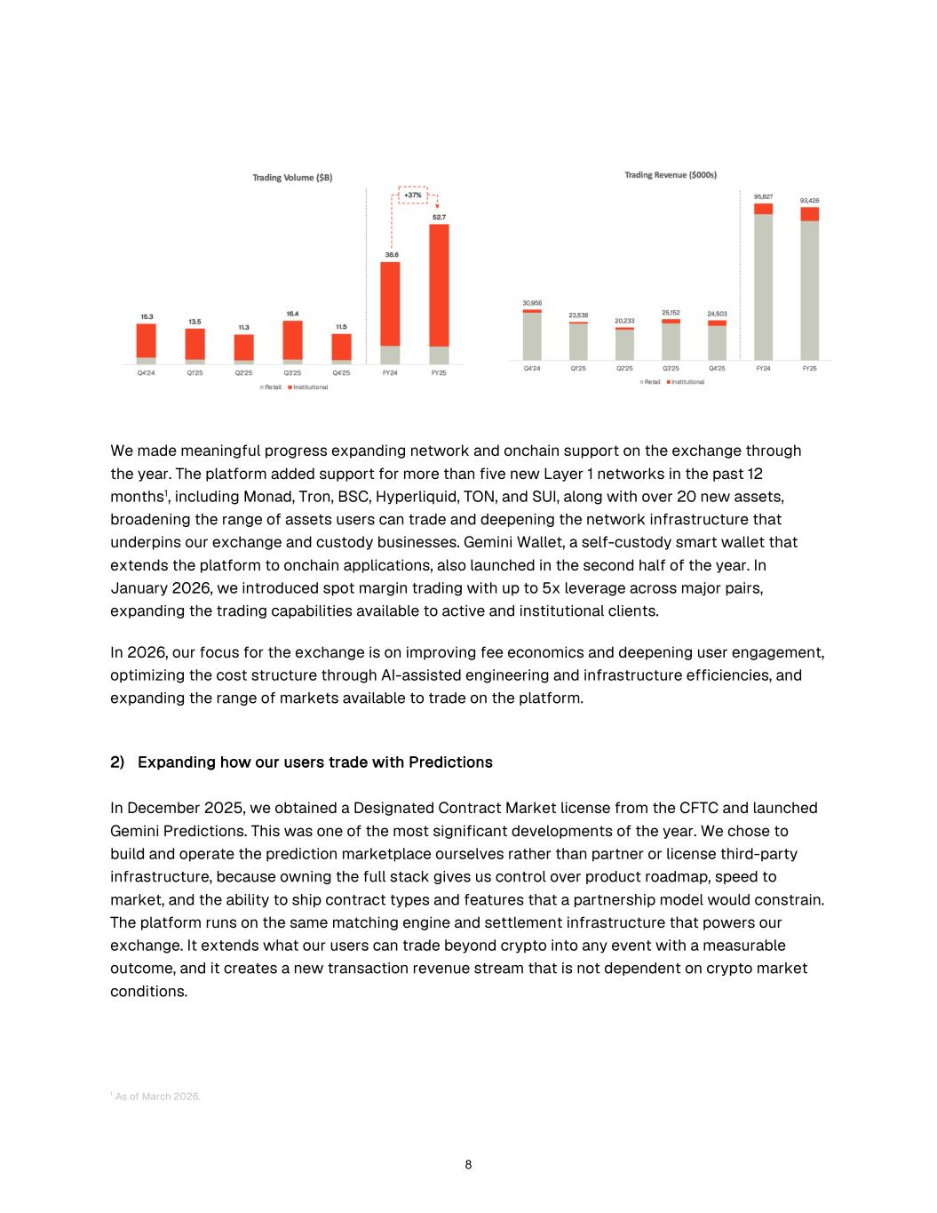
We made meaningful progress expanding network and onchain support on the exchange through the year. The platform added support for more than five new Layer 1 networks in the past 12 months1, including Monad, Tron, BSC, Hyperliquid, TON, and SUI, along with over 20 new assets, broadening the range of assets users can trade and deepening the network infrastructure that underpins our exchange and custody businesses. Gemini Wallet, a self-custody smart wallet that extends the platform to onchain applications, also launched in the second half of the year. In January 2026, we introduced spot margin trading with up to 5x leverage across major pairs, expanding the trading capabilities available to active and institutional clients. In 2026, our focus for the exchange is on improving fee economics and deepening user engagement, optimizing the cost structure through AI-assisted engineering and infrastructure efficiencies, and expanding the range of markets available to trade on the platform. 2) Expanding how our users trade with Predictions In December 2025, we obtained a Designated Contract Market license from the CFTC and launched Gemini Predictions. This was one of the most significant developments of the year. We chose to build and operate the prediction marketplace ourselves rather than partner or license third-party infrastructure, because owning the full stack gives us control over product roadmap, speed to market, and the ability to ship contract types and features that a partnership model would constrain. The platform runs on the same matching engine and settlement infrastructure that powers our exchange. It extends what our users can trade beyond crypto into any event with a measurable outcome, and it creates a new transaction revenue stream that is not dependent on crypto market conditions. 1 As of March 2026. 8

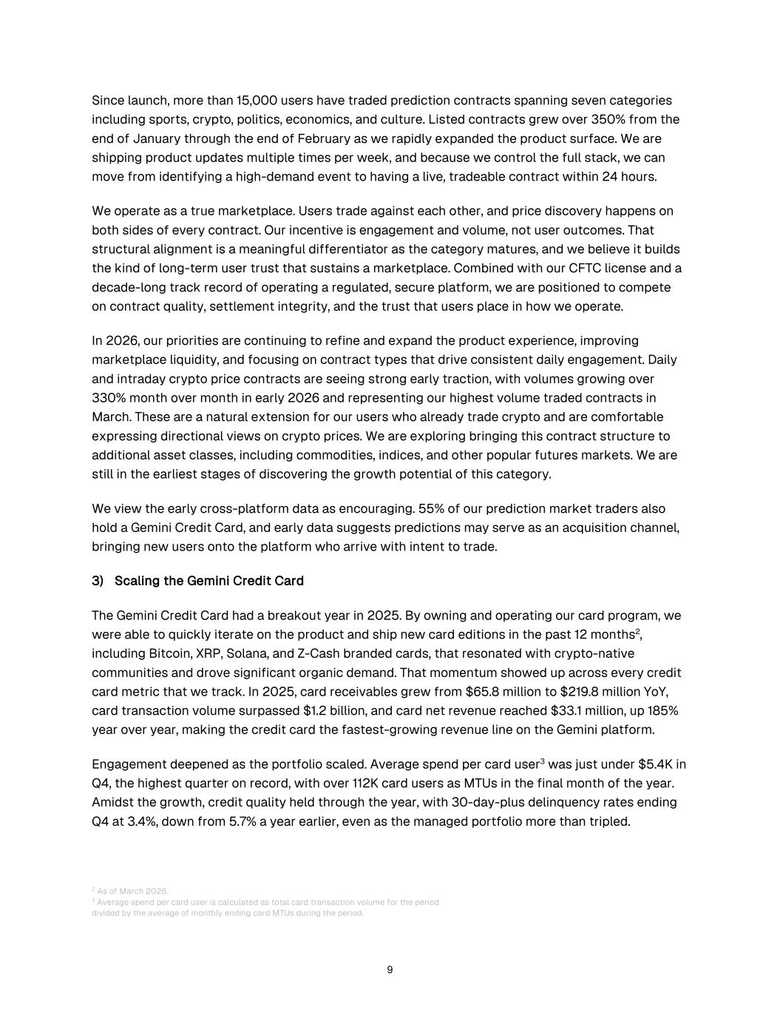
Since launch, more than 15,000 users have traded prediction contracts spanning seven categories including sports, crypto, politics, economics, and culture. Listed contracts grew over 350% from the end of January through the end of February as we rapidly expanded the product surface. We are shipping product updates multiple times per week, and because we control the full stack, we can move from identifying a high-demand event to having a live, tradeable contract within 24 hours. We operate as a true marketplace. Users trade against each other, and price discovery happens on both sides of every contract. Our incentive is engagement and volume, not user outcomes. That structural alignment is a meaningful differentiator as the category matures, and we believe it builds the kind of long-term user trust that sustains a marketplace. Combined with our CFTC license and a decade-long track record of operating a regulated, secure platform, we are positioned to compete on contract quality, settlement integrity, and the trust that users place in how we operate. In 2026, our priorities are continuing to refine and expand the product experience, improving marketplace liquidity, and focusing on contract types that drive consistent daily engagement. Daily and intraday crypto price contracts are seeing strong early traction, with volumes growing over 330% month over month in early 2026 and representing our highest volume traded contracts in March. These are a natural extension for our users who already trade crypto and are comfortable expressing directional views on crypto prices. We are exploring bringing this contract structure to additional asset classes, including commodities, indices, and other popular futures markets. We are still in the earliest stages of discovering the growth potential of this category. We view the early cross-platform data as encouraging. 55% of our prediction market traders also hold a Gemini Credit Card, and early data suggests predictions may serve as an acquisition channel, bringing new users onto the platform who arrive with intent to trade. 3) Scaling the Gemini Credit Card The Gemini Credit Card had a breakout year in 2025. By owning and operating our card program, we were able to quickly iterate on the product and ship new card editions in the past 12 months2, including Bitcoin, XRP, Solana, and Z-Cash branded cards, that resonated with crypto-native communities and drove significant organic demand. That momentum showed up across every credit card metric that we track. In 2025, card receivables grew from $65.8 million to $219.8 million YoY, card transaction volume surpassed $1.2 billion, and card net revenue reached $33.1 million, up 185% year over year, making the credit card the fastest-growing revenue line on the Gemini platform. Engagement deepened as the portfolio scaled. Average spend per card user3 was just under $5.4K in Q4, the highest quarter on record, with over 112K card users as MTUs in the final month of the year. Amidst the growth, credit quality held through the year, with 30-day-plus delinquency rates ending Q4 at 3.4%, down from 5.7% a year earlier, even as the managed portfolio more than tripled. 2 As of March 2026. 3 Average spend per card user is calculated as total card transaction volume for the period divided by the average of monthly ending card MTUs during the period. 9

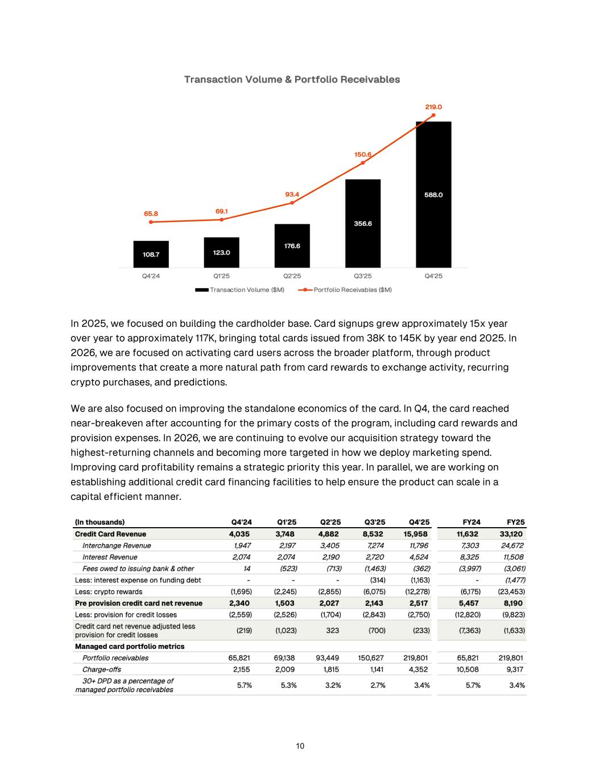
In 2025, we focused on building the cardholder base. Card signups grew approximately 15x year over year to approximately 117K, bringing total cards issued from 38K to 145K by year end 2025. In 2026, we are focused on activating card users across the broader platform, through product improvements that create a more natural path from card rewards to exchange activity, recurring crypto purchases, and predictions. We are also focused on improving the standalone economics of the card. In Q4, the card reached near-breakeven after accounting for the primary costs of the program, including card rewards and provision expenses. In 2026, we are continuing to evolve our acquisition strategy toward the highest-returning channels and becoming more targeted in how we deploy marketing spend. Improving card profitability remains a strategic priority this year. In parallel, we are working on establishing additional credit card financing facilities to help ensure the product can scale in a capital efficient manner. 10

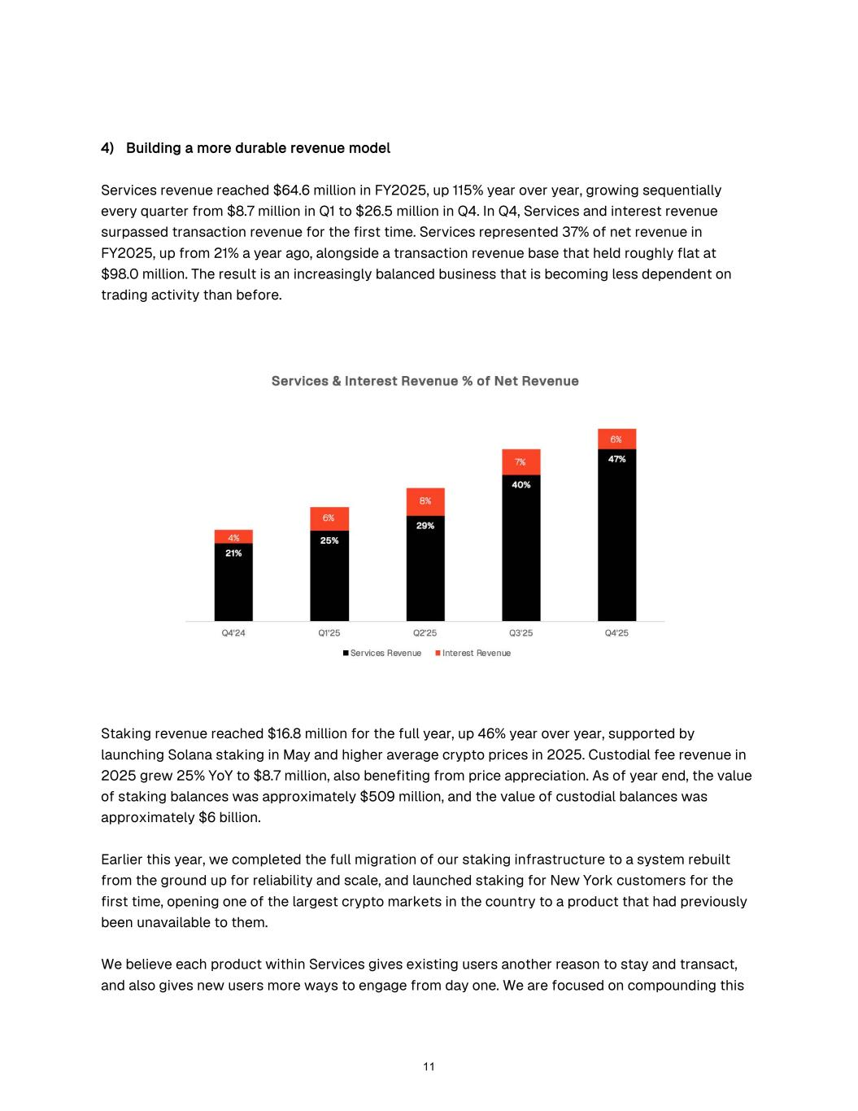
4) Building a more durable revenue model Services revenue reached $64.6 million in FY2025, up 115% year over year, growing sequentially every quarter from $8.7 million in Q1 to $26.5 million in Q4. In Q4, Services and interest revenue surpassed transaction revenue for the first time. Services represented 37% of net revenue in FY2025, up from 21% a year ago, alongside a transaction revenue base that held roughly flat at $98.0 million. The result is an increasingly balanced business that is becoming less dependent on trading activity than before. Staking revenue reached $16.8 million for the full year, up 46% year over year, supported by launching Solana staking in May and higher average crypto prices in 2025. Custodial fee revenue in 2025 grew 25% YoY to $8.7 million, also benefiting from price appreciation. As of year end, the value of staking balances was approximately $509 million, and the value of custodial balances was approximately $6 billion. Earlier this year, we completed the full migration of our staking infrastructure to a system rebuilt from the ground up for reliability and scale, and launched staking for New York customers for the first time, opening one of the largest crypto markets in the country to a product that had previously been unavailable to them. We believe each product within Services gives existing users another reason to stay and transact, and also gives new users more ways to engage from day one. We are focused on compounding this 11

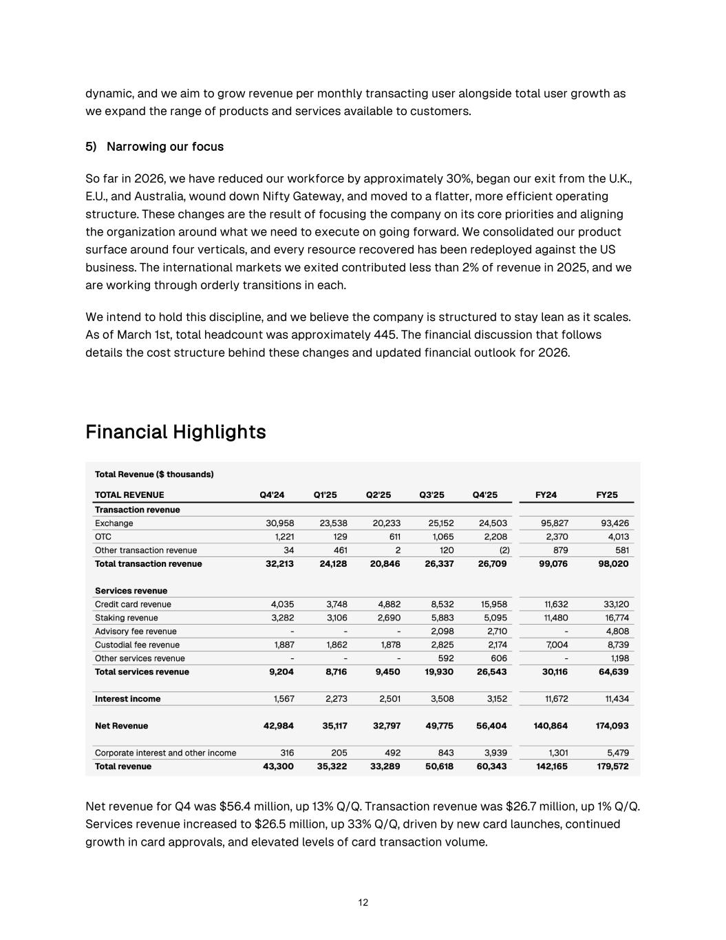
dynamic, and we aim to grow revenue per monthly transacting user alongside total user growth as we expand the range of products and services available to customers. 5) Narrowing our focus So far in 2026, we have reduced our workforce by approximately 30%, began our exit from the U.K., E.U., and Australia, wound down Nifty Gateway, and moved to a flatter, more efficient operating structure. These changes are the result of focusing the company on its core priorities and aligning the organization around what we need to execute on going forward. We consolidated our product surface around four verticals, and every resource recovered has been redeployed against the US business. The international markets we exited contributed less than 2% of revenue in 2025, and we are working through orderly transitions in each. We intend to hold this discipline, and we believe the company is structured to stay lean as it scales. As of March 1st, total headcount was approximately 445. The financial discussion that follows details the cost structure behind these changes and updated financial outlook for 2026. Financial Highlights Net revenue for Q4 was $56.4 million, up 13% Q/Q. Transaction revenue was $26.7 million, up 1% Q/Q. Services revenue increased to $26.5 million, up 33% Q/Q, driven by new card launches, continued growth in card approvals, and elevated levels of card transaction volume. 12

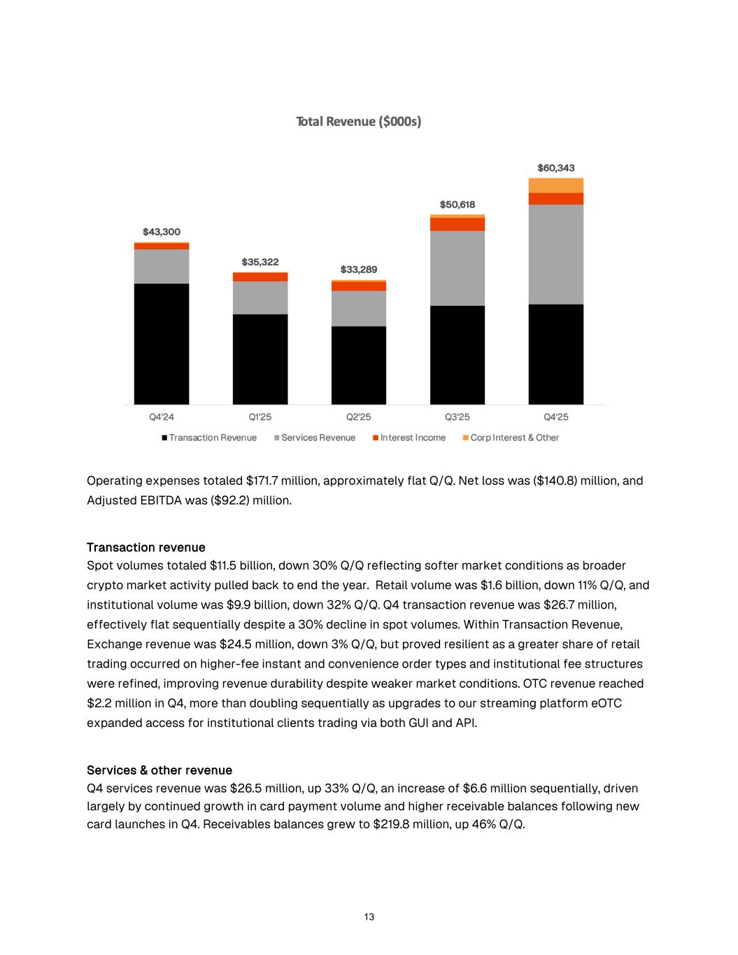
Operating expenses totaled $171.7 million, approximately flat Q/Q. Net loss was ($140.8) million, and Adjusted EBITDA was ($92.2) million. Transaction revenue Spot volumes totaled $11.5 billion, down 30% Q/Q reflecting softer market conditions as broader crypto market activity pulled back to end the year. Retail volume was $1.6 billion, down 11% Q/Q, and institutional volume was $9.9 billion, down 32% Q/Q. Q4 transaction revenue was $26.7 million, effectively flat sequentially despite a 30% decline in spot volumes. Within Transaction Revenue, Exchange revenue was $24.5 million, down 3% Q/Q, but proved resilient as a greater share of retail trading occurred on higher-fee instant and convenience order types and institutional fee structures were refined, improving revenue durability despite weaker market conditions. OTC revenue reached $2.2 million in Q4, more than doubling sequentially as upgrades to our streaming platform eOTC expanded access for institutional clients trading via both GUI and API. Services & other revenue Q4 services revenue was $26.5 million, up 33% Q/Q, an increase of $6.6 million sequentially, driven largely by continued growth in card payment volume and higher receivable balances following new card launches in Q4. Receivables balances grew to $219.8 million, up 46% Q/Q. 13

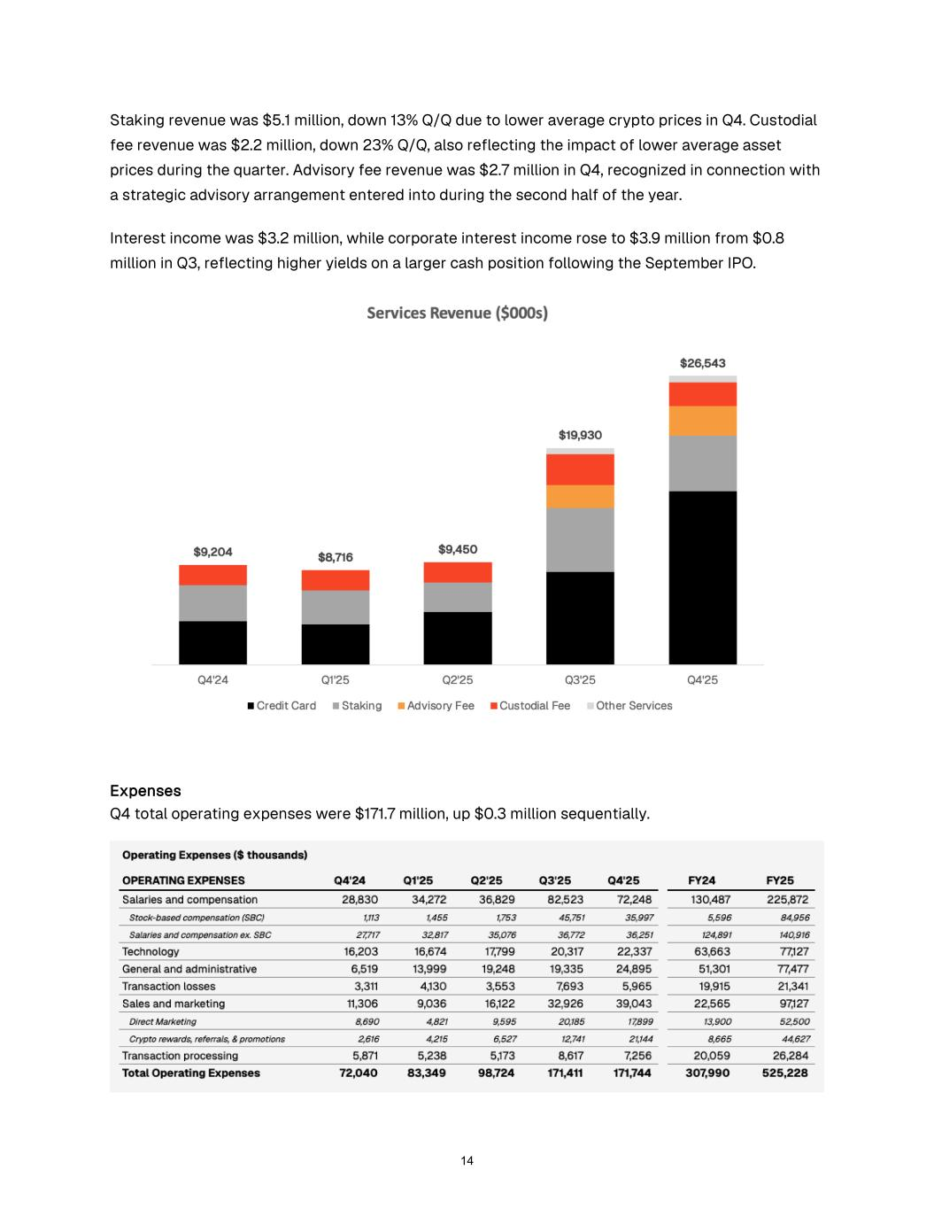
Staking revenue was $5.1 million, down 13% Q/Q due to lower average crypto prices in Q4. Custodial fee revenue was $2.2 million, down 23% Q/Q, also reflecting the impact of lower average asset prices during the quarter. Advisory fee revenue was $2.7 million in Q4, recognized in connection with a strategic advisory arrangement entered into during the second half of the year. Interest income was $3.2 million, while corporate interest income rose to $3.9 million from $0.8 million in Q3, reflecting higher yields on a larger cash position following the September IPO. Expenses Q4 total operating expenses were $171.7 million, up $0.3 million sequentially. 14

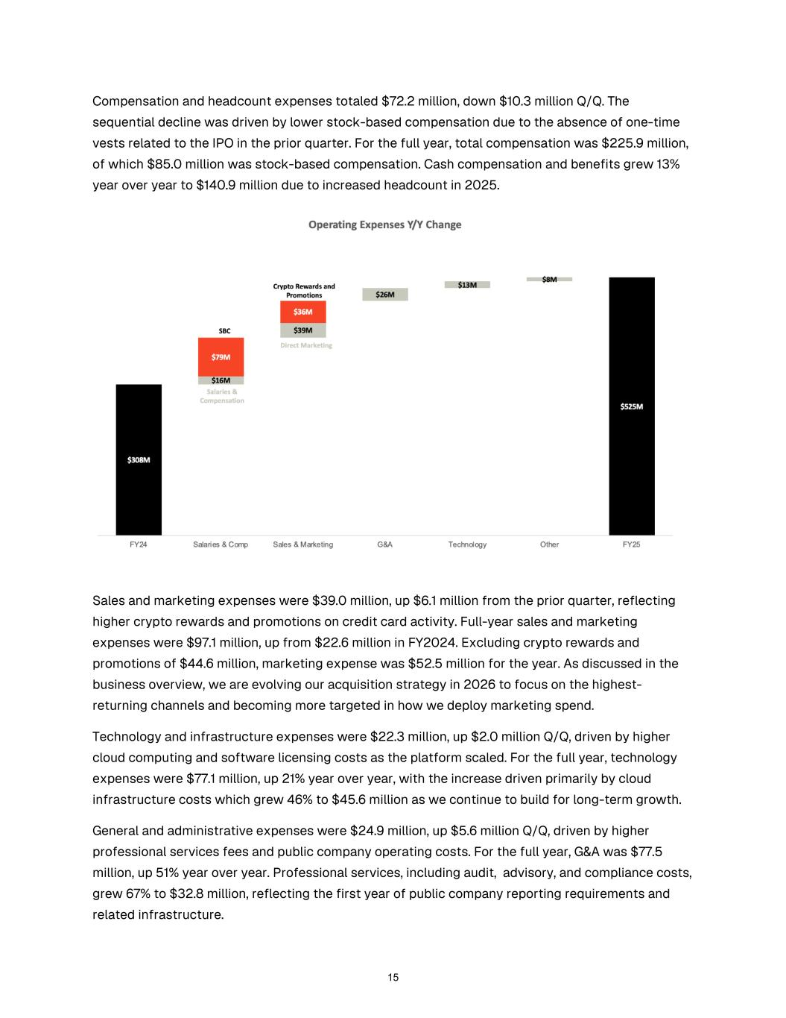
Compensation and headcount expenses totaled $72.2 million, down $10.3 million Q/Q. The sequential decline was driven by lower stock-based compensation due to the absence of one-time vests related to the IPO in the prior quarter. For the full year, total compensation was $225.9 million, of which $85.0 million was stock-based compensation. Cash compensation and benefits grew 13% year over year to $140.9 million due to increased headcount in 2025. Sales and marketing expenses were $39.0 million, up $6.1 million from the prior quarter, reflecting higher crypto rewards and promotions on credit card activity. Full-year sales and marketing expenses were $97.1 million, up from $22.6 million in FY2024. Excluding crypto rewards and promotions of $44.6 million, marketing expense was $52.5 million for the year. As discussed in the business overview, we are evolving our acquisition strategy in 2026 to focus on the highest- returning channels and becoming more targeted in how we deploy marketing spend. Technology and infrastructure expenses were $22.3 million, up $2.0 million Q/Q, driven by higher cloud computing and software licensing costs as the platform scaled. For the full year, technology expenses were $77.1 million, up 21% year over year, with the increase driven primarily by cloud infrastructure costs which grew 46% to $45.6 million as we continue to build for long-term growth. General and administrative expenses were $24.9 million, up $5.6 million Q/Q, driven by higher professional services fees and public company operating costs. For the full year, G&A was $77.5 million, up 51% year over year. Professional services, including audit, advisory, and compliance costs, grew 67% to $32.8 million, reflecting the first year of public company reporting requirements and related infrastructure. 15

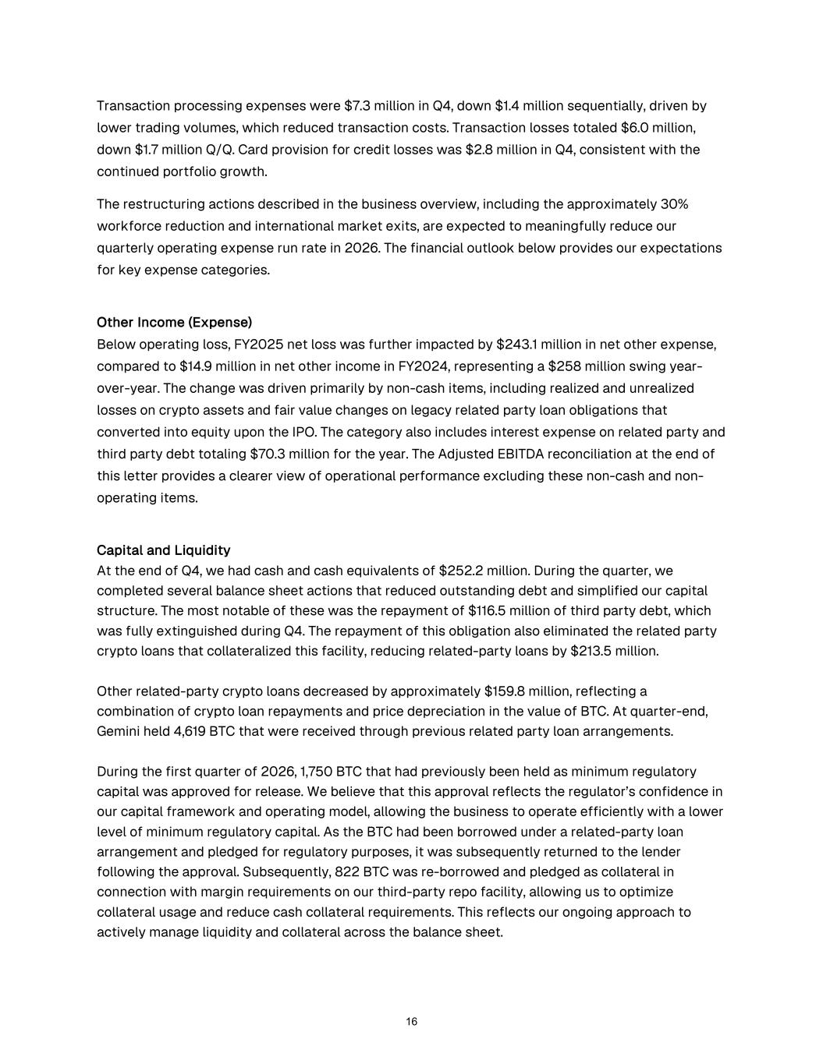
Transaction processing expenses were $7.3 million in Q4, down $1.4 million sequentially, driven by lower trading volumes, which reduced transaction costs. Transaction losses totaled $6.0 million, down $1.7 million Q/Q. Card provision for credit losses was $2.8 million in Q4, consistent with the continued portfolio growth. The restructuring actions described in the business overview, including the approximately 30% workforce reduction and international market exits, are expected to meaningfully reduce our quarterly operating expense run rate in 2026. The financial outlook below provides our expectations for key expense categories. Other Income (Expense) Below operating loss, FY2025 net loss was further impacted by $243.1 million in net other expense, compared to $14.9 million in net other income in FY2024, representing a $258 million swing year- over-year. The change was driven primarily by non-cash items, including realized and unrealized losses on crypto assets and fair value changes on legacy related party loan obligations that converted into equity upon the IPO. The category also includes interest expense on related party and third party debt totaling $70.3 million for the year. The Adjusted EBITDA reconciliation at the end of this letter provides a clearer view of operational performance excluding these non-cash and non- operating items. Capital and Liquidity At the end of Q4, we had cash and cash equivalents of $252.2 million. During the quarter, we completed several balance sheet actions that reduced outstanding debt and simplified our capital structure. The most notable of these was the repayment of $116.5 million of third party debt, which was fully extinguished during Q4. The repayment of this obligation also eliminated the related party crypto loans that collateralized this facility, reducing related-party loans by $213.5 million. Other related-party crypto loans decreased by approximately $159.8 million, reflecting a combination of crypto loan repayments and price depreciation in the value of BTC. At quarter-end, Gemini held 4,619 BTC that were received through previous related party loan arrangements. During the first quarter of 2026, 1,750 BTC that had previously been held as minimum regulatory capital was approved for release. We believe that this approval reflects the regulator’s confidence in our capital framework and operating model, allowing the business to operate efficiently with a lower level of minimum regulatory capital. As the BTC had been borrowed under a related-party loan arrangement and pledged for regulatory purposes, it was subsequently returned to the lender following the approval. Subsequently, 822 BTC was re-borrowed and pledged as collateral in connection with margin requirements on our third-party repo facility, allowing us to optimize collateral usage and reduce cash collateral requirements. This reflects our ongoing approach to actively manage liquidity and collateral across the balance sheet. 16

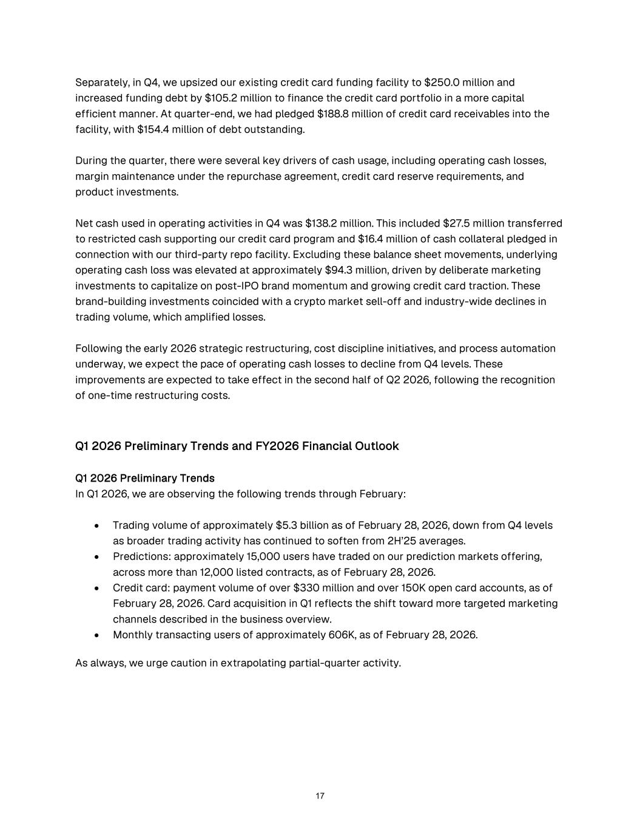
Separately, in Q4, we upsized our existing credit card funding facility to $250.0 million and increased funding debt by $105.2 million to finance the credit card portfolio in a more capital efficient manner. At quarter-end, we had pledged $188.8 million of credit card receivables into the facility, with $154.4 million of debt outstanding. During the quarter, there were several key drivers of cash usage, including operating cash losses, margin maintenance under the repurchase agreement, credit card reserve requirements, and product investments. Net cash used in operating activities in Q4 was $138.2 million. This included $27.5 million transferred to restricted cash supporting our credit card program and $16.4 million of cash collateral pledged in connection with our third-party repo facility. Excluding these balance sheet movements, underlying operating cash loss was elevated at approximately $94.3 million, driven by deliberate marketing investments to capitalize on post-IPO brand momentum and growing credit card traction. These brand-building investments coincided with a crypto market sell-off and industry-wide declines in trading volume, which amplified losses. Following the early 2026 strategic restructuring, cost discipline initiatives, and process automation underway, we expect the pace of operating cash losses to decline from Q4 levels. These improvements are expected to take effect in the second half of Q2 2026, following the recognition of one-time restructuring costs. Q1 2026 Preliminary Trends and FY2026 Financial Outlook Q1 2026 Preliminary Trends In Q1 2026, we are observing the following trends through February: • Trading volume of approximately $5.3 billion as of February 28, 2026, down from Q4 levels as broader trading activity has continued to soften from 2H’25 averages. • Predictions: approximately 15,000 users have traded on our prediction markets offering, across more than 12,000 listed contracts, as of February 28, 2026. • Credit card: payment volume of over $330 million and over 150K open card accounts, as of February 28, 2026. Card acquisition in Q1 reflects the shift toward more targeted marketing channels described in the business overview. • Monthly transacting users of approximately 606K, as of February 28, 2026. As always, we urge caution in extrapolating partial-quarter activity. 17

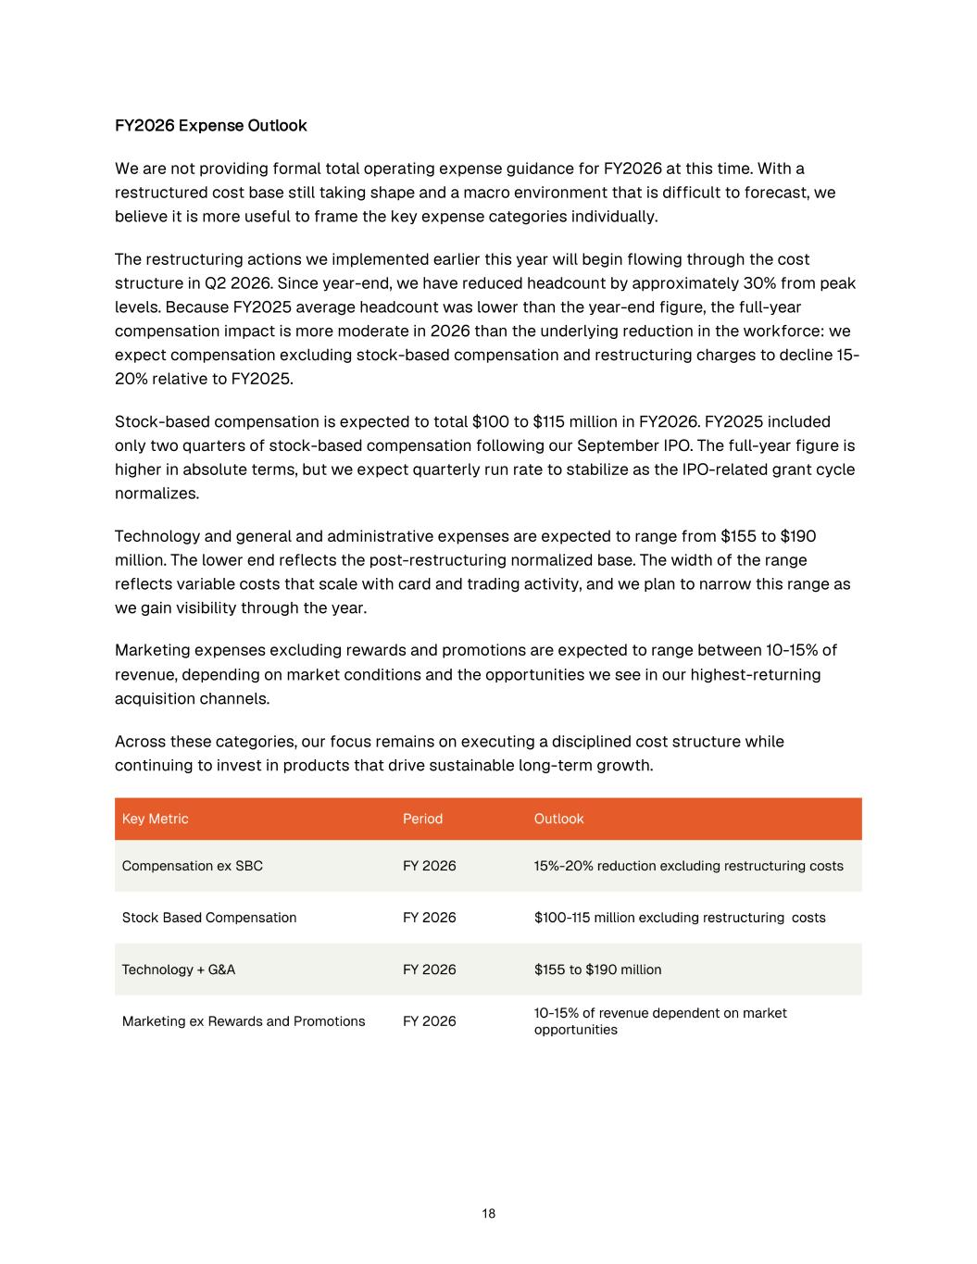
FY2026 Expense Outlook We are not providing formal total operating expense guidance for FY2026 at this time. With a restructured cost base still taking shape and a macro environment that is difficult to forecast, we believe it is more useful to frame the key expense categories individually. The restructuring actions we implemented earlier this year will begin flowing through the cost structure in Q2 2026. Since year-end, we have reduced headcount by approximately 30% from peak levels. Because FY2025 average headcount was lower than the year-end figure, the full-year compensation impact is more moderate in 2026 than the underlying reduction in the workforce: we expect compensation excluding stock-based compensation and restructuring charges to decline 15- 20% relative to FY2025. Stock-based compensation is expected to total $100 to $115 million in FY2026. FY2025 included only two quarters of stock-based compensation following our September IPO. The full-year figure is higher in absolute terms, but we expect quarterly run rate to stabilize as the IPO-related grant cycle normalizes. Technology and general and administrative expenses are expected to range from $155 to $190 million. The lower end reflects the post-restructuring normalized base. The width of the range reflects variable costs that scale with card and trading activity, and we plan to narrow this range as we gain visibility through the year. Marketing expenses excluding rewards and promotions are expected to range between 10-15% of revenue, depending on market conditions and the opportunities we see in our highest-returning acquisition channels. Across these categories, our focus remains on executing a disciplined cost structure while continuing to invest in products that drive sustainable long-term growth. 18

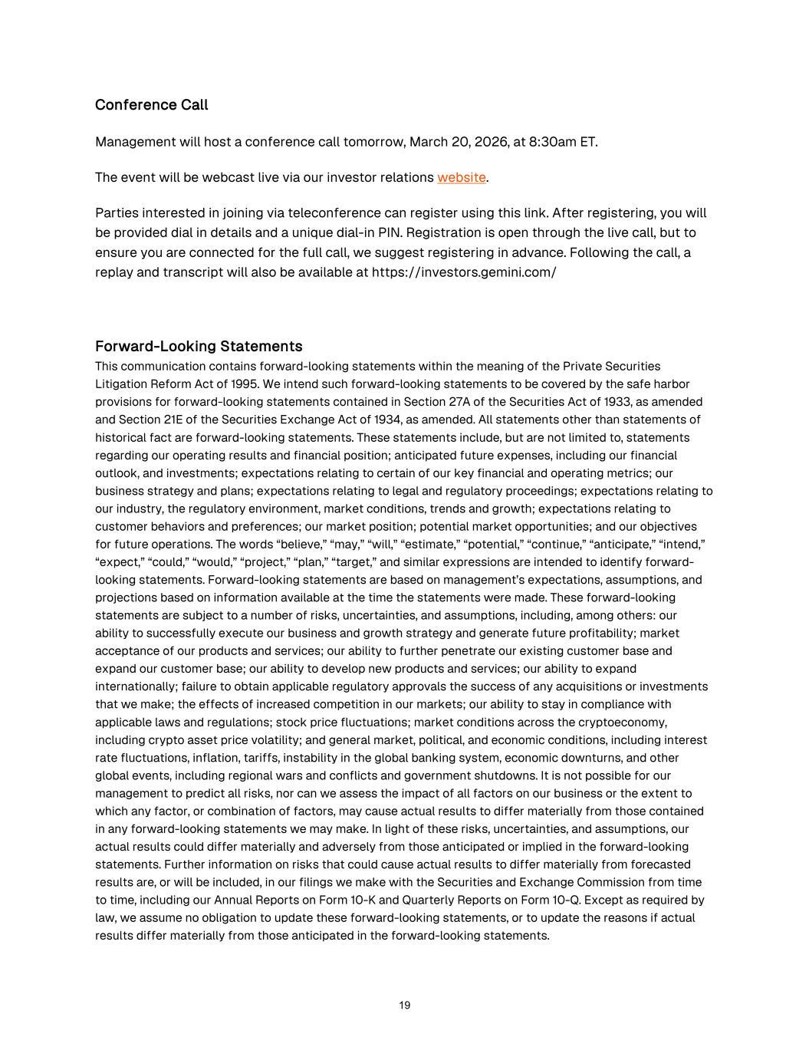
Conference Call Management will host a conference call tomorrow, March 20, 2026, at 8:30am ET. The event will be webcast live via our investor relations website. Parties interested in joining via teleconference can register using this link. After registering, you will be provided dial in details and a unique dial-in PIN. Registration is open through the live call, but to ensure you are connected for the full call, we suggest registering in advance. Following the call, a replay and transcript will also be available at https://investors.gemini.com/ Forward-Looking Statements This communication contains forward-looking statements within the meaning of the Private Securities Litigation Reform Act of 1995. We intend such forward-looking statements to be covered by the safe harbor provisions for forward-looking statements contained in Section 27A of the Securities Act of 1933, as amended and Section 21E of the Securities Exchange Act of 1934, as amended. All statements other than statements of historical fact are forward-looking statements. These statements include, but are not limited to, statements regarding our operating results and financial position; anticipated future expenses, including our financial outlook, and investments; expectations relating to certain of our key financial and operating metrics; our business strategy and plans; expectations relating to legal and regulatory proceedings; expectations relating to our industry, the regulatory environment, market conditions, trends and growth; expectations relating to customer behaviors and preferences; our market position; potential market opportunities; and our objectives for future operations. The words “believe,” “may,” “will,” “estimate,” “potential,” “continue,” “anticipate,” “intend,” “expect,” “could,” “would,” “project,” “plan,” “target,” and similar expressions are intended to identify forward- looking statements. Forward-looking statements are based on management’s expectations, assumptions, and projections based on information available at the time the statements were made. These forward-looking statements are subject to a number of risks, uncertainties, and assumptions, including, among others: our ability to successfully execute our business and growth strategy and generate future profitability; market acceptance of our products and services; our ability to further penetrate our existing customer base and expand our customer base; our ability to develop new products and services; our ability to expand internationally; failure to obtain applicable regulatory approvals the success of any acquisitions or investments that we make; the effects of increased competition in our markets; our ability to stay in compliance with applicable laws and regulations; stock price fluctuations; market conditions across the cryptoeconomy, including crypto asset price volatility; and general market, political, and economic conditions, including interest rate fluctuations, inflation, tariffs, instability in the global banking system, economic downturns, and other global events, including regional wars and conflicts and government shutdowns. It is not possible for our management to predict all risks, nor can we assess the impact of all factors on our business or the extent to which any factor, or combination of factors, may cause actual results to differ materially from those contained in any forward-looking statements we may make. In light of these risks, uncertainties, and assumptions, our actual results could differ materially and adversely from those anticipated or implied in the forward-looking statements. Further information on risks that could cause actual results to differ materially from forecasted results are, or will be included, in our filings we make with the Securities and Exchange Commission from time to time, including our Annual Reports on Form 10-K and Quarterly Reports on Form 10-Q. Except as required by law, we assume no obligation to update these forward-looking statements, or to update the reasons if actual results differ materially from those anticipated in the forward-looking statements. 19

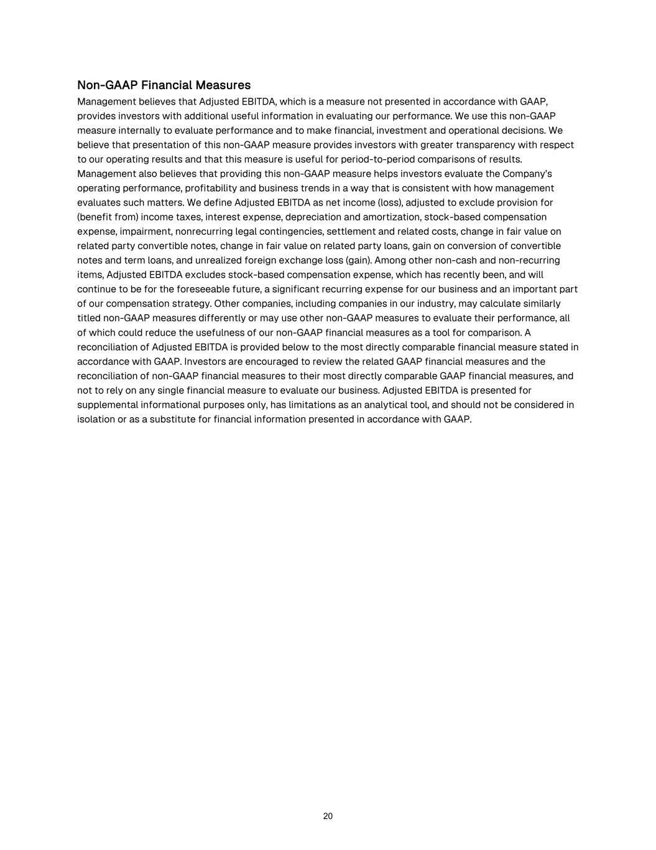
Non-GAAP Financial Measures Management believes that Adjusted EBITDA, which is a measure not presented in accordance with GAAP, provides investors with additional useful information in evaluating our performance. We use this non-GAAP measure internally to evaluate performance and to make financial, investment and operational decisions. We believe that presentation of this non-GAAP measure provides investors with greater transparency with respect to our operating results and that this measure is useful for period-to-period comparisons of results. Management also believes that providing this non-GAAP measure helps investors evaluate the Company’s operating performance, profitability and business trends in a way that is consistent with how management evaluates such matters. We define Adjusted EBITDA as net income (loss), adjusted to exclude provision for (benefit from) income taxes, interest expense, depreciation and amortization, stock-based compensation expense, impairment, nonrecurring legal contingencies, settlement and related costs, change in fair value on related party convertible notes, change in fair value on related party loans, gain on conversion of convertible notes and term loans, and unrealized foreign exchange loss (gain). Among other non-cash and non-recurring items, Adjusted EBITDA excludes stock-based compensation expense, which has recently been, and will continue to be for the foreseeable future, a significant recurring expense for our business and an important part of our compensation strategy. Other companies, including companies in our industry, may calculate similarly titled non-GAAP measures differently or may use other non-GAAP measures to evaluate their performance, all of which could reduce the usefulness of our non-GAAP financial measures as a tool for comparison. A reconciliation of Adjusted EBITDA is provided below to the most directly comparable financial measure stated in accordance with GAAP. Investors are encouraged to review the related GAAP financial measures and the reconciliation of non-GAAP financial measures to their most directly comparable GAAP financial measures, and not to rely on any single financial measure to evaluate our business. Adjusted EBITDA is presented for supplemental informational purposes only, has limitations as an analytical tool, and should not be considered in isolation or as a substitute for financial information presented in accordance with GAAP. 20

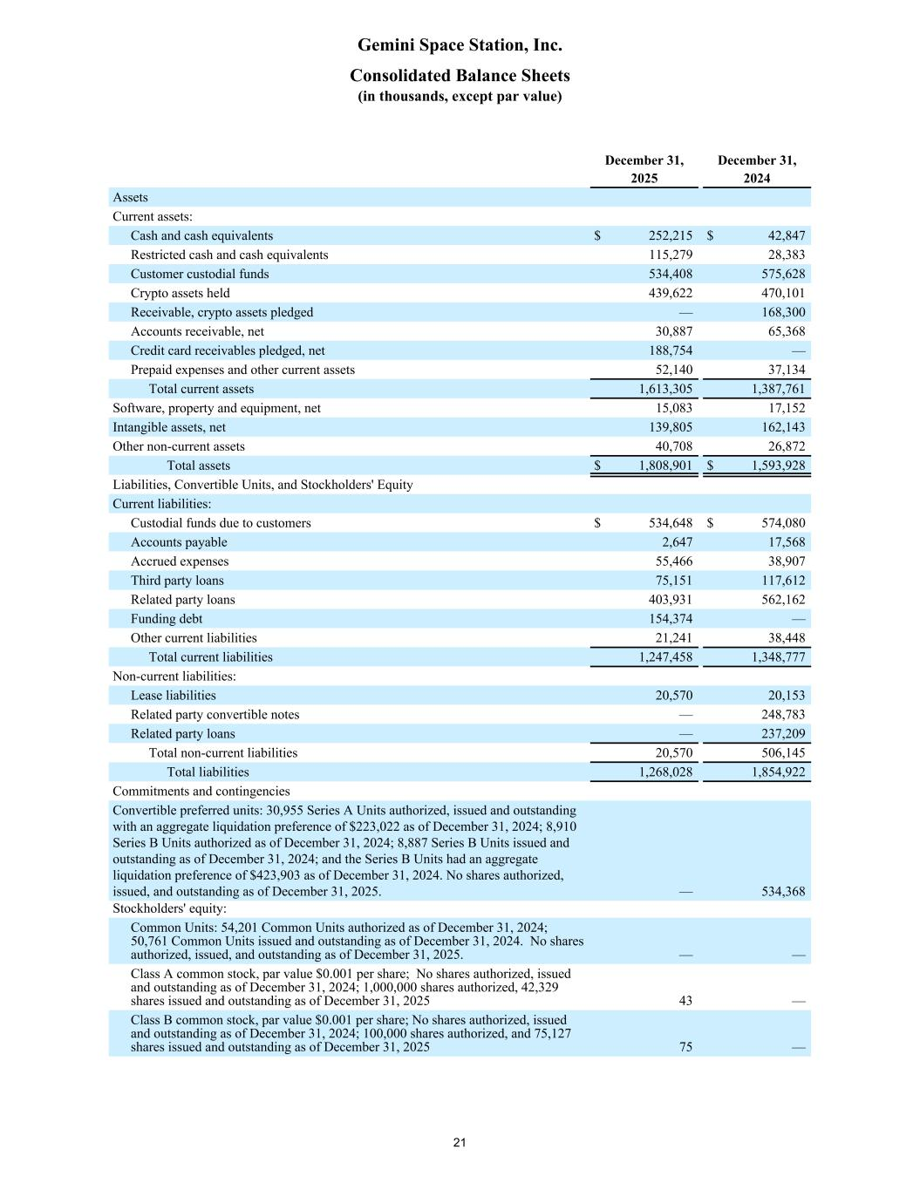
December 31, December 31, 2025 2024 Assets Current assets: Cash and cash equivalents $ 252,215 $ 42,847 Restricted cash and cash equivalents 115,279 28,383 Customer custodial funds 534,408 575,628 Crypto assets held 439,622 470,101 Receivable, crypto assets pledged — 168,300 Accounts receivable, net 30,887 65,368 Credit card receivables pledged, net 188,754 — Prepaid expenses and other current assets 52,140 37,134 Total current assets 1,613,305 1,387,761 Software, property and equipment, net 15,083 17,152 Intangible assets, net 139,805 162,143 Other non-current assets 40,708 26,872 Total assets $ 1,808,901 $ 1,593,928 Liabilities, Convertible Units, and Stockholders' Equity Current liabilities: Custodial funds due to customers $ 534,648 $ 574,080 Accounts payable 2,647 17,568 Accrued expenses 55,466 38,907 Third party loans 75,151 117,612 Related party loans 403,931 562,162 Funding debt 154,374 — Other current liabilities 21,241 38,448 Total current liabilities 1,247,458 1,348,777 Non-current liabilities: Lease liabilities 20,570 20,153 Related party convertible notes — 248,783 Related party loans — 237,209 Total non-current liabilities 20,570 506,145 Total liabilities 1,268,028 1,854,922 Commitments and contingencies Convertible preferred units: 30,955 Series A Units authorized, issued and outstanding with an aggregate liquidation preference of $223,022 as of December 31, 2024; 8,910 Series B Units authorized as of December 31, 2024; 8,887 Series B Units issued and outstanding as of December 31, 2024; and the Series B Units had an aggregate liquidation preference of $423,903 as of December 31, 2024. No shares authorized, issued, and outstanding as of December 31, 2025. — 534,368 Stockholders' equity: Common Units: 54,201 Common Units authorized as of December 31, 2024; 50,761 Common Units issued and outstanding as of December 31, 2024. No shares authorized, issued, and outstanding as of December 31, 2025. — — Class A common stock, par value $0.001 per share; No shares authorized, issued and outstanding as of December 31, 2024; 1,000,000 shares authorized, 42,329 shares issued and outstanding as of December 31, 2025 43 — Class B common stock, par value $0.001 per share; No shares authorized, issued and outstanding as of December 31, 2024; 100,000 shares authorized, and 75,127 shares issued and outstanding as of December 31, 2025 75 — Gemini Space Station, Inc. Consolidated Balance Sheets (in thousands, except par value) 21

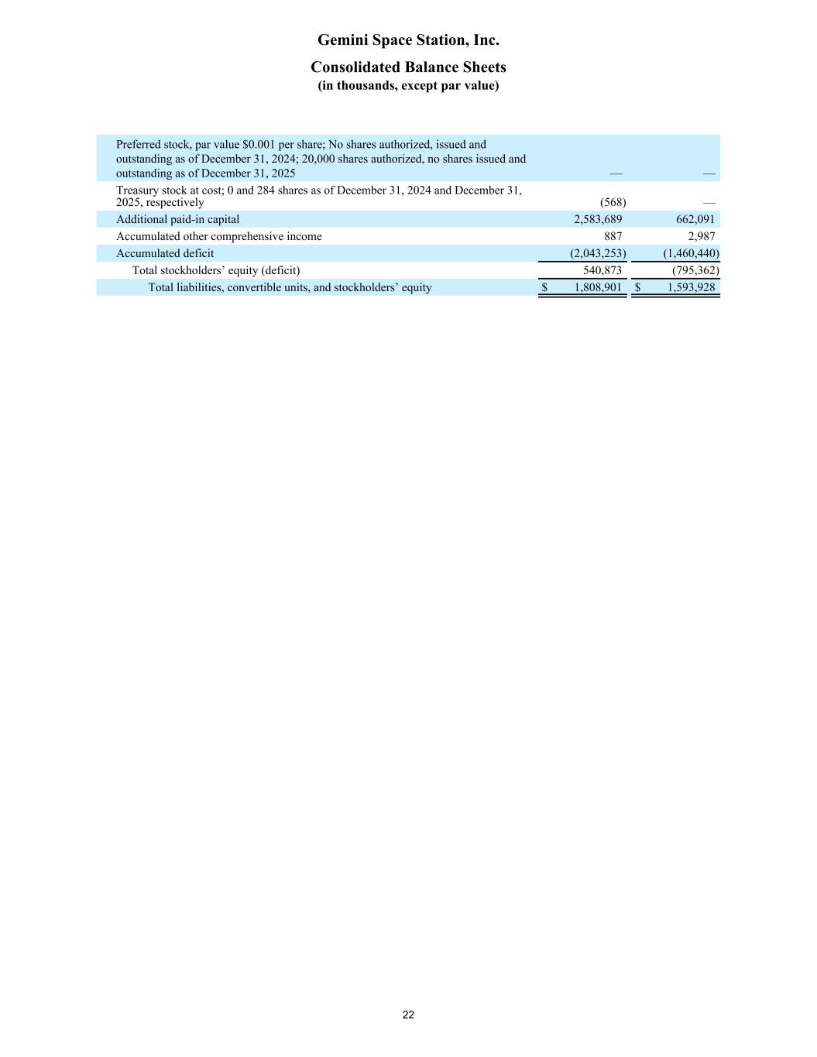
Preferred stock, par value $0.001 per share; No shares authorized, issued and outstanding as of December 31, 2024; 20,000 shares authorized, no shares issued and outstanding as of December 31, 2025 — — Treasury stock at cost; 0 and 284 shares as of December 31, 2024 and December 31, 2025, respectively (568) — Additional paid-in capital 2,583,689 662,091 Accumulated other comprehensive income 887 2,987 Accumulated deficit (2,043,253) (1,460,440) Total stockholders’ equity (deficit) 540,873 (795,362) Total liabilities, convertible units, and stockholders’ equity $ 1,808,901 $ 1,593,928 Gemini Space Station, Inc. Consolidated Balance Sheets (in thousands, except par value) 22

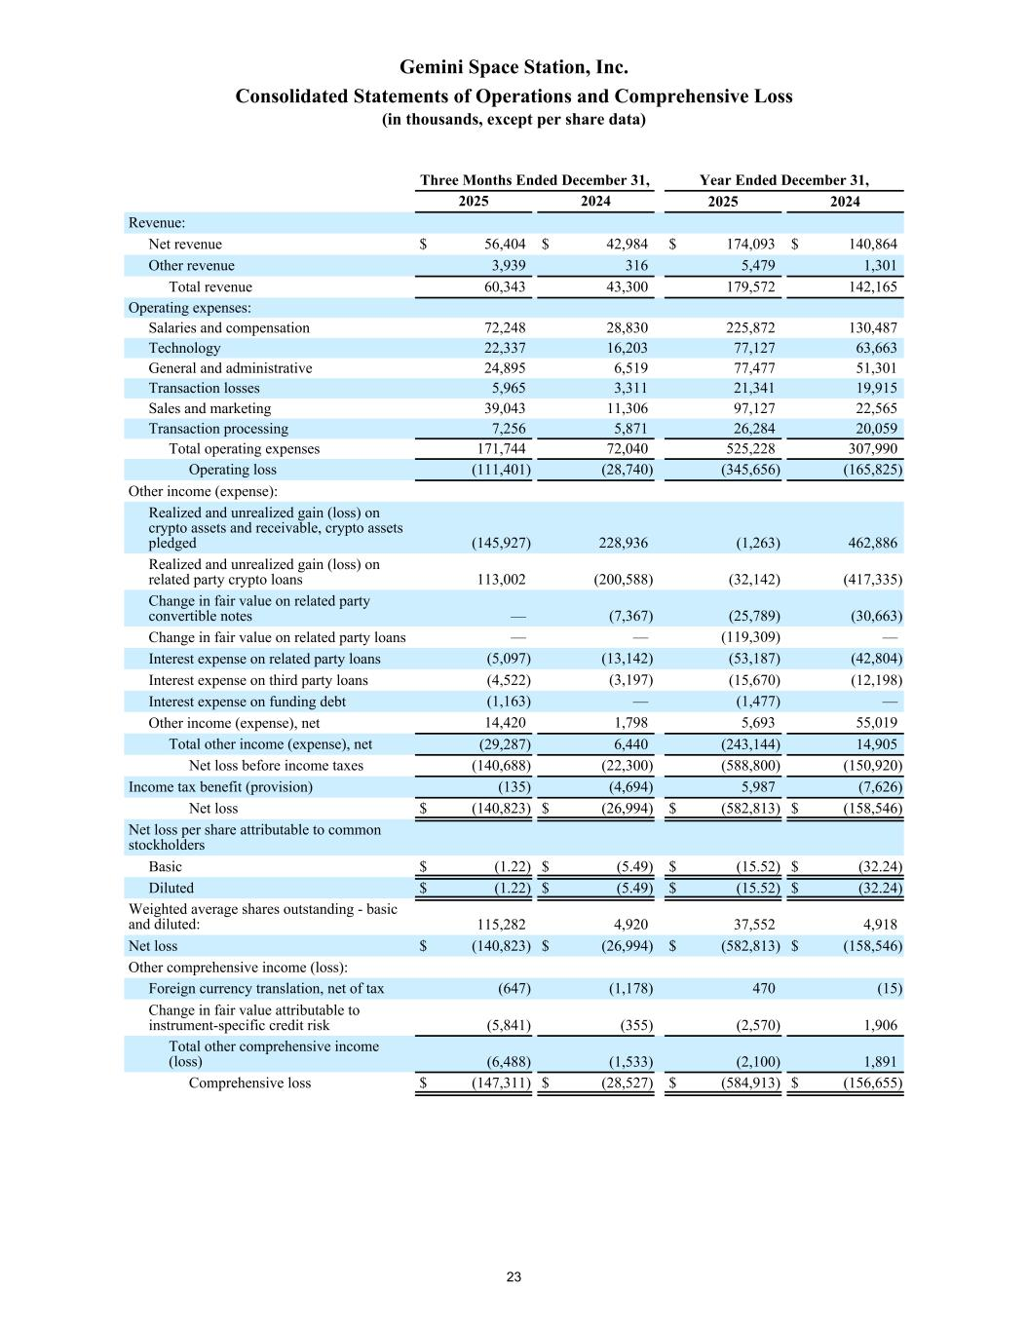
Three Months Ended December 31, Year Ended December 31, 2025 2024 2025 2024 Revenue: Net revenue $ 56,404 $ 42,984 $ 174,093 $ 140,864 Other revenue 3,939 316 5,479 1,301 Total revenue 60,343 43,300 179,572 142,165 Operating expenses: Salaries and compensation 72,248 28,830 225,872 130,487 Technology 22,337 16,203 77,127 63,663 General and administrative 24,895 6,519 77,477 51,301 Transaction losses 5,965 3,311 21,341 19,915 Sales and marketing 39,043 11,306 97,127 22,565 Transaction processing 7,256 5,871 26,284 20,059 Total operating expenses 171,744 72,040 525,228 307,990 Operating loss (111,401) (28,740) (345,656) (165,825) Other income (expense): Realized and unrealized gain (loss) on crypto assets and receivable, crypto assets pledged (145,927) 228,936 (1,263) 462,886 Realized and unrealized gain (loss) on related party crypto loans 113,002 (200,588) (32,142) (417,335) Change in fair value on related party convertible notes — (7,367) (25,789) (30,663) Change in fair value on related party loans — — (119,309) — Interest expense on related party loans (5,097) (13,142) (53,187) (42,804) Interest expense on third party loans (4,522) (3,197) (15,670) (12,198) Interest expense on funding debt (1,163) — (1,477) — Other income (expense), net 14,420 1,798 5,693 55,019 Total other income (expense), net (29,287) 6,440 (243,144) 14,905 Net loss before income taxes (140,688) (22,300) (588,800) (150,920) Income tax benefit (provision) (135) (4,694) 5,987 (7,626) Net loss $ (140,823) $ (26,994) $ (582,813) $ (158,546) Net loss per share attributable to common stockholders Basic $ (1.22) $ (5.49) $ (15.52) $ (32.24) Diluted $ (1.22) $ (5.49) $ (15.52) $ (32.24) Weighted average shares outstanding - basic and diluted: 115,282 4,920 37,552 4,918 Net loss $ (140,823) $ (26,994) $ (582,813) $ (158,546) Other comprehensive income (loss): Foreign currency translation, net of tax (647) (1,178) 470 (15) Change in fair value attributable to instrument-specific credit risk (5,841) (355) (2,570) 1,906 Total other comprehensive income (loss) (6,488) (1,533) (2,100) 1,891 Comprehensive loss $ (147,311) $ (28,527) $ (584,913) $ (156,655) Gemini Space Station, Inc. Consolidated Statements of Operations and Comprehensive Loss (in thousands, except per share data) 23

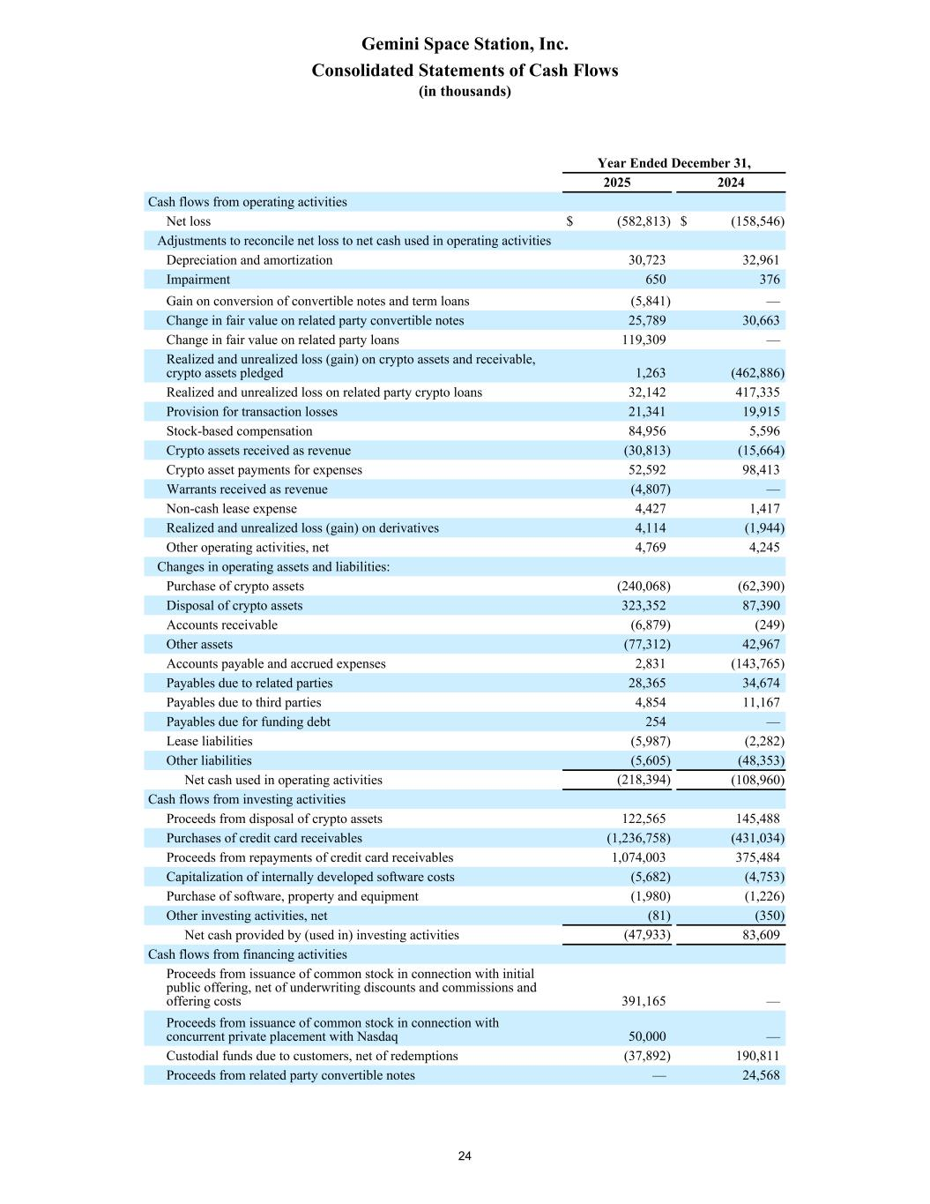
Year Ended December 31, 2025 2024 Cash flows from operating activities Net loss $ (582,813) $ (158,546) Adjustments to reconcile net loss to net cash used in operating activities Depreciation and amortization 30,723 32,961 Impairment 650 376 Gain on conversion of convertible notes and term loans (5,841) — Change in fair value on related party convertible notes 25,789 30,663 Change in fair value on related party loans 119,309 — Realized and unrealized loss (gain) on crypto assets and receivable, crypto assets pledged 1,263 (462,886) Realized and unrealized loss on related party crypto loans 32,142 417,335 Provision for transaction losses 21,341 19,915 Stock-based compensation 84,956 5,596 Crypto assets received as revenue (30,813) (15,664) Crypto asset payments for expenses 52,592 98,413 Warrants received as revenue (4,807) — Non-cash lease expense 4,427 1,417 Realized and unrealized loss (gain) on derivatives 4,114 (1,944) Other operating activities, net 4,769 4,245 Changes in operating assets and liabilities: Purchase of crypto assets (240,068) (62,390) Disposal of crypto assets 323,352 87,390 Accounts receivable (6,879) (249) Other assets (77,312) 42,967 Accounts payable and accrued expenses 2,831 (143,765) Payables due to related parties 28,365 34,674 Payables due to third parties 4,854 11,167 Payables due for funding debt 254 — Lease liabilities (5,987) (2,282) Other liabilities (5,605) (48,353) Net cash used in operating activities (218,394) (108,960) Cash flows from investing activities Proceeds from disposal of crypto assets 122,565 145,488 Purchases of credit card receivables (1,236,758) (431,034) Proceeds from repayments of credit card receivables 1,074,003 375,484 Capitalization of internally developed software costs (5,682) (4,753) Purchase of software, property and equipment (1,980) (1,226) Other investing activities, net (81) (350) Net cash provided by (used in) investing activities (47,933) 83,609 Cash flows from financing activities Proceeds from issuance of common stock in connection with initial public offering, net of underwriting discounts and commissions and offering costs 391,165 — Proceeds from issuance of common stock in connection with concurrent private placement with Nasdaq 50,000 — Custodial funds due to customers, net of redemptions (37,892) 190,811 Proceeds from related party convertible notes — 24,568 Gemini Space Station, Inc. Consolidated Statements of Cash Flows (in thousands) 24

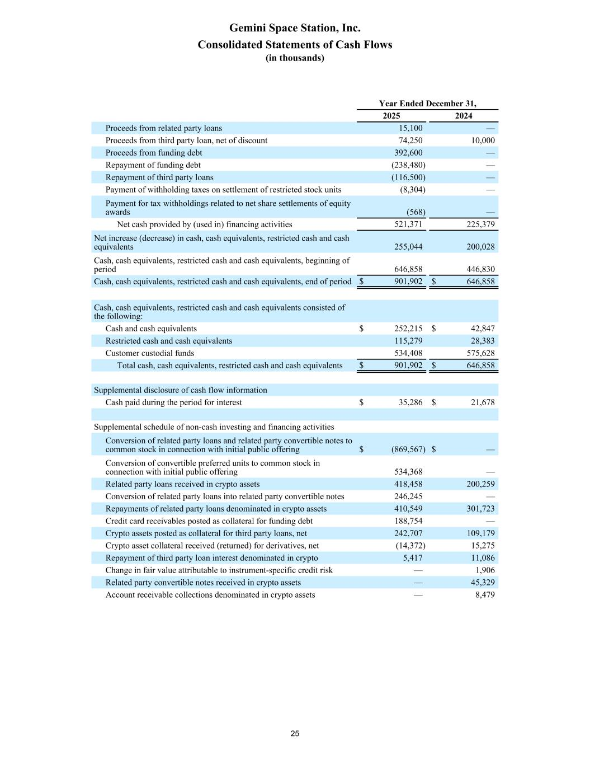
Year Ended December 31, 2025 2024 Proceeds from related party loans 15,100 — Proceeds from third party loan, net of discount 74,250 10,000 Proceeds from funding debt 392,600 — Repayment of funding debt (238,480) — Repayment of third party loans (116,500) — Payment of withholding taxes on settlement of restricted stock units (8,304) — Payment for tax withholdings related to net share settlements of equity awards (568) — Net cash provided by (used in) financing activities 521,371 225,379 Net increase (decrease) in cash, cash equivalents, restricted cash and cash equivalents 255,044 200,028 Cash, cash equivalents, restricted cash and cash equivalents, beginning of period 646,858 446,830 Cash, cash equivalents, restricted cash and cash equivalents, end of period $ 901,902 $ 646,858 Cash, cash equivalents, restricted cash and cash equivalents consisted of the following: Cash and cash equivalents $ 252,215 $ 42,847 Restricted cash and cash equivalents 115,279 28,383 Customer custodial funds 534,408 575,628 Total cash, cash equivalents, restricted cash and cash equivalents $ 901,902 $ 646,858 Supplemental disclosure of cash flow information Cash paid during the period for interest $ 35,286 $ 21,678 Supplemental schedule of non-cash investing and financing activities Conversion of related party loans and related party convertible notes to common stock in connection with initial public offering $ (869,567) $ — Conversion of convertible preferred units to common stock in connection with initial public offering 534,368 — Related party loans received in crypto assets 418,458 200,259 Conversion of related party loans into related party convertible notes 246,245 — Repayments of related party loans denominated in crypto assets 410,549 301,723 Credit card receivables posted as collateral for funding debt 188,754 — Crypto assets posted as collateral for third party loans, net 242,707 109,179 Crypto asset collateral received (returned) for derivatives, net (14,372) 15,275 Repayment of third party loan interest denominated in crypto 5,417 11,086 Change in fair value attributable to instrument-specific credit risk — 1,906 Related party convertible notes received in crypto assets — 45,329 Account receivable collections denominated in crypto assets — 8,479 Gemini Space Station, Inc. Consolidated Statements of Cash Flows (in thousands) 25

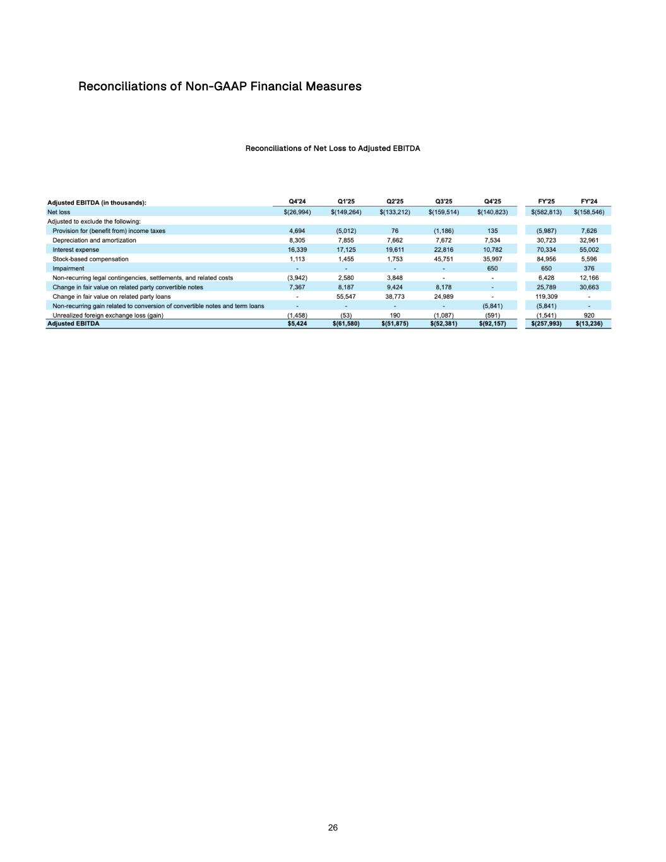
Reconciliations of Non-GAAP Financial Measures Reconciliations of Net Loss to Adjusted EBITDA 26

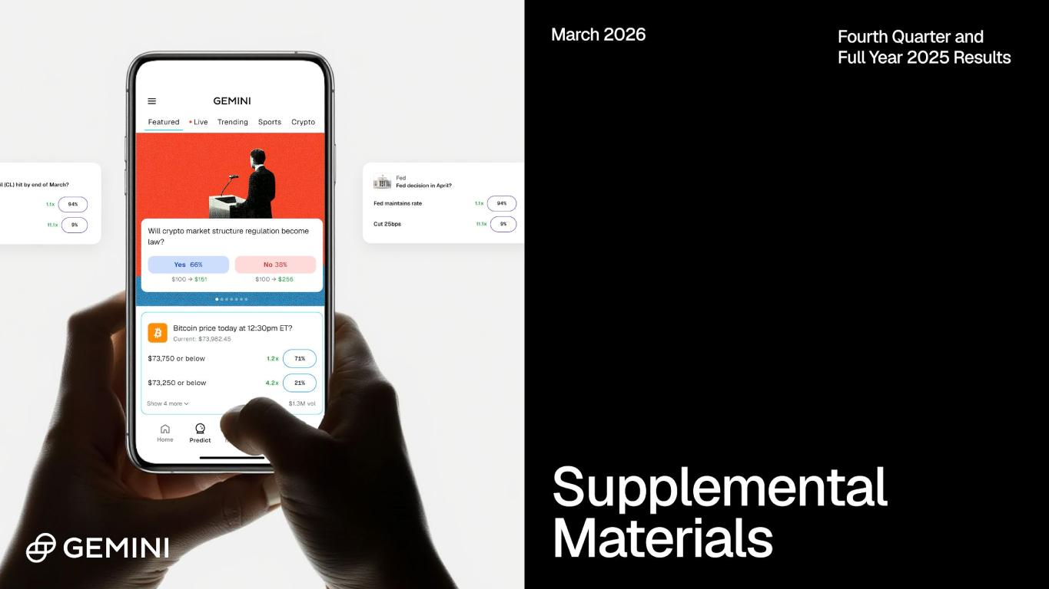

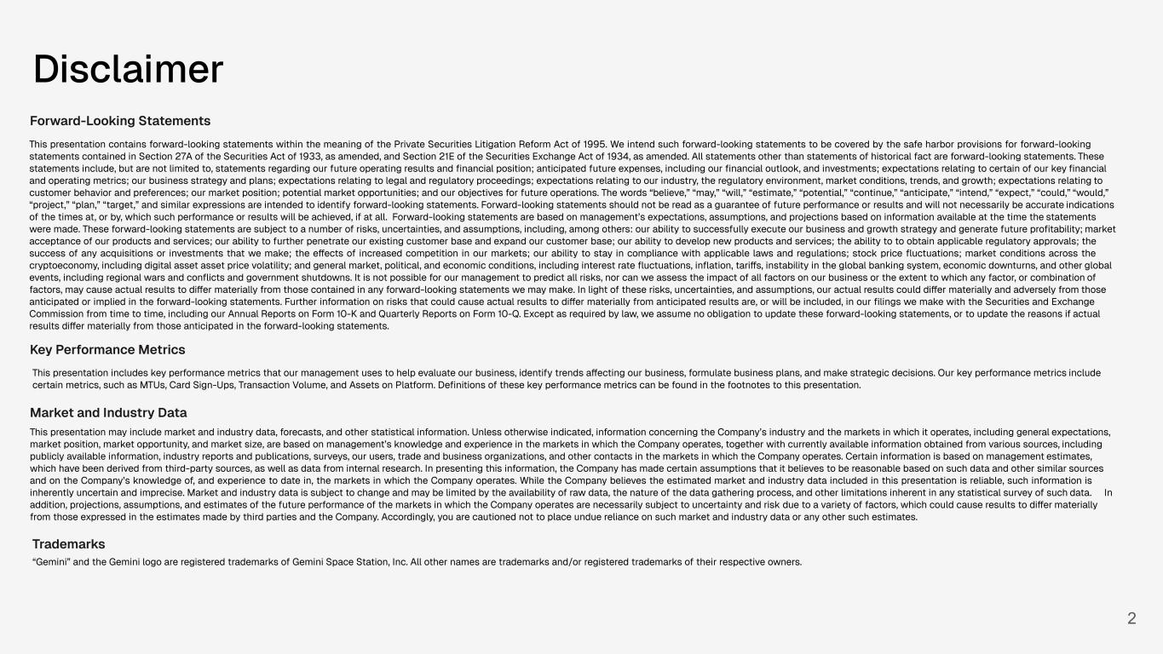
2 Disclaimer Forward-Looking Statements This presentation contains forward-looking statements within the meaning of the Private Securities Litigation Reform Act of 1995. We intend such forward-looking statements to be covered by the safe harbor provisions for forward-looking statements contained in Section 27A of the Securities Act of 1933, as amended, and Section 21E of the Securities Exchange Act of 1934, as amended. All statements other than statements of historical fact are forward-looking statements. These statements include, but are not limited to, statements regarding our future operating results and financial position; anticipated future expenses, including our financial outlook, and investments; expectations relating to certain of our key financial and operating metrics; our business strategy and plans; expectations relating to legal and regulatory proceedings; expectations relating to our industry, the regulatory environment, market conditions, trends, and growth; expectations relating to customer behavior and preferences; our market position; potential market opportunities; and our objectives for future operations. The words “believe,” “may,” “will,” “estimate,” “potential,” “continue,” “anticipate,” “intend,” “expect,” “could,” “would,” “project,” “plan,” “target,” and similar expressions are intended to identify forward-looking statements. Forward-looking statements should not be read as a guarantee of future performance or results and will not necessarily be accurate indications of the times at, or by, which such performance or results will be achieved, if at all. Forward-looking statements are based on management’s expectations, assumptions, and projections based on information available at the time the statements were made. These forward-looking statements are subject to a number of risks, uncertainties, and assumptions, including, among others: our ability to successfully execute our business and growth strategy and generate future profitability; market acceptance of our products and services; our ability to further penetrate our existing customer base and expand our customer base; our ability to develop new products and services; the ability to to obtain applicable regulatory approvals; the success of any acquisitions or investments that we make; the effects of increased competition in our markets; our ability to stay in compliance with applicable laws and regulations; stock price fluctuations; market conditions across the cryptoeconomy, including digital asset asset price volatility; and general market, political, and economic conditions, including interest rate fluctuations, inflation, tariffs, instability in the global banking system, economic downturns, and other global events, including regional wars and conflicts and government shutdowns. It is not possible for our management to predict all risks, nor can we assess the impact of all factors on our business or the extent to which any factor, or combination of factors, may cause actual results to differ materially from those contained in any forward-looking statements we may make. In light of these risks, uncertainties, and assumptions, our actual results could differ materially and adversely from those anticipated or implied in the forward-looking statements. Further information on risks that could cause actual results to differ materially from anticipated results are, or will be included, in our filings we make with the Securities and Exchange Commission from time to time, including our Annual Reports on Form 10-K and Quarterly Reports on Form 10-Q. Except as required by law, we assume no obligation to update these forward-looking statements, or to update the reasons if actual results differ materially from those anticipated in the forward-looking statements. Key Performance Metrics This presentation includes key performance metrics that our management uses to help evaluate our business, identify trends affecting our business, formulate business plans, and make strategic decisions. Our key performance metrics include certain metrics, such as MTUs, Card Sign-Ups, Transaction Volume, and Assets on Platform. Definitions of these key performance metrics can be found in the footnotes to this presentation. Market and Industry Data This presentation may include market and industry data, forecasts, and other statistical information. Unless otherwise indicated, information concerning the Company’s industry and the markets in which it operates, including general expectations, market position, market opportunity, and market size, are based on management’s knowledge and experience in the markets in which the Company operates, together with currently available information obtained from various sources, including publicly available information, industry reports and publications, surveys, our users, trade and business organizations, and other contacts in the markets in which the Company operates. Certain information is based on management estimates, which have been derived from third-party sources, as well as data from internal research. In presenting this information, the Company has made certain assumptions that it believes to be reasonable based on such data and other similar sources and on the Company’s knowledge of, and experience to date in, the markets in which the Company operates. While the Company believes the estimated market and industry data included in this presentation is reliable, such information is inherently uncertain and imprecise. Market and industry data is subject to change and may be limited by the availability of raw data, the nature of the data gathering process, and other limitations inherent in any statistical survey of such data. In addition, projections, assumptions, and estimates of the future performance of the markets in which the Company operates are necessarily subject to uncertainty and risk due to a variety of factors, which could cause results to differ materially from those expressed in the estimates made by third parties and the Company. Accordingly, you are cautioned not to place undue reliance on such market and industry data or any other such estimates. Trademarks “Gemini” and the Gemini logo are registered trademarks of Gemini Space Station, Inc. All other names are trademarks and/or registered trademarks of their respective owners.

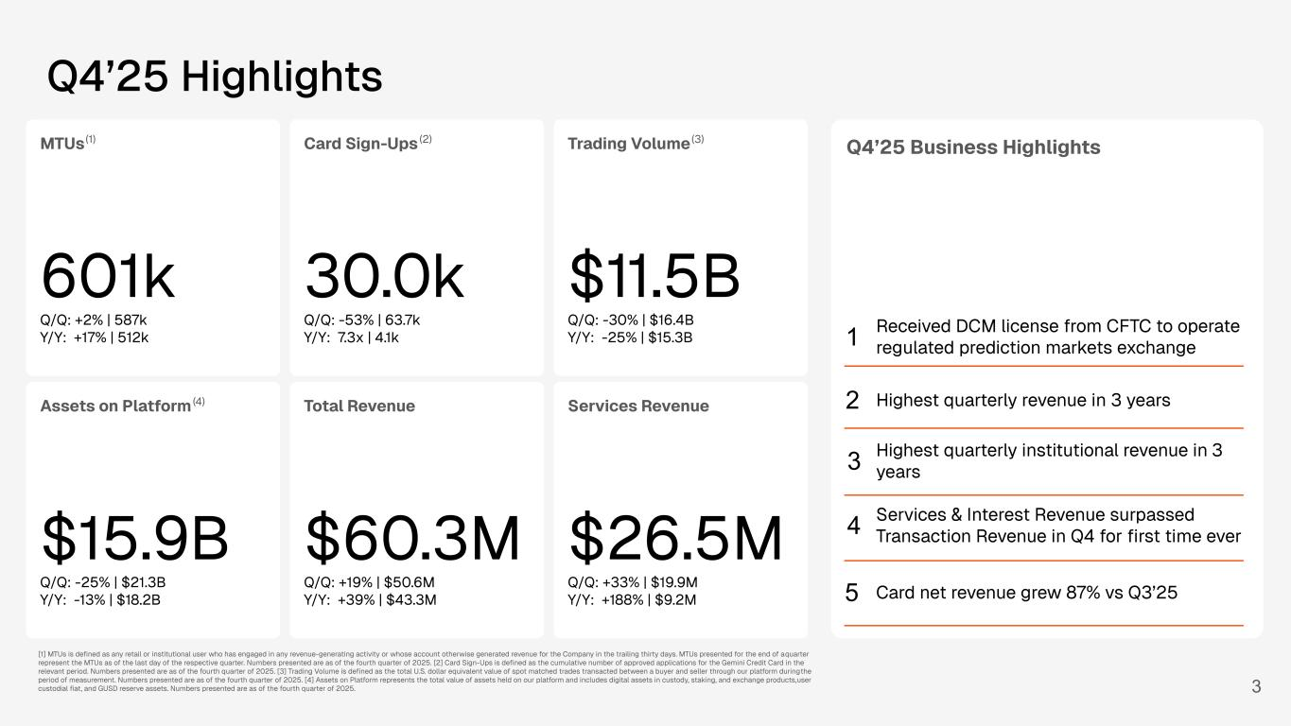
Q4’25 Business Highlights Highest quarterly institutional revenue in 3 years Services & Interest Revenue surpassed Transaction Revenue in Q4 for first time ever 3 Q4’25 Highlights MTUs 601k Q/Q: +2% | 587k Y/Y: +17% | 512k (1) Card Sign-Ups 30.0k Q/Q: -53% | 63.7k Y/Y: 7.3x | 4.1k (2) Trading Volume $11.5B Q/Q: -30% | $16.4B Y/Y: -25% | $15.3B (3) Assets on Platform $15.9B Q/Q: -25% | $21.3B Y/Y: -13% | $18.2B (4) Total Revenue $60.3M Q/Q: +19% | $50.6M Y/Y: +39% | $43.3M Services Revenue $26.5M Q/Q: +33% | $19.9M Y/Y: +188% | $9.2M 1 3 2 4 5 [1] MTUs is defined as any retail or institutional user who has engaged in any revenue-generating activity or whose account otherwise generated revenue for the Company in the trailing thirty days. MTUs presented for the end of a quarter represent the MTUs as of the last day of the respective quarter. Numbers presented are as of the fourth quarter of 2025. [2] Card Sign-Ups is defined as the cumulative number of approved applications for the Gemini Credit Card in the relevant period. Numbers presented are as of the fourth quarter of 2025. [3] Trading Volume is defined as the total U.S. dollar equivalent value of spot matched trades transacted between a buyer and seller through our platform during the period of measurement. Numbers presented are as of the fourth quarter of 2025. [4] Assets on Platform represents the total value of assets held on our platform and includes digital assets in custody, staking, and exchange products, user custodial fiat, and GUSD reserve assets. Numbers presented are as of the fourth quarter of 2025. Received DCM license from CFTC to operate regulated prediction markets exchange Highest quarterly revenue in 3 years Card net revenue grew 87% vs Q3’25

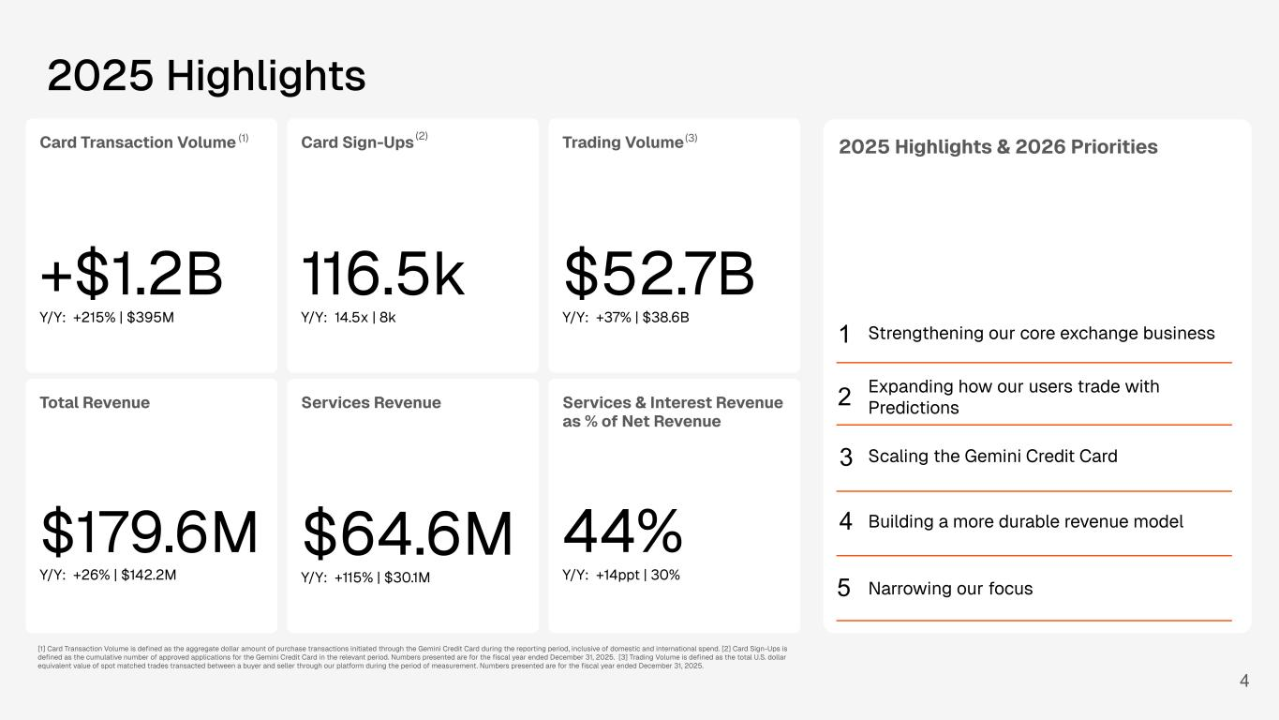
2025 Highlights & 2026 Priorities Strengthening our core exchange business Expanding how our users trade with Predictions 4 2025 Highlights Card Transaction Volume +$1.2B Y/Y: +215% | $395M (1) Card Sign-Ups 116.5k Y/Y: 14.5x | 8k (2) Trading Volume $52.7B Y/Y: +37% | $38.6B (3) Assets on Platform $15.9B Y/Y: -13% | $18.1B (4)Total Revenue 79.6M / : +26% | $142.2M Services Revenue $64.6M Y/Y: +115% | $30.1M [1] Card Transaction Volume is defined as the aggregate dollar amount of purchase transactions initiated through the Gemini Credit Card during the reporting period, inclusive of domestic and international spend. [2] Card Sign-Ups is defined as the cumulative number of approved applications for the Gemini Credit Card in the relevant period. Numbers presented are for the fiscal year ended December 31, 2025. [3] Trading Volume is defined as the total U.S. dollar equivalent value of spot matched trades transacted between a buyer and seller through our platform during the period of measurement. Numbers presented are for the fiscal year ended December 31, 2025. option 2 - fy 2025 Services & Interest Revenue as % of Net Revenue 44% Y/Y: +14ppt | 30% Scaling the Gemini Credit Card Building a more durable revenue model Narrowing our focus 1 3 2 4 5

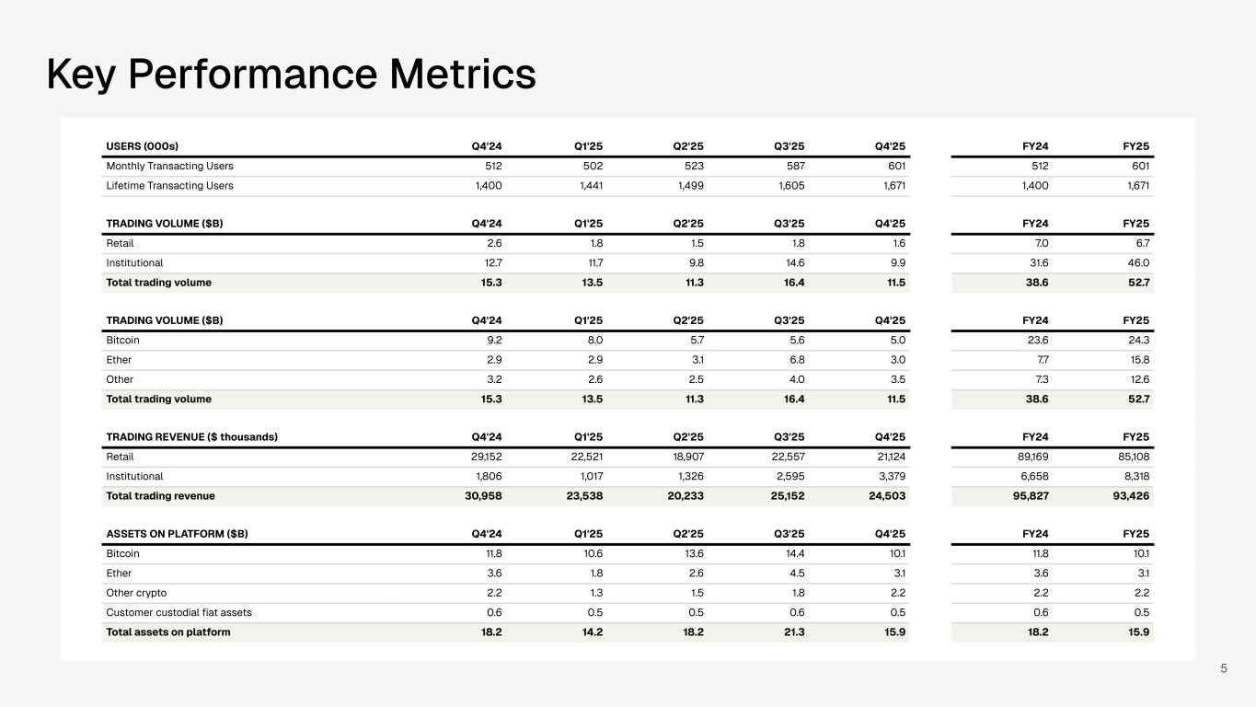
5 USERS (000s) Q4'24 Q1'25 Q2'25 Q3'25 Q4'25 FY24 FY25 Monthly Transacting Users 512 502 523 587 601 512 601 Lifetime Transacting Users 1,400 1,441 1,499 1,605 1,671 1,400 1,671 TRADING VOLUME ($B) Q4'24 Q1'25 Q2'25 Q3'25 Q4'25 FY24 FY25 Retail 2.6 1.8 1.5 1.8 1.6 7.0 6.7 Institutional 12.7 11.7 9.8 14.6 9.9 31.6 46.0 Total trading volume 15.3 13.5 11.3 16.4 11.5 38.6 52.7 TRADING VOLUME ($B) Q4'24 Q1'25 Q2'25 Q3'25 Q4'25 FY24 FY25 Bitcoin 9.2 8.0 5.7 5.6 5.0 23.6 24.3 Ether 2.9 2.9 3.1 6.8 3.0 7.7 15.8 Other 3.2 2.6 2.5 4.0 3.5 7.3 12.6 Total trading volume 15.3 13.5 11.3 16.4 11.5 38.6 52.7 TRADING REVENUE ($ thousands) Q4'24 Q1'25 Q2'25 Q3'25 Q4'25 FY24 FY25 Retail 29,152 22,521 18,907 22,557 21,124 89,169 85,108 Institutional 1,806 1,017 1,326 2,595 3,379 6,658 8,318 Total trading revenue 30,958 23,538 20,233 25,152 24,503 95,827 93,426 ASSETS ON PLATFORM ($B) Q4'24 Q1'25 Q2'25 Q3'25 Q4'25 FY24 FY25 Bitcoin 11.8 10.6 13.6 14.4 10.1 11.8 10.1 Ether 3.6 1.8 2.6 4.5 3.1 3.6 3.1 Other crypto 2.2 1.3 1.5 1.8 2.2 2.2 2.2 Customer custodial fiat assets 0.6 0.5 0.5 0.6 0.5 0.6 0.5 Total assets on platform 18.2 14.2 18.2 21.3 15.9 18.2 15.9 Key Performance Metrics

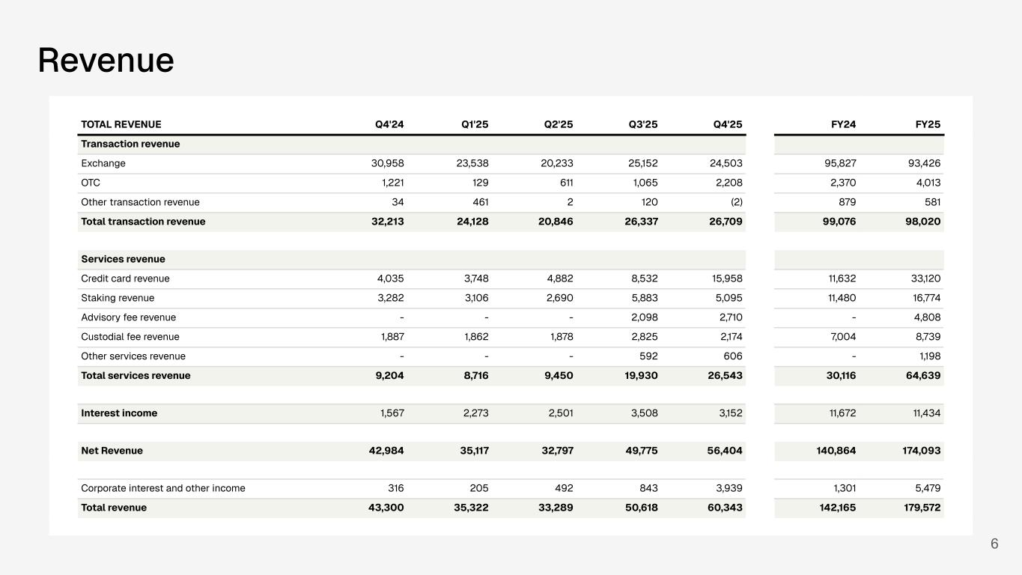
6 Revenue TOTAL REVENUE Q4'24 Q1'25 Q2'25 Q3'25 Q4'25 FY24 FY25 Transaction revenue Exchange 30,958 23,538 20,233 25,152 24,503 95,827 93,426 OTC 1,221 129 611 1,065 2,208 2,370 4,013 Other transaction revenue 34 461 2 120 (2) 879 581 Total transaction revenue 32,213 24,128 20,846 26,337 26,709 99,076 98,020 Services revenue Credit card revenue 4,035 3,748 4,882 8,532 15,958 11,632 33,120 Staking revenue 3,282 3,106 2,690 5,883 5,095 11,480 16,774 Advisory fee revenue - - - 2,098 2,710 - 4,808 Custodial fee revenue 1,887 1,862 1,878 2,825 2,174 7,004 8,739 Other services revenue - - - 592 606 - 1,198 Total services revenue 9,204 8,716 9,450 19,930 26,543 30,116 64,639 Interest income 1,567 2,273 2,501 3,508 3,152 11,672 11,434 Net Revenue 42,984 35,117 32,797 49,775 56,404 140,864 174,093 Corporate interest and other income 316 205 492 843 3,939 1,301 5,479 Total revenue 43,300 35,322 33,289 50,618 60,343 142,165 179,572

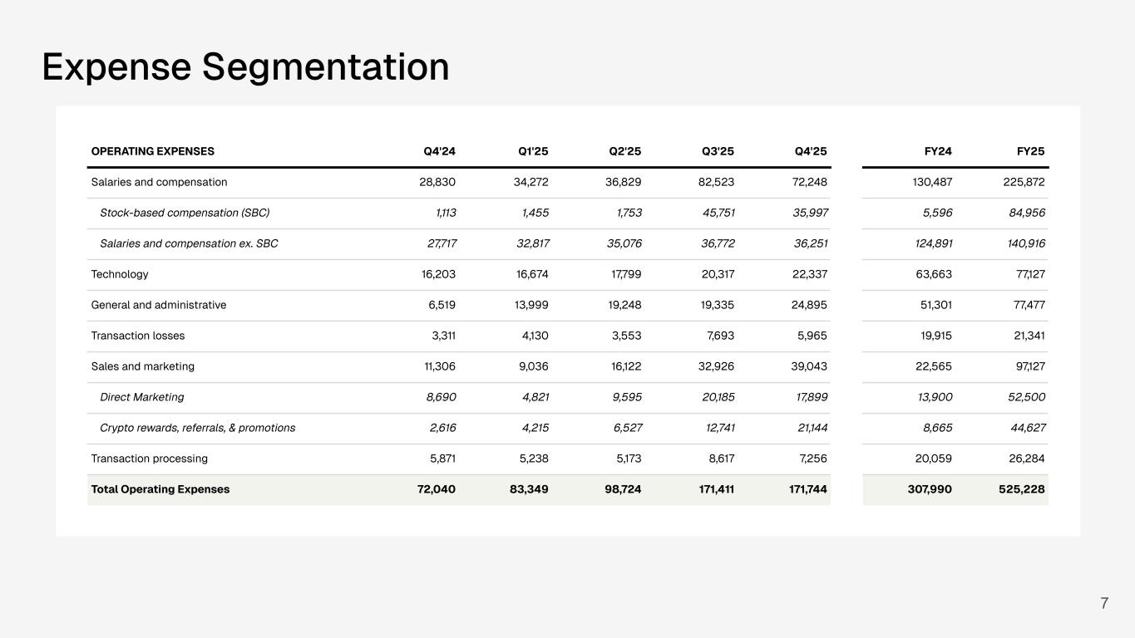
OPERATING EXPENSES 4Q'24 1Q'25 2Q'25 3Q'25 4Q'25 Salaries and compensation 28,830 34,272 36,829 82,523 72,752 Technology 16,203 16,674 17,799 20,317 22,336 General and administrative 6,519 13,999 19,248 19,335 22,050 Transaction losses 3,311 4,130 3,553 7,693 6,551 Sales and marketing 11,306 9,036 16,122 32,926 37,361 Transaction processing 5,871 5,238 5,173 8,617 7,102 Total Operating Expenses 72,040 83,349 98,724 171,411 168,1527 Expense Segmentation Break out SBC from Comp Break out crypto rewards, promos, referrals, etc from marketing OPERATING EXPENSES Q4'24 Q1'25 Q2'25 Q3'25 Q4'25 FY24 FY25 Salaries and compensation 28,830 34,272 36,829 82,523 72,248 130,487 225,872 Stock-based compensation (SBC) 1,113 1,455 1,753 45,751 35,997 5,596 84,956 Salaries and compensation ex. SBC 27,717 32,817 35,076 36,772 36,251 124,891 140,916 Technology 16,203 16,674 17,799 20,317 22,337 63,663 77,127 General and administrative 6,519 13,999 19,248 19,335 24,895 51,301 77,477 Transaction losses 3,311 4,130 3,553 7,693 5,965 19,915 21,341 Sales and marketing 11,306 9,036 16,122 32,926 39,043 22,565 97,127 Direct Marketing 8,690 4,821 9,595 20,185 17,899 13,900 52,500 Crypto rewards, referrals, & promotions 2,616 4,215 6,527 12,741 21,144 8,665 44,627 Transaction processing 5,871 5,238 5,173 8,617 7,256 20,059 26,284 Total Operating Expenses 72,040 83,349 98,724 171,411 171,744 307,990 525,228

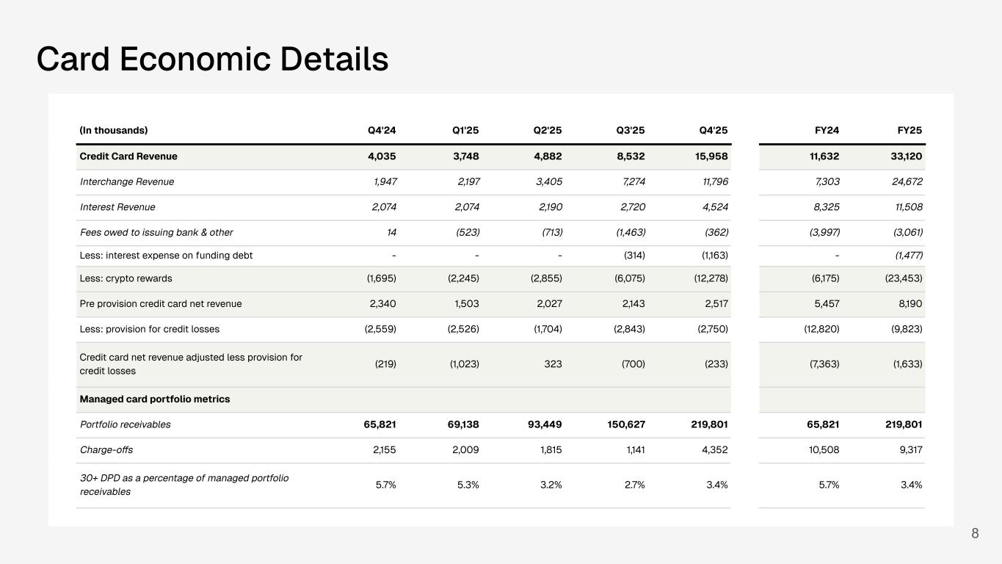
Card Economic Details 8 (In thousands) Q4'24 Q1'25 Q2'25 Q3'25 Q4'25 FY24 FY25 Credit Card Revenue 4,035 3,748 4,882 8,532 15,958 11,632 33,120 Interchange Revenue 1,947 2,197 3,405 7,274 11,796 7,303 24,672 Interest Revenue 2,074 2,074 2,190 2,720 4,524 8,325 11,508 Fees owed to issuing bank & other 14 (523) (713) (1,463) (362) (3,997) (3,061) Less: interest expense on funding debt - - - (314) (1,163) - (1,477) Less: crypto rewards (1,695) (2,245) (2,855) (6,075) (12,278) (6,175) (23,453) Pre provision credit card net revenue 2,340 1,503 2,027 2,143 2,517 5,457 8,190 Less: provision for credit losses (2,559) (2,526) (1,704) (2,843) (2,750) (12,820) (9,823) Credit card net revenue adjusted less provision for credit losses (219) (1,023) 323 (700) (233) (7,363) (1,633) Managed card portfolio metrics Portfolio receivables 65,821 69,138 93,449 150,627 219,801 65,821 219,801 Charge-offs 2,155 2,009 1,815 1,141 4,352 10,508 9,317 30+ DPD as a percentage of managed portfolio receivables 5.7% 5.3% 3.2% 2.7% 3.4% 5.7% 3.4%

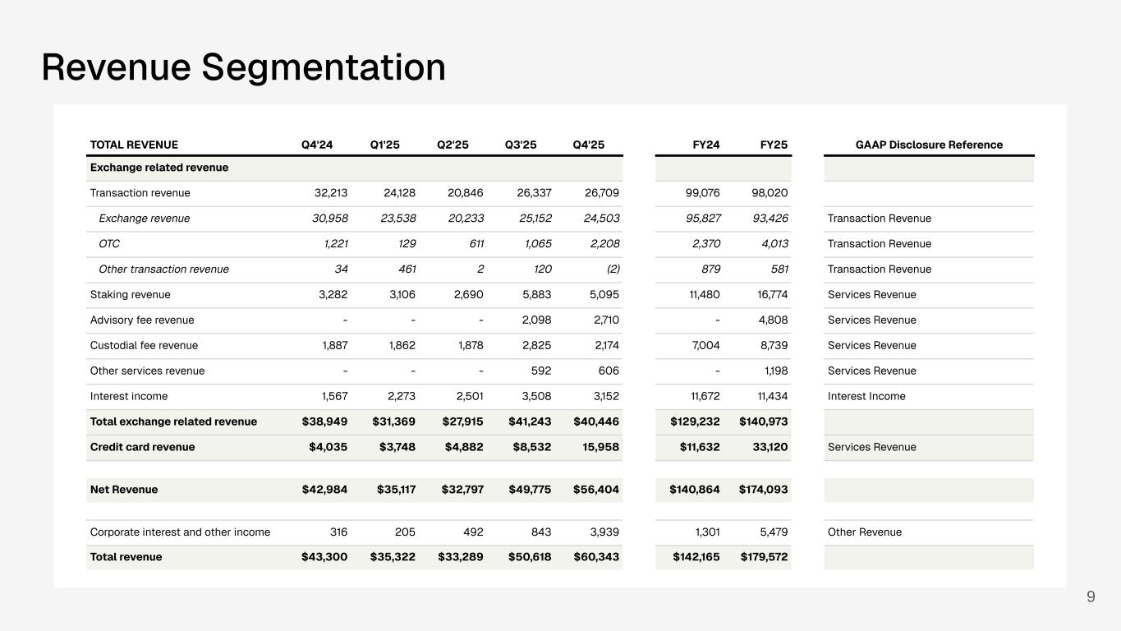
Revenue Segmentation 9 TOTAL REVENUE Q4'24 Q1'25 Q2'25 Q3'25 Q4'25 FY24 FY25 GAAP Disclosure Reference Exchange related revenue Transaction revenue 32,213 24,128 20,846 26,337 26,709 99,076 98,020 Exchange revenue 30,958 23,538 20,233 25,152 24,503 95,827 93,426 Transaction Revenue OTC 1,221 129 611 1,065 2,208 2,370 4,013 Transaction Revenue Other transaction revenue 34 461 2 120 (2) 879 581 Transaction Revenue Staking revenue 3,282 3,106 2,690 5,883 5,095 11,480 16,774 Services Revenue Advisory fee revenue - - - 2,098 2,710 - 4,808 Services Revenue Custodial fee revenue 1,887 1,862 1,878 2,825 2,174 7,004 8,739 Services Revenue Other services revenue - - - 592 606 - 1,198 Services Revenue Interest income 1,567 2,273 2,501 3,508 3,152 11,672 11,434 Interest Income Total exchange related revenue $38,949 $31,369 $27,915 $41,243 $40,446 $129,232 $140,973 Credit card revenue $4,035 $3,748 $4,882 $8,532 15,958 $11,632 33,120 Services Revenue Net Revenue $42,984 $35,117 $32,797 $49,775 $56,404 $140,864 $174,093 Corporate interest and other income 316 205 492 843 3,939 1,301 5,479 Other Revenue Total revenue $43,300 $35,322 $33,289 $50,618 $60,343 $142,165 $179,572

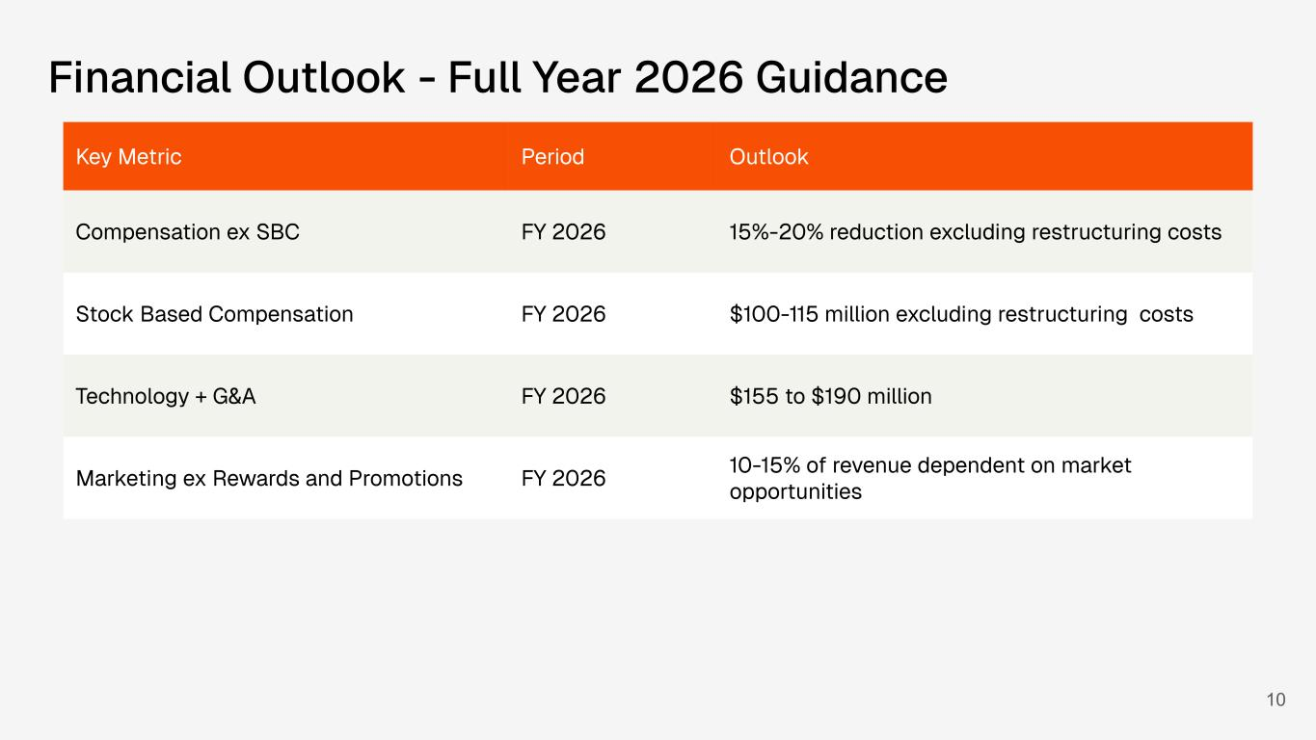
10 Financial Outlook - Full Year 2026 Guidance Key Metric Period Outlook Compensation ex SBC FY 2026 15%-20% reduction excluding restructuring costs Stock Based Compensation FY 2026 $100-115 million excluding restructuring costs Technology + G&A FY 2026 $155 to $190 million Marketing ex Rewards and Promotions FY 2026 10-15% of revenue dependent on market opportunities

