Name:
Title:

By:
/s/ Danijela Stojanovic

UNITED STATES
SECURITIES AND EXCHANGE COMMISSION
Washington, D.C. 20549
___________________________________
FORM 8-K
___________________________________
CURRENT REPORT
Pursuant to Section 13 or 15(d)
of the Securities Exchange Act of 1934

Date of Report (Date of earliest event reported): May 14, 2026
___________________________________
Gemini Space Station, Inc.
(Exact name of registrant as specified in its charter)
___________________________________

Nevada  (State or other jurisdiction of  incorporation or organization) |  |  | 001-42836  (Commission File Number) |  |  | 33-3263417  (I.R.S. Employer Identification Number)
600 Third Avenue, 2nd Floor
New York, NY 100161
(Address of principal executive offices) (Zip code)
(646) 751-4401
(Registrant's telephone number, including area code)
 |  |  | Not Applicable
(Former name or former address, if changed since last report)
___________________________________
Check the appropriate box below if the Form 8-K filing is intended to simultaneously satisfy the filing obligation of the registrant under any of the following provisions:

☐ |  |  | Written communications pursuant to Rule 425 under the Securities Act (17 CFR 230.425)
☐ |  |  | Soliciting material pursuant to Rule 14a-12 under the Exchange Act (17 CFR 240.14a-12)
☐ |  |  | Pre-commencement communications pursuant to Rule 14d-2(b) under the Exchange Act (17 CFR 240.14d-2(b))
☐ |  |  | Pre-commencement communications pursuant to Rule 13e-4(c) under the Exchange Act (17 CFR 240.13e-4(c))
Securities registered pursuant to Section 12(b) of the Act:
Title of each class |  |  | Trading Symbol |  |  | Name of each exchange on which registered
Class A common stock, $0.001 par value per share |  |  | GEMI |  |  | The Nasdaq Stock Market LLC
Indicate by check mark whether the registrant is an emerging growth company as defined in Rule 12b-2 of the Exchange Act.
Emerging growth company ☒
If an emerging growth company, indicate by check mark if the registrant has elected not to use the extended transition period for complying with any new or revised financial accounting standards provided pursuant to Section 13(a) of the Exchange Act. ☐
1 We use this address for receiving mail and correspondence to our principal executive office located in New York, NY.

Item 1.01 Entry into a Material Definitive Agreement.
On May 14, 2026, Gemini Space Station, Inc. (“Gemini,” the “Company,” “we,” or “us”) entered into a securities purchase agreement (the “Securities Purchase Agreement”) with Winklevoss Capital Fund, LLC (the “Purchaser”) pursuant to which the Company agreed to issue and sell to the Purchaser, in a private placement, 7,142,857 shares of the Company’s Class A common stock, $0.001 par value per share (the “Shares”), at a price of $14.00 per share, for aggregate proceeds to the Company of $100.0 million (the “Private Placement”). The Purchaser delivered to the Company approximately 1,258 Bitcoin as payment-in-kind for the Shares pursuant to the terms of the Securities Purchase Agreement. The Purchaser is the Company's largest existing stockholder and is an entity which is owned and controlled by Cameron and Tyler Winklevoss, the Company's President and Chief Executive Officer, respectively, and each directors of the Company. The Private Placement closed on May 14, 2026.

The foregoing description of the Securities Purchase Agreement does not purport to be complete and is qualified in its entirety by reference to the full text of the Securities Purchase Agreement, a copy of which is filed as Exhibit 99.1 hereto and incorporated by reference herein.

On May 14, 2026, the Company entered into an amendment (the “Amendment”) to its existing Registration Rights Agreement, dated as of September 12, 2025 (the “Existing Registration Rights Agreement”) with the Purchaser pertaining to the Shares, which provides that the Shares are “Registrable Securities” under the Existing Registration Rights Agreement and subject to the demand registration, piggyback registration and shelf registration rights contained therein. The Amendment also lowers the minimum anticipated aggregate offering proceeds threshold, net of Selling Expenses (as defined in the Existing Registration Rights Agreement), required to trigger a Form S-3 demand registration from $75.0 million to $50.0 million.

The foregoing description of the Amendment does not purport to be complete and is qualified in its entirety by reference to the full text of the Amendment, a copy of which is filed as Exhibit 99.2 hereto and incorporated by reference herein.

Item 2.02 Results of Operations and Financial Condition
On May 14, 2026, Gemini issued a press release (the “Q1 2026 Earnings Release”) announcing its financial results for the three months ended March 31, 2026. A copy of the Q1 2026 Earnings Release is furnished as Exhibit 99.3 to this Current Report on Form 8-K.

Item 3.02 Unregistered Sale of Equity Securities.

The information contained above in Item 1.01 is hereby incorporated by reference into this Item 3.02. Based in part upon the representations of the Purchaser in the Securities Purchase Agreement, the offering and sale of the Shares was exempt from registration under Section 4(a)(2) of the Securities Act of 1933, as amended (the “Securities Act”). The sale of the Shares by the Company in the Private Placement was not registered under the Securities Act or any state securities laws and the Shares may not be offered or sold absent registration with the SEC or an applicable exemption from the registration requirements. The sale of the Shares did not involve a public offering and was made without general solicitation or general advertising. In the Securities Purchase Agreement, the Purchaser represented that it is an accredited investor, as such term is defined in Rule 501(a) of Regulation D under the Securities Act, and it is acquiring the Shares as principal for its own account and not with a view to any distribution or resale of the Shares in violation of the Securities Act or any applicable state securities law.

Item 7.01 Regulation FD Disclosure
As previously announced, Gemini will hold an earnings conference call on May 15, 2026 at 8:30 a.m. E.T. to discuss the Company's earnings results for the three months ended March 31, 2026. A copy of an earnings presentation for the conference call is furnished as Exhibit 99.4 to this Current Report on Form 8-K.

The information furnished in Item 2.02, including Exhibit 99.3, and Item 7.01, including Exhibit 99.4, of this Current Report on Form 8-K shall not be deemed “filed” for purposes of Section 18 of the Securities Exchange Act of 1934, as amended (the “Exchange Act”), or otherwise subject to the liabilities of that section, nor shall it be deemed incorporated by

reference into any other filing under the Securities Act of 1933, as amended, or the Exchange Act, except as expressly set forth by specific reference in such filing.

Item 9.01 Financial Statements and Exhibits
(d) Exhibits

Exhibit No. |  |  |  |  |  | Description
99.1 |  |  |  |  |  | Securities Purchase Agreement, dated as of May 14, 2026, by and between Gemini Space Station, Inc. and Winklevoss Capital Fund, LLC.
99.2 |  |  |  |  |  | Amendment No. 1 to Registration Rights Agreement, dated as of May 14, 2026.
99.3 |  |  |  |  |  | Q1 2026 Earnings Release, dated May 14, 2026.
99.4 |  |  |  |  |  | Q1 2026 Earnings Presentation, dated May 14, 2026.
104 |  |  |  |  |  | Cover Page Interactive Data File (embedded within the Inline XBRL document)

SIGNATURE

Pursuant to the requirements of the Securities Exchange Act of 1934, as amended, the Registrant has duly caused this report to be signed on its behalf by the undersigned hereunto duly authorized.

 |  |  |  |  |  | GEMINI SPACE STATION, INC.
Date: |  |  | May 14, 2026
 |  |  |  |  |  | By: |  |  | /s/ Danijela Stojanovic
 |  |  |  |  |  | Name: |  |  | Danijela Stojanovic
 |  |  |  |  |  | Title: |  |  | Interim Chief Financial Officer

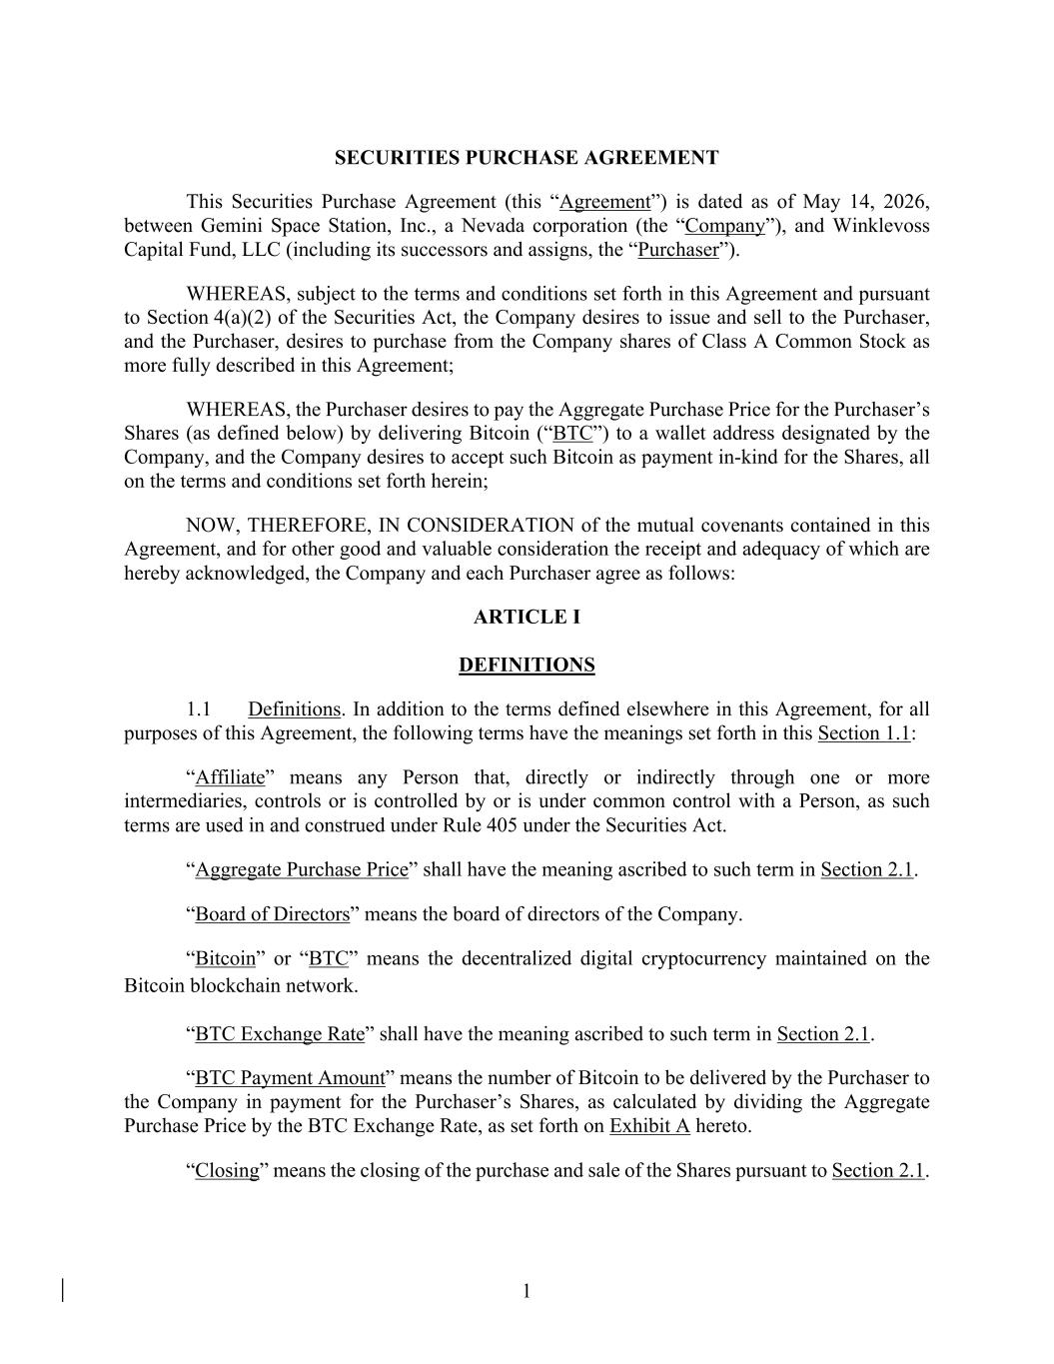

1 SECURITIES PURCHASE AGREEMENT This Securities Purchase Agreement (this “Agreement”) is dated as of May 14, 2026, between Gemini Space Station, Inc., a Nevada corporation (the “Company”), and Winklevoss Capital Fund, LLC (including its successors and assigns, the “Purchaser”). WHEREAS, subject to the terms and conditions set forth in this Agreement and pursuant to Section 4(a)(2) of the Securities Act, the Company desires to issue and sell to the Purchaser, and the Purchaser, desires to purchase from the Company shares of Class A Common Stock as more fully described in this Agreement; WHEREAS, the Purchaser desires to pay the Aggregate Purchase Price for the Purchaser’s Shares (as defined below) by delivering Bitcoin (“BTC”) to a wallet address designated by the Company, and the Company desires to accept such Bitcoin as payment in-kind for the Shares, all on the terms and conditions set forth herein; NOW, THEREFORE, IN CONSIDERATION of the mutual covenants contained in this Agreement, and for other good and valuable consideration the receipt and adequacy of which are hereby acknowledged, the Company and each Purchaser agree as follows: ARTICLE I DEFINITIONS 1.1 Definitions. In addition to the terms defined elsewhere in this Agreement, for all purposes of this Agreement, the following terms have the meanings set forth in this Section 1.1: “Affiliate” means any Person that, directly or indirectly through one or more intermediaries, controls or is controlled by or is under common control with a Person, as such terms are used in and construed under Rule 405 under the Securities Act. “Aggregate Purchase Price” shall have the meaning ascribed to such term in Section 2.1. “Board of Directors” means the board of directors of the Company. “Bitcoin” or “BTC” means the decentralized digital cryptocurrency maintained on the Bitcoin blockchain network. “BTC Exchange Rate” shall have the meaning ascribed to such term in Section 2.1. “BTC Payment Amount” means the number of Bitcoin to be delivered by the Purchaser to the Company in payment for the Purchaser’s Shares, as calculated by dividing the Aggregate Purchase Price by the BTC Exchange Rate, as set forth on Exhibit A hereto. “Closing” means the closing of the purchase and sale of the Shares pursuant to Section 2.1.

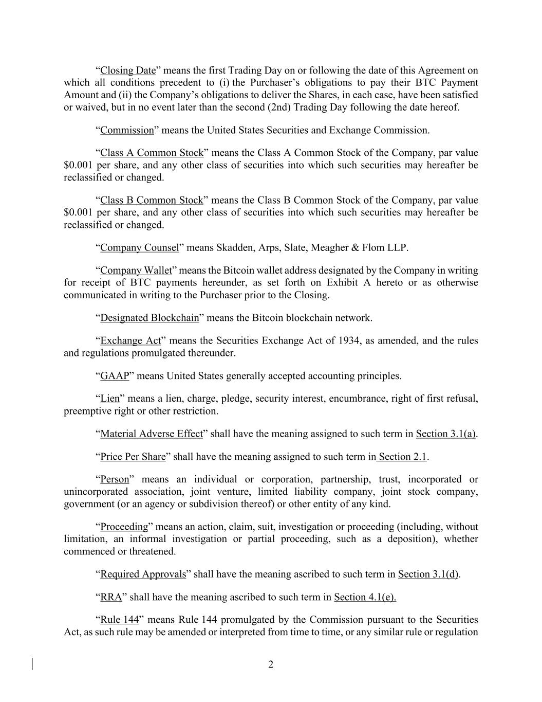
2 “Closing Date” means the first Trading Day on or following the date of this Agreement on which all conditions precedent to (i) the Purchaser’s obligations to pay their BTC Payment Amount and (ii) the Company’s obligations to deliver the Shares, in each case, have been satisfied or waived, but in no event later than the second (2nd) Trading Day following the date hereof. “Commission” means the United States Securities and Exchange Commission. “Class A Common Stock” means the Class A Common Stock of the Company, par value $0.001 per share, and any other class of securities into which such securities may hereafter be reclassified or changed. “Class B Common Stock” means the Class B Common Stock of the Company, par value $0.001 per share, and any other class of securities into which such securities may hereafter be reclassified or changed. “Company Counsel” means Skadden, Arps, Slate, Meagher & Flom LLP. “Company Wallet” means the Bitcoin wallet address designated by the Company in writing for receipt of BTC payments hereunder, as set forth on Exhibit A hereto or as otherwise communicated in writing to the Purchaser prior to the Closing. “Designated Blockchain” means the Bitcoin blockchain network. “Exchange Act” means the Securities Exchange Act of 1934, as amended, and the rules and regulations promulgated thereunder. “GAAP” means United States generally accepted accounting principles. “Lien” means a lien, charge, pledge, security interest, encumbrance, right of first refusal, preemptive right or other restriction. “Material Adverse Effect” shall have the meaning assigned to such term in Section 3.1(a). “Price Per Share” shall have the meaning assigned to such term in Section 2.1. “Person” means an individual or corporation, partnership, trust, incorporated or unincorporated association, joint venture, limited liability company, joint stock company, government (or an agency or subdivision thereof) or other entity of any kind. “Proceeding” means an action, claim, suit, investigation or proceeding (including, without limitation, an informal investigation or partial proceeding, such as a deposition), whether commenced or threatened. “Required Approvals” shall have the meaning ascribed to such term in Section 3.1(d). “RRA” shall have the meaning ascribed to such term in Section 4.1(e). “Rule 144” means Rule 144 promulgated by the Commission pursuant to the Securities Act, as such rule may be amended or interpreted from time to time, or any similar rule or regulation

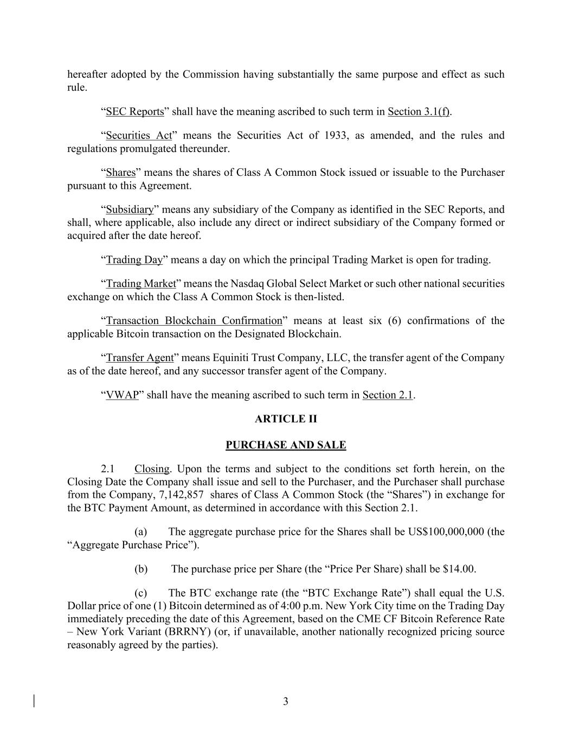
3 hereafter adopted by the Commission having substantially the same purpose and effect as such rule. “SEC Reports” shall have the meaning ascribed to such term in Section 3.1(f). “Securities Act” means the Securities Act of 1933, as amended, and the rules and regulations promulgated thereunder. “Shares” means the shares of Class A Common Stock issued or issuable to the Purchaser pursuant to this Agreement. “Subsidiary” means any subsidiary of the Company as identified in the SEC Reports, and shall, where applicable, also include any direct or indirect subsidiary of the Company formed or acquired after the date hereof. “Trading Day” means a day on which the principal Trading Market is open for trading. “Trading Market” means the Nasdaq Global Select Market or such other national securities exchange on which the Class A Common Stock is then-listed. “Transaction Blockchain Confirmation” means at least six (6) confirmations of the applicable Bitcoin transaction on the Designated Blockchain. “Transfer Agent” means Equiniti Trust Company, LLC, the transfer agent of the Company as of the date hereof, and any successor transfer agent of the Company. “VWAP” shall have the meaning ascribed to such term in Section 2.1. ARTICLE II PURCHASE AND SALE 2.1 Closing. Upon the terms and subject to the conditions set forth herein, on the Closing Date the Company shall issue and sell to the Purchaser, and the Purchaser shall purchase from the Company, 7,142,857 shares of Class A Common Stock (the “Shares”) in exchange for the BTC Payment Amount, as determined in accordance with this Section 2.1. (a) The aggregate purchase price for the Shares shall be US$100,000,000 (the “Aggregate Purchase Price”). (b) The purchase price per Share (the “Price Per Share) shall be $14.00. (c) The BTC exchange rate (the “BTC Exchange Rate”) shall equal the U.S. Dollar price of one (1) Bitcoin determined as of 4:00 p.m. New York City time on the Trading Day immediately preceding the date of this Agreement, based on the CME CF Bitcoin Reference Rate – New York Variant (BRRNY) (or, if unavailable, another nationally recognized pricing source reasonably agreed by the parties).

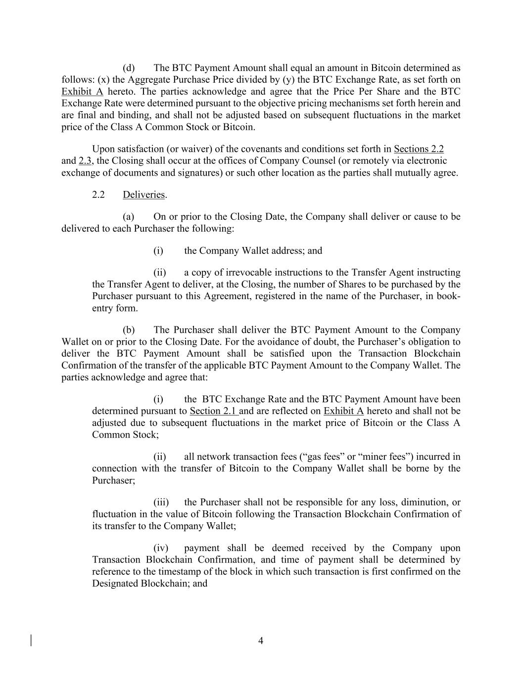
4 (d) The BTC Payment Amount shall equal an amount in Bitcoin determined as follows: (x) the Aggregate Purchase Price divided by (y) the BTC Exchange Rate, as set forth on Exhibit A hereto. The parties acknowledge and agree that the Price Per Share and the BTC Exchange Rate were determined pursuant to the objective pricing mechanisms set forth herein and are final and binding, and shall not be adjusted based on subsequent fluctuations in the market price of the Class A Common Stock or Bitcoin. Upon satisfaction (or waiver) of the covenants and conditions set forth in Sections 2.2 and 2.3, the Closing shall occur at the offices of Company Counsel (or remotely via electronic exchange of documents and signatures) or such other location as the parties shall mutually agree. 2.2 Deliveries. (a) On or prior to the Closing Date, the Company shall deliver or cause to be delivered to each Purchaser the following: (i) the Company Wallet address; and (ii) a copy of irrevocable instructions to the Transfer Agent instructing the Transfer Agent to deliver, at the Closing, the number of Shares to be purchased by the Purchaser pursuant to this Agreement, registered in the name of the Purchaser, in book- entry form. (b) The Purchaser shall deliver the BTC Payment Amount to the Company Wallet on or prior to the Closing Date. For the avoidance of doubt, the Purchaser’s obligation to deliver the BTC Payment Amount shall be satisfied upon the Transaction Blockchain Confirmation of the transfer of the applicable BTC Payment Amount to the Company Wallet. The parties acknowledge and agree that: (i) the BTC Exchange Rate and the BTC Payment Amount have been determined pursuant to Section 2.1 and are reflected on Exhibit A hereto and shall not be adjusted due to subsequent fluctuations in the market price of Bitcoin or the Class A Common Stock; (ii) all network transaction fees (“gas fees” or “miner fees”) incurred in connection with the transfer of Bitcoin to the Company Wallet shall be borne by the Purchaser; (iii) the Purchaser shall not be responsible for any loss, diminution, or fluctuation in the value of Bitcoin following the Transaction Blockchain Confirmation of its transfer to the Company Wallet; (iv) payment shall be deemed received by the Company upon Transaction Blockchain Confirmation, and time of payment shall be determined by reference to the timestamp of the block in which such transaction is first confirmed on the Designated Blockchain; and

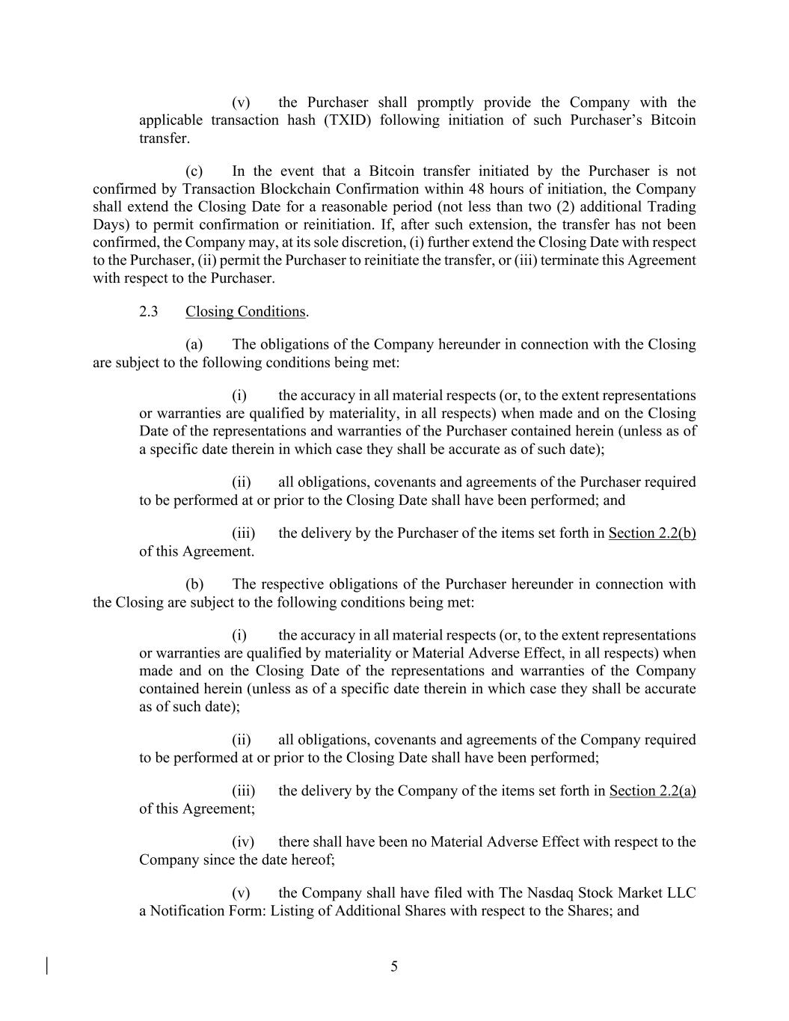
5 (v) the Purchaser shall promptly provide the Company with the applicable transaction hash (TXID) following initiation of such Purchaser’s Bitcoin transfer. (c) In the event that a Bitcoin transfer initiated by the Purchaser is not confirmed by Transaction Blockchain Confirmation within 48 hours of initiation, the Company shall extend the Closing Date for a reasonable period (not less than two (2) additional Trading Days) to permit confirmation or reinitiation. If, after such extension, the transfer has not been confirmed, the Company may, at its sole discretion, (i) further extend the Closing Date with respect to the Purchaser, (ii) permit the Purchaser to reinitiate the transfer, or (iii) terminate this Agreement with respect to the Purchaser. 2.3 Closing Conditions. (a) The obligations of the Company hereunder in connection with the Closing are subject to the following conditions being met: (i) the accuracy in all material respects (or, to the extent representations or warranties are qualified by materiality, in all respects) when made and on the Closing Date of the representations and warranties of the Purchaser contained herein (unless as of a specific date therein in which case they shall be accurate as of such date); (ii) all obligations, covenants and agreements of the Purchaser required to be performed at or prior to the Closing Date shall have been performed; and (iii) the delivery by the Purchaser of the items set forth in Section 2.2(b) of this Agreement. (b) The respective obligations of the Purchaser hereunder in connection with the Closing are subject to the following conditions being met: (i) the accuracy in all material respects (or, to the extent representations or warranties are qualified by materiality or Material Adverse Effect, in all respects) when made and on the Closing Date of the representations and warranties of the Company contained herein (unless as of a specific date therein in which case they shall be accurate as of such date); (ii) all obligations, covenants and agreements of the Company required to be performed at or prior to the Closing Date shall have been performed; (iii) the delivery by the Company of the items set forth in Section 2.2(a) of this Agreement; (iv) there shall have been no Material Adverse Effect with respect to the Company since the date hereof; (v) the Company shall have filed with The Nasdaq Stock Market LLC a Notification Form: Listing of Additional Shares with respect to the Shares; and

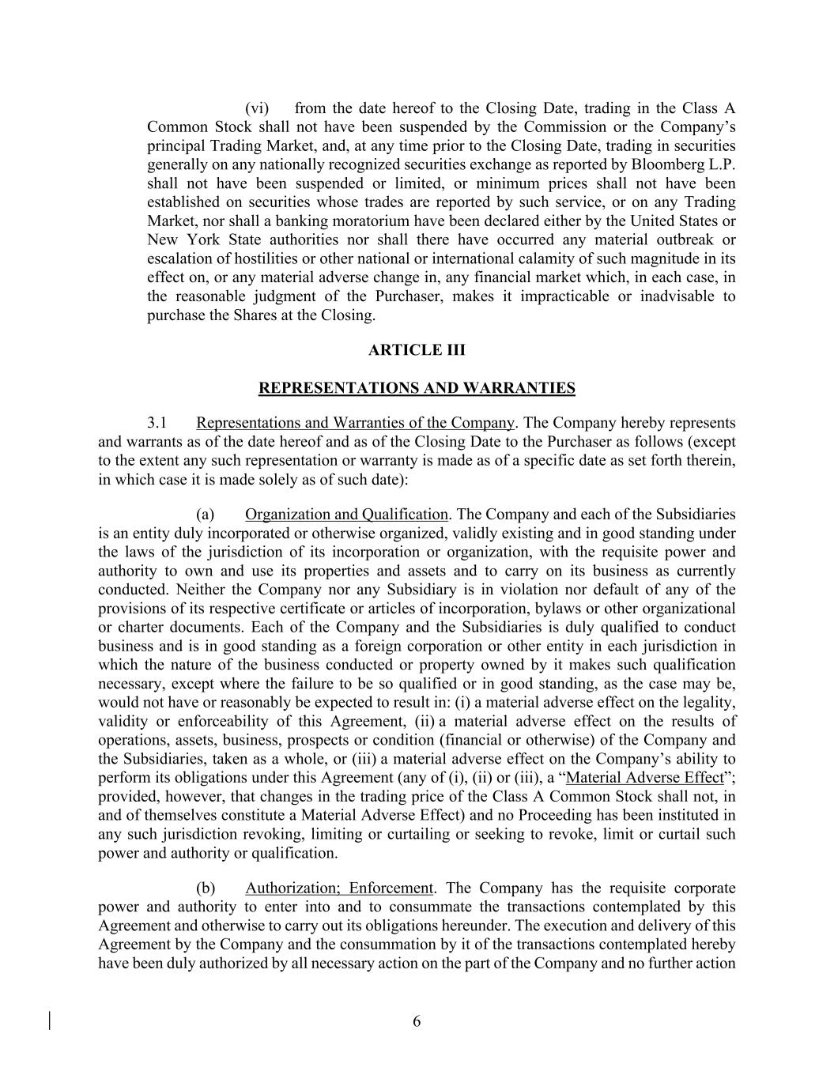
6 (vi) from the date hereof to the Closing Date, trading in the Class A Common Stock shall not have been suspended by the Commission or the Company’s principal Trading Market, and, at any time prior to the Closing Date, trading in securities generally on any nationally recognized securities exchange as reported by Bloomberg L.P. shall not have been suspended or limited, or minimum prices shall not have been established on securities whose trades are reported by such service, or on any Trading Market, nor shall a banking moratorium have been declared either by the United States or New York State authorities nor shall there have occurred any material outbreak or escalation of hostilities or other national or international calamity of such magnitude in its effect on, or any material adverse change in, any financial market which, in each case, in the reasonable judgment of the Purchaser, makes it impracticable or inadvisable to purchase the Shares at the Closing. ARTICLE III REPRESENTATIONS AND WARRANTIES 3.1 Representations and Warranties of the Company. The Company hereby represents and warrants as of the date hereof and as of the Closing Date to the Purchaser as follows (except to the extent any such representation or warranty is made as of a specific date as set forth therein, in which case it is made solely as of such date): (a) Organization and Qualification. The Company and each of the Subsidiaries is an entity duly incorporated or otherwise organized, validly existing and in good standing under the laws of the jurisdiction of its incorporation or organization, with the requisite power and authority to own and use its properties and assets and to carry on its business as currently conducted. Neither the Company nor any Subsidiary is in violation nor default of any of the provisions of its respective certificate or articles of incorporation, bylaws or other organizational or charter documents. Each of the Company and the Subsidiaries is duly qualified to conduct business and is in good standing as a foreign corporation or other entity in each jurisdiction in which the nature of the business conducted or property owned by it makes such qualification necessary, except where the failure to be so qualified or in good standing, as the case may be, would not have or reasonably be expected to result in: (i) a material adverse effect on the legality, validity or enforceability of this Agreement, (ii) a material adverse effect on the results of operations, assets, business, prospects or condition (financial or otherwise) of the Company and the Subsidiaries, taken as a whole, or (iii) a material adverse effect on the Company’s ability to perform its obligations under this Agreement (any of (i), (ii) or (iii), a “Material Adverse Effect”; provided, however, that changes in the trading price of the Class A Common Stock shall not, in and of themselves constitute a Material Adverse Effect) and no Proceeding has been instituted in any such jurisdiction revoking, limiting or curtailing or seeking to revoke, limit or curtail such power and authority or qualification. (b) Authorization; Enforcement. The Company has the requisite corporate power and authority to enter into and to consummate the transactions contemplated by this Agreement and otherwise to carry out its obligations hereunder. The execution and delivery of this Agreement by the Company and the consummation by it of the transactions contemplated hereby have been duly authorized by all necessary action on the part of the Company and no further action

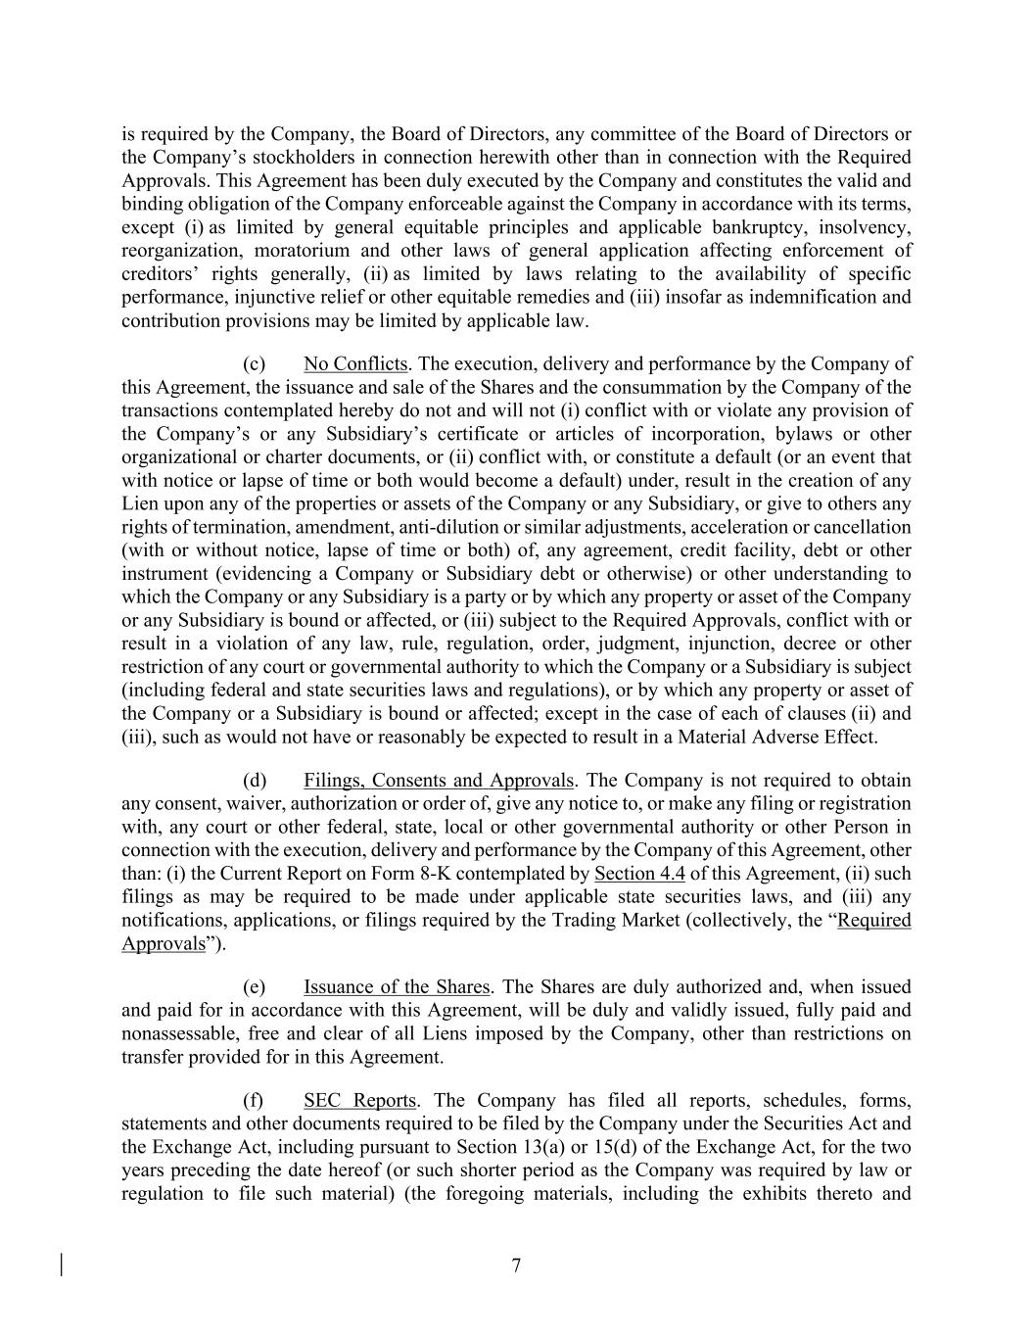
7 is required by the Company, the Board of Directors, any committee of the Board of Directors or the Company’s stockholders in connection herewith other than in connection with the Required Approvals. This Agreement has been duly executed by the Company and constitutes the valid and binding obligation of the Company enforceable against the Company in accordance with its terms, except (i) as limited by general equitable principles and applicable bankruptcy, insolvency, reorganization, moratorium and other laws of general application affecting enforcement of creditors’ rights generally, (ii) as limited by laws relating to the availability of specific performance, injunctive relief or other equitable remedies and (iii) insofar as indemnification and contribution provisions may be limited by applicable law. (c) No Conflicts. The execution, delivery and performance by the Company of this Agreement, the issuance and sale of the Shares and the consummation by the Company of the transactions contemplated hereby do not and will not (i) conflict with or violate any provision of the Company’s or any Subsidiary’s certificate or articles of incorporation, bylaws or other organizational or charter documents, or (ii) conflict with, or constitute a default (or an event that with notice or lapse of time or both would become a default) under, result in the creation of any Lien upon any of the properties or assets of the Company or any Subsidiary, or give to others any rights of termination, amendment, anti-dilution or similar adjustments, acceleration or cancellation (with or without notice, lapse of time or both) of, any agreement, credit facility, debt or other instrument (evidencing a Company or Subsidiary debt or otherwise) or other understanding to which the Company or any Subsidiary is a party or by which any property or asset of the Company or any Subsidiary is bound or affected, or (iii) subject to the Required Approvals, conflict with or result in a violation of any law, rule, regulation, order, judgment, injunction, decree or other restriction of any court or governmental authority to which the Company or a Subsidiary is subject (including federal and state securities laws and regulations), or by which any property or asset of the Company or a Subsidiary is bound or affected; except in the case of each of clauses (ii) and (iii), such as would not have or reasonably be expected to result in a Material Adverse Effect. (d) Filings, Consents and Approvals. The Company is not required to obtain any consent, waiver, authorization or order of, give any notice to, or make any filing or registration with, any court or other federal, state, local or other governmental authority or other Person in connection with the execution, delivery and performance by the Company of this Agreement, other than: (i) the Current Report on Form 8-K contemplated by Section 4.4 of this Agreement, (ii) such filings as may be required to be made under applicable state securities laws, and (iii) any notifications, applications, or filings required by the Trading Market (collectively, the “Required Approvals”). (e) Issuance of the Shares. The Shares are duly authorized and, when issued and paid for in accordance with this Agreement, will be duly and validly issued, fully paid and nonassessable, free and clear of all Liens imposed by the Company, other than restrictions on transfer provided for in this Agreement. (f) SEC Reports. The Company has filed all reports, schedules, forms, statements and other documents required to be filed by the Company under the Securities Act and the Exchange Act, including pursuant to Section 13(a) or 15(d) of the Exchange Act, for the two years preceding the date hereof (or such shorter period as the Company was required by law or regulation to file such material) (the foregoing materials, including the exhibits thereto and

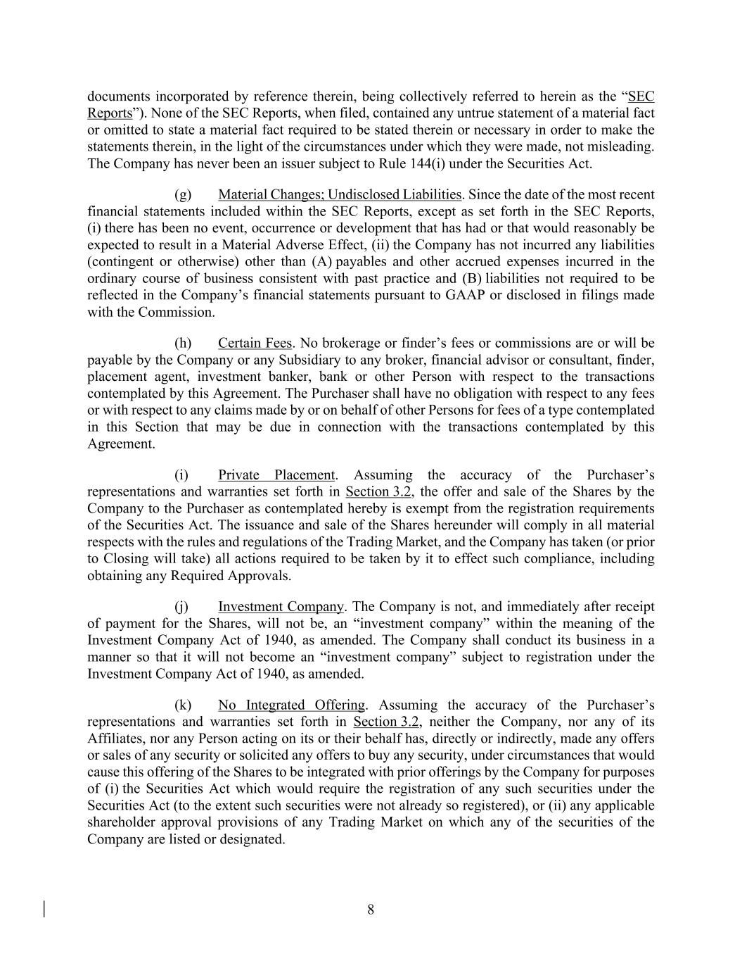
8 documents incorporated by reference therein, being collectively referred to herein as the “SEC Reports”). None of the SEC Reports, when filed, contained any untrue statement of a material fact or omitted to state a material fact required to be stated therein or necessary in order to make the statements therein, in the light of the circumstances under which they were made, not misleading. The Company has never been an issuer subject to Rule 144(i) under the Securities Act. (g) Material Changes; Undisclosed Liabilities. Since the date of the most recent financial statements included within the SEC Reports, except as set forth in the SEC Reports, (i) there has been no event, occurrence or development that has had or that would reasonably be expected to result in a Material Adverse Effect, (ii) the Company has not incurred any liabilities (contingent or otherwise) other than (A) payables and other accrued expenses incurred in the ordinary course of business consistent with past practice and (B) liabilities not required to be reflected in the Company’s financial statements pursuant to GAAP or disclosed in filings made with the Commission. (h) Certain Fees. No brokerage or finder’s fees or commissions are or will be payable by the Company or any Subsidiary to any broker, financial advisor or consultant, finder, placement agent, investment banker, bank or other Person with respect to the transactions contemplated by this Agreement. The Purchaser shall have no obligation with respect to any fees or with respect to any claims made by or on behalf of other Persons for fees of a type contemplated in this Section that may be due in connection with the transactions contemplated by this Agreement. (i) Private Placement. Assuming the accuracy of the Purchaser’s representations and warranties set forth in Section 3.2, the offer and sale of the Shares by the Company to the Purchaser as contemplated hereby is exempt from the registration requirements of the Securities Act. The issuance and sale of the Shares hereunder will comply in all material respects with the rules and regulations of the Trading Market, and the Company has taken (or prior to Closing will take) all actions required to be taken by it to effect such compliance, including obtaining any Required Approvals. (j) Investment Company. The Company is not, and immediately after receipt of payment for the Shares, will not be, an “investment company” within the meaning of the Investment Company Act of 1940, as amended. The Company shall conduct its business in a manner so that it will not become an “investment company” subject to registration under the Investment Company Act of 1940, as amended. (k) No Integrated Offering. Assuming the accuracy of the Purchaser’s representations and warranties set forth in Section 3.2, neither the Company, nor any of its Affiliates, nor any Person acting on its or their behalf has, directly or indirectly, made any offers or sales of any security or solicited any offers to buy any security, under circumstances that would cause this offering of the Shares to be integrated with prior offerings by the Company for purposes of (i) the Securities Act which would require the registration of any such securities under the Securities Act (to the extent such securities were not already so registered), or (ii) any applicable shareholder approval provisions of any Trading Market on which any of the securities of the Company are listed or designated.

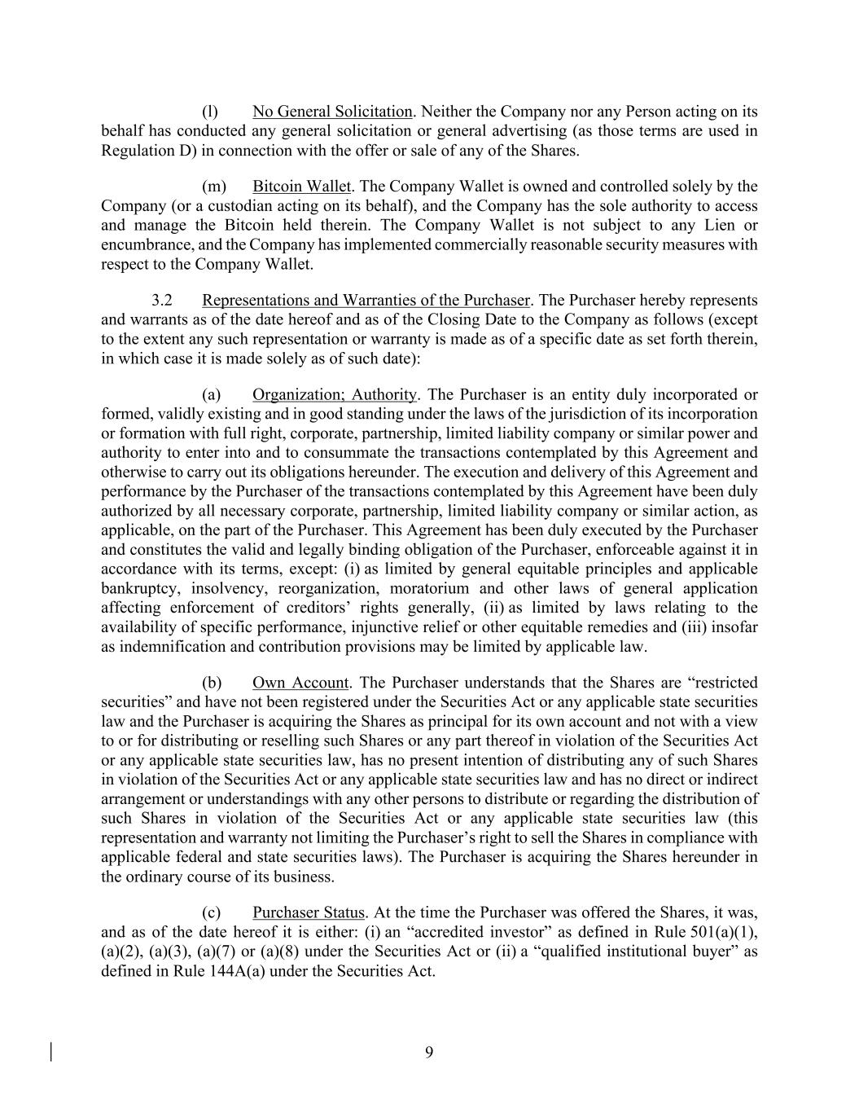
9 (l) No General Solicitation. Neither the Company nor any Person acting on its behalf has conducted any general solicitation or general advertising (as those terms are used in Regulation D) in connection with the offer or sale of any of the Shares. (m) Bitcoin Wallet. The Company Wallet is owned and controlled solely by the Company (or a custodian acting on its behalf), and the Company has the sole authority to access and manage the Bitcoin held therein. The Company Wallet is not subject to any Lien or encumbrance, and the Company has implemented commercially reasonable security measures with respect to the Company Wallet. 3.2 Representations and Warranties of the Purchaser. The Purchaser hereby represents and warrants as of the date hereof and as of the Closing Date to the Company as follows (except to the extent any such representation or warranty is made as of a specific date as set forth therein, in which case it is made solely as of such date): (a) Organization; Authority. The Purchaser is an entity duly incorporated or formed, validly existing and in good standing under the laws of the jurisdiction of its incorporation or formation with full right, corporate, partnership, limited liability company or similar power and authority to enter into and to consummate the transactions contemplated by this Agreement and otherwise to carry out its obligations hereunder. The execution and delivery of this Agreement and performance by the Purchaser of the transactions contemplated by this Agreement have been duly authorized by all necessary corporate, partnership, limited liability company or similar action, as applicable, on the part of the Purchaser. This Agreement has been duly executed by the Purchaser and constitutes the valid and legally binding obligation of the Purchaser, enforceable against it in accordance with its terms, except: (i) as limited by general equitable principles and applicable bankruptcy, insolvency, reorganization, moratorium and other laws of general application affecting enforcement of creditors’ rights generally, (ii) as limited by laws relating to the availability of specific performance, injunctive relief or other equitable remedies and (iii) insofar as indemnification and contribution provisions may be limited by applicable law. (b) Own Account. The Purchaser understands that the Shares are “restricted securities” and have not been registered under the Securities Act or any applicable state securities law and the Purchaser is acquiring the Shares as principal for its own account and not with a view to or for distributing or reselling such Shares or any part thereof in violation of the Securities Act or any applicable state securities law, has no present intention of distributing any of such Shares in violation of the Securities Act or any applicable state securities law and has no direct or indirect arrangement or understandings with any other persons to distribute or regarding the distribution of such Shares in violation of the Securities Act or any applicable state securities law (this representation and warranty not limiting the Purchaser’s right to sell the Shares in compliance with applicable federal and state securities laws). The Purchaser is acquiring the Shares hereunder in the ordinary course of its business. (c) Purchaser Status. At the time the Purchaser was offered the Shares, it was, and as of the date hereof it is either: (i) an “accredited investor” as defined in Rule 501(a)(1), (a)(2), (a)(3), (a)(7) or (a)(8) under the Securities Act or (ii) a “qualified institutional buyer” as defined in Rule 144A(a) under the Securities Act.

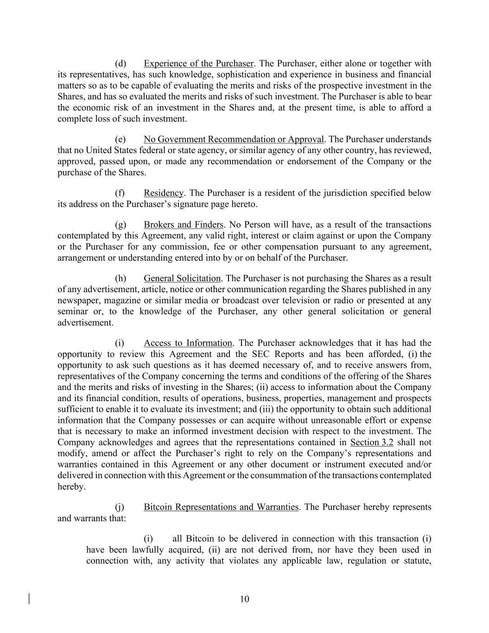
10 (d) Experience of the Purchaser. The Purchaser, either alone or together with its representatives, has such knowledge, sophistication and experience in business and financial matters so as to be capable of evaluating the merits and risks of the prospective investment in the Shares, and has so evaluated the merits and risks of such investment. The Purchaser is able to bear the economic risk of an investment in the Shares and, at the present time, is able to afford a complete loss of such investment. (e) No Government Recommendation or Approval. The Purchaser understands that no United States federal or state agency, or similar agency of any other country, has reviewed, approved, passed upon, or made any recommendation or endorsement of the Company or the purchase of the Shares. (f) Residency. The Purchaser is a resident of the jurisdiction specified below its address on the Purchaser’s signature page hereto. (g) Brokers and Finders. No Person will have, as a result of the transactions contemplated by this Agreement, any valid right, interest or claim against or upon the Company or the Purchaser for any commission, fee or other compensation pursuant to any agreement, arrangement or understanding entered into by or on behalf of the Purchaser. (h) General Solicitation. The Purchaser is not purchasing the Shares as a result of any advertisement, article, notice or other communication regarding the Shares published in any newspaper, magazine or similar media or broadcast over television or radio or presented at any seminar or, to the knowledge of the Purchaser, any other general solicitation or general advertisement. (i) Access to Information. The Purchaser acknowledges that it has had the opportunity to review this Agreement and the SEC Reports and has been afforded, (i) the opportunity to ask such questions as it has deemed necessary of, and to receive answers from, representatives of the Company concerning the terms and conditions of the offering of the Shares and the merits and risks of investing in the Shares; (ii) access to information about the Company and its financial condition, results of operations, business, properties, management and prospects sufficient to enable it to evaluate its investment; and (iii) the opportunity to obtain such additional information that the Company possesses or can acquire without unreasonable effort or expense that is necessary to make an informed investment decision with respect to the investment. The Company acknowledges and agrees that the representations contained in Section 3.2 shall not modify, amend or affect the Purchaser’s right to rely on the Company’s representations and warranties contained in this Agreement or any other document or instrument executed and/or delivered in connection with this Agreement or the consummation of the transactions contemplated hereby. (j) Bitcoin Representations and Warranties. The Purchaser hereby represents and warrants that: (i) all Bitcoin to be delivered in connection with this transaction (i) have been lawfully acquired, (ii) are not derived from, nor have they been used in connection with, any activity that violates any applicable law, regulation or statute,

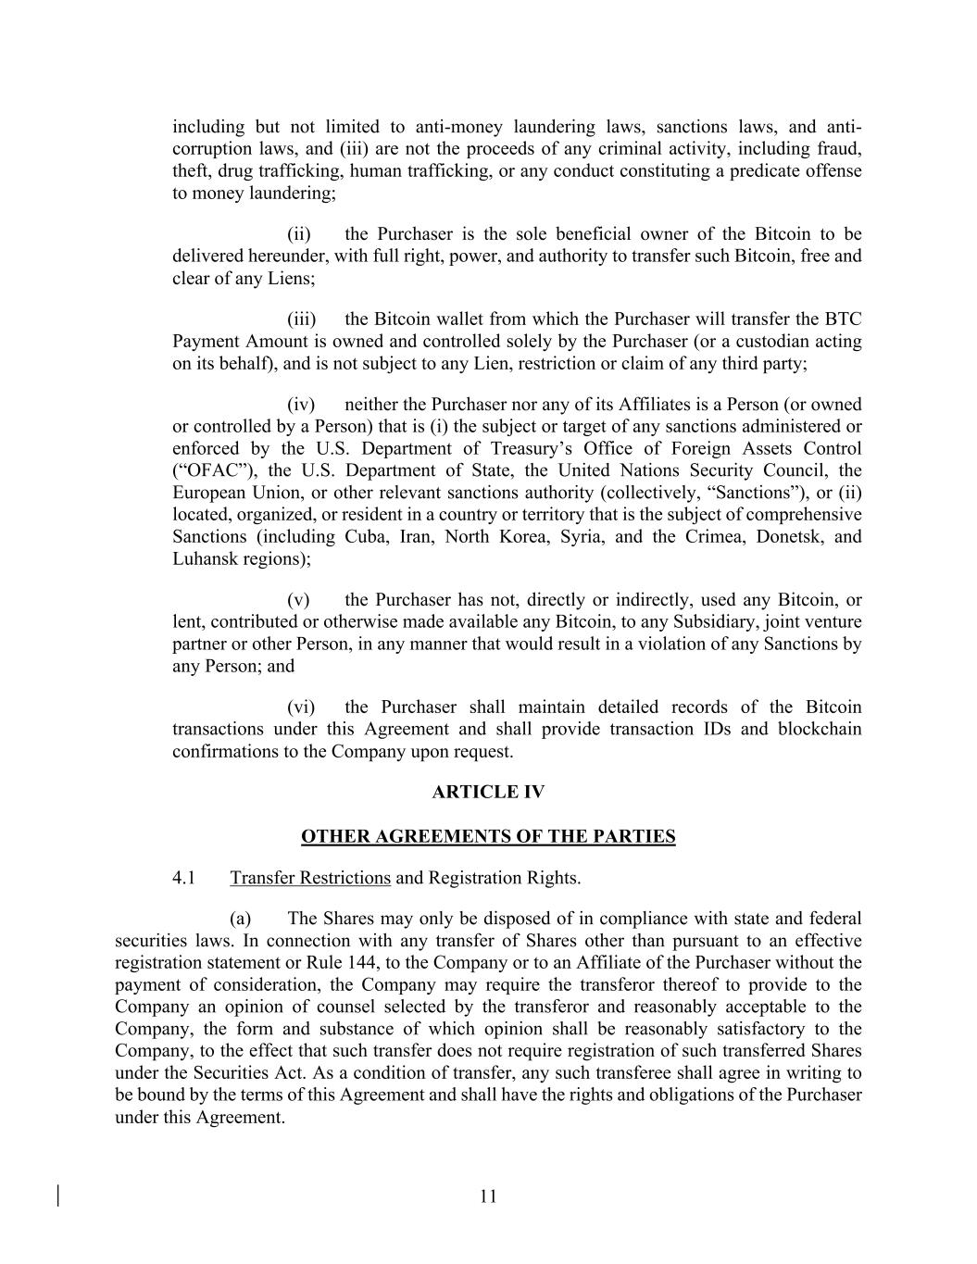
11 including but not limited to anti-money laundering laws, sanctions laws, and anti- corruption laws, and (iii) are not the proceeds of any criminal activity, including fraud, theft, drug trafficking, human trafficking, or any conduct constituting a predicate offense to money laundering; (ii) the Purchaser is the sole beneficial owner of the Bitcoin to be delivered hereunder, with full right, power, and authority to transfer such Bitcoin, free and clear of any Liens; (iii) the Bitcoin wallet from which the Purchaser will transfer the BTC Payment Amount is owned and controlled solely by the Purchaser (or a custodian acting on its behalf), and is not subject to any Lien, restriction or claim of any third party; (iv) neither the Purchaser nor any of its Affiliates is a Person (or owned or controlled by a Person) that is (i) the subject or target of any sanctions administered or enforced by the U.S. Department of Treasury’s Office of Foreign Assets Control (“OFAC”), the U.S. Department of State, the United Nations Security Council, the European Union, or other relevant sanctions authority (collectively, “Sanctions”), or (ii) located, organized, or resident in a country or territory that is the subject of comprehensive Sanctions (including Cuba, Iran, North Korea, Syria, and the Crimea, Donetsk, and Luhansk regions); (v) the Purchaser has not, directly or indirectly, used any Bitcoin, or lent, contributed or otherwise made available any Bitcoin, to any Subsidiary, joint venture partner or other Person, in any manner that would result in a violation of any Sanctions by any Person; and (vi) the Purchaser shall maintain detailed records of the Bitcoin transactions under this Agreement and shall provide transaction IDs and blockchain confirmations to the Company upon request. ARTICLE IV OTHER AGREEMENTS OF THE PARTIES 4.1 Transfer Restrictions and Registration Rights. (a) The Shares may only be disposed of in compliance with state and federal securities laws. In connection with any transfer of Shares other than pursuant to an effective registration statement or Rule 144, to the Company or to an Affiliate of the Purchaser without the payment of consideration, the Company may require the transferor thereof to provide to the Company an opinion of counsel selected by the transferor and reasonably acceptable to the Company, the form and substance of which opinion shall be reasonably satisfactory to the Company, to the effect that such transfer does not require registration of such transferred Shares under the Securities Act. As a condition of transfer, any such transferee shall agree in writing to be bound by the terms of this Agreement and shall have the rights and obligations of the Purchaser under this Agreement.

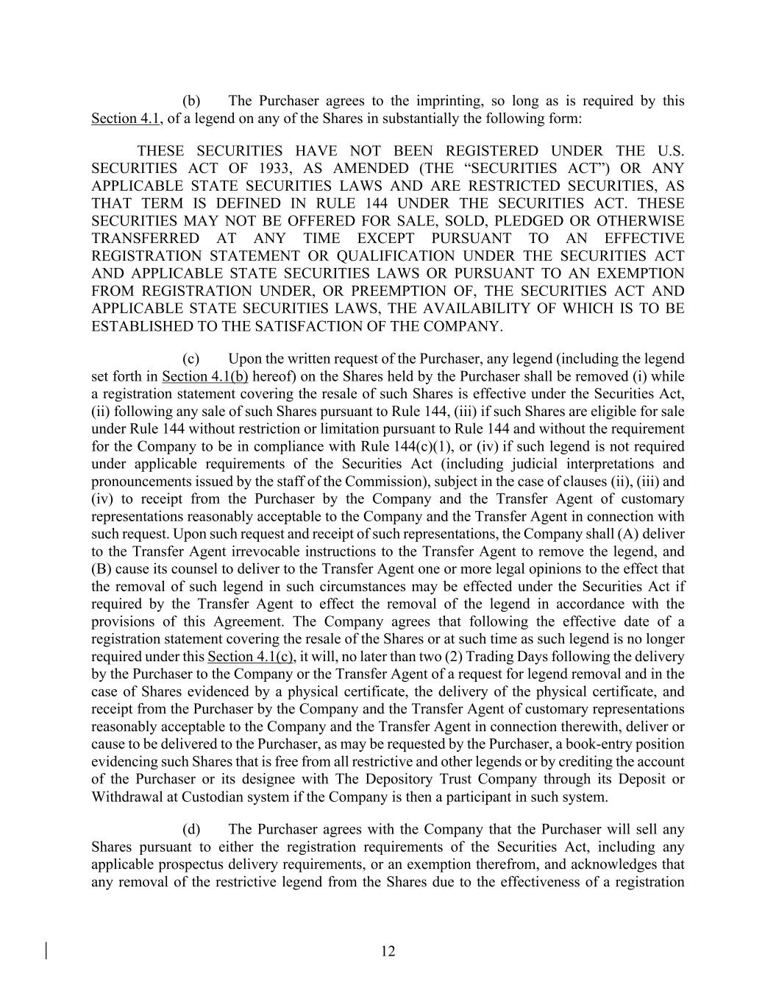
12 (b) The Purchaser agrees to the imprinting, so long as is required by this Section 4.1, of a legend on any of the Shares in substantially the following form: THESE SECURITIES HAVE NOT BEEN REGISTERED UNDER THE U.S. SECURITIES ACT OF 1933, AS AMENDED (THE “SECURITIES ACT”) OR ANY APPLICABLE STATE SECURITIES LAWS AND ARE RESTRICTED SECURITIES, AS THAT TERM IS DEFINED IN RULE 144 UNDER THE SECURITIES ACT. THESE SECURITIES MAY NOT BE OFFERED FOR SALE, SOLD, PLEDGED OR OTHERWISE TRANSFERRED AT ANY TIME EXCEPT PURSUANT TO AN EFFECTIVE REGISTRATION STATEMENT OR QUALIFICATION UNDER THE SECURITIES ACT AND APPLICABLE STATE SECURITIES LAWS OR PURSUANT TO AN EXEMPTION FROM REGISTRATION UNDER, OR PREEMPTION OF, THE SECURITIES ACT AND APPLICABLE STATE SECURITIES LAWS, THE AVAILABILITY OF WHICH IS TO BE ESTABLISHED TO THE SATISFACTION OF THE COMPANY. (c) Upon the written request of the Purchaser, any legend (including the legend set forth in Section 4.1(b) hereof) on the Shares held by the Purchaser shall be removed (i) while a registration statement covering the resale of such Shares is effective under the Securities Act, (ii) following any sale of such Shares pursuant to Rule 144, (iii) if such Shares are eligible for sale under Rule 144 without restriction or limitation pursuant to Rule 144 and without the requirement for the Company to be in compliance with Rule 144(c)(1), or (iv) if such legend is not required under applicable requirements of the Securities Act (including judicial interpretations and pronouncements issued by the staff of the Commission), subject in the case of clauses (ii), (iii) and (iv) to receipt from the Purchaser by the Company and the Transfer Agent of customary representations reasonably acceptable to the Company and the Transfer Agent in connection with such request. Upon such request and receipt of such representations, the Company shall (A) deliver to the Transfer Agent irrevocable instructions to the Transfer Agent to remove the legend, and (B) cause its counsel to deliver to the Transfer Agent one or more legal opinions to the effect that the removal of such legend in such circumstances may be effected under the Securities Act if required by the Transfer Agent to effect the removal of the legend in accordance with the provisions of this Agreement. The Company agrees that following the effective date of a registration statement covering the resale of the Shares or at such time as such legend is no longer required under this Section 4.1(c), it will, no later than two (2) Trading Days following the delivery by the Purchaser to the Company or the Transfer Agent of a request for legend removal and in the case of Shares evidenced by a physical certificate, the delivery of the physical certificate, and receipt from the Purchaser by the Company and the Transfer Agent of customary representations reasonably acceptable to the Company and the Transfer Agent in connection therewith, deliver or cause to be delivered to the Purchaser, as may be requested by the Purchaser, a book-entry position evidencing such Shares that is free from all restrictive and other legends or by crediting the account of the Purchaser or its designee with The Depository Trust Company through its Deposit or Withdrawal at Custodian system if the Company is then a participant in such system. (d) The Purchaser agrees with the Company that the Purchaser will sell any Shares pursuant to either the registration requirements of the Securities Act, including any applicable prospectus delivery requirements, or an exemption therefrom, and acknowledges that any removal of the restrictive legend from the Shares due to the effectiveness of a registration

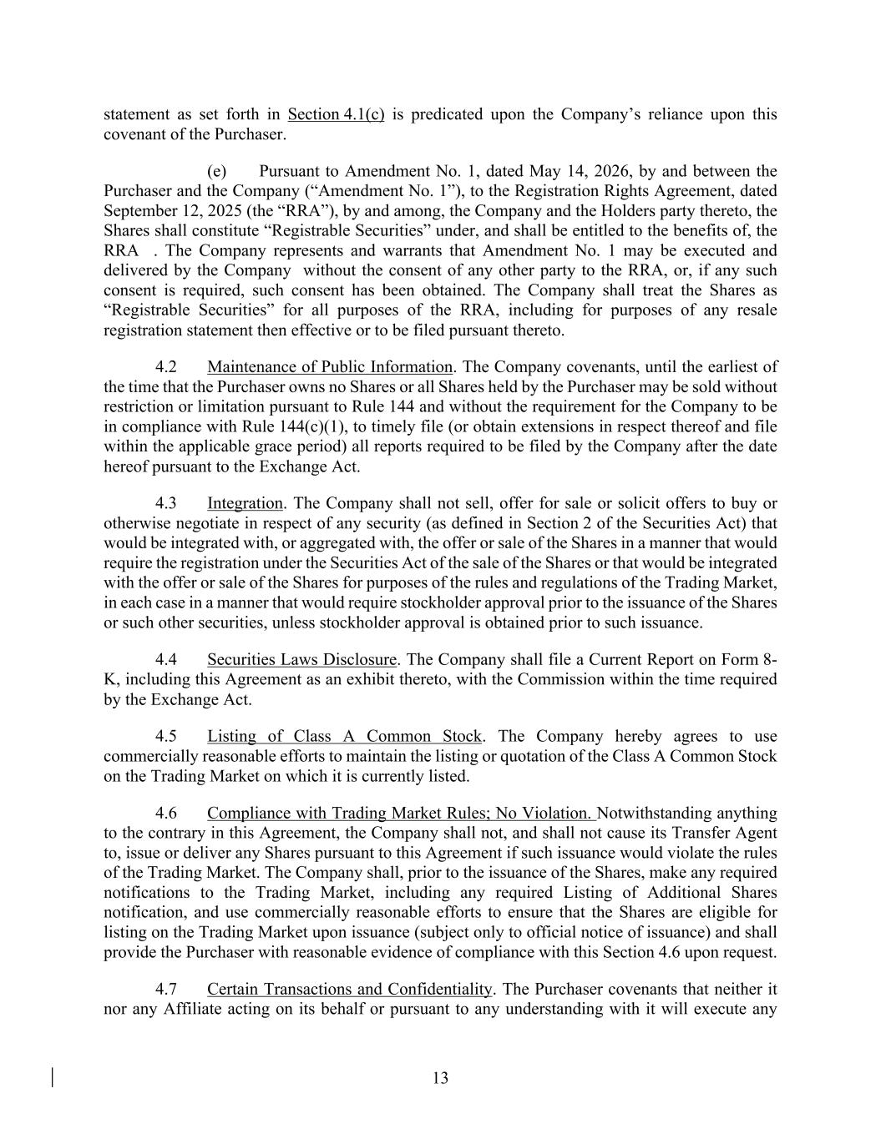
13 statement as set forth in Section 4.1(c) is predicated upon the Company’s reliance upon this covenant of the Purchaser. (e) Pursuant to Amendment No. 1, dated May 14, 2026, by and between the Purchaser and the Company (“Amendment No. 1”), to the Registration Rights Agreement, dated September 12, 2025 (the “RRA”), by and among, the Company and the Holders party thereto, the Shares shall constitute “Registrable Securities” under, and shall be entitled to the benefits of, the RRA . The Company represents and warrants that Amendment No. 1 may be executed and delivered by the Company without the consent of any other party to the RRA, or, if any such consent is required, such consent has been obtained. The Company shall treat the Shares as “Registrable Securities” for all purposes of the RRA, including for purposes of any resale registration statement then effective or to be filed pursuant thereto. 4.2 Maintenance of Public Information. The Company covenants, until the earliest of the time that the Purchaser owns no Shares or all Shares held by the Purchaser may be sold without restriction or limitation pursuant to Rule 144 and without the requirement for the Company to be in compliance with Rule 144(c)(1), to timely file (or obtain extensions in respect thereof and file within the applicable grace period) all reports required to be filed by the Company after the date hereof pursuant to the Exchange Act. 4.3 Integration. The Company shall not sell, offer for sale or solicit offers to buy or otherwise negotiate in respect of any security (as defined in Section 2 of the Securities Act) that would be integrated with, or aggregated with, the offer or sale of the Shares in a manner that would require the registration under the Securities Act of the sale of the Shares or that would be integrated with the offer or sale of the Shares for purposes of the rules and regulations of the Trading Market, in each case in a manner that would require stockholder approval prior to the issuance of the Shares or such other securities, unless stockholder approval is obtained prior to such issuance. 4.4 Securities Laws Disclosure. The Company shall file a Current Report on Form 8- K, including this Agreement as an exhibit thereto, with the Commission within the time required by the Exchange Act. 4.5 Listing of Class A Common Stock. The Company hereby agrees to use commercially reasonable efforts to maintain the listing or quotation of the Class A Common Stock on the Trading Market on which it is currently listed. 4.6 Compliance with Trading Market Rules; No Violation. Notwithstanding anything to the contrary in this Agreement, the Company shall not, and shall not cause its Transfer Agent to, issue or deliver any Shares pursuant to this Agreement if such issuance would violate the rules of the Trading Market. The Company shall, prior to the issuance of the Shares, make any required notifications to the Trading Market, including any required Listing of Additional Shares notification, and use commercially reasonable efforts to ensure that the Shares are eligible for listing on the Trading Market upon issuance (subject only to official notice of issuance) and shall provide the Purchaser with reasonable evidence of compliance with this Section 4.6 upon request. 4.7 Certain Transactions and Confidentiality. The Purchaser covenants that neither it nor any Affiliate acting on its behalf or pursuant to any understanding with it will execute any

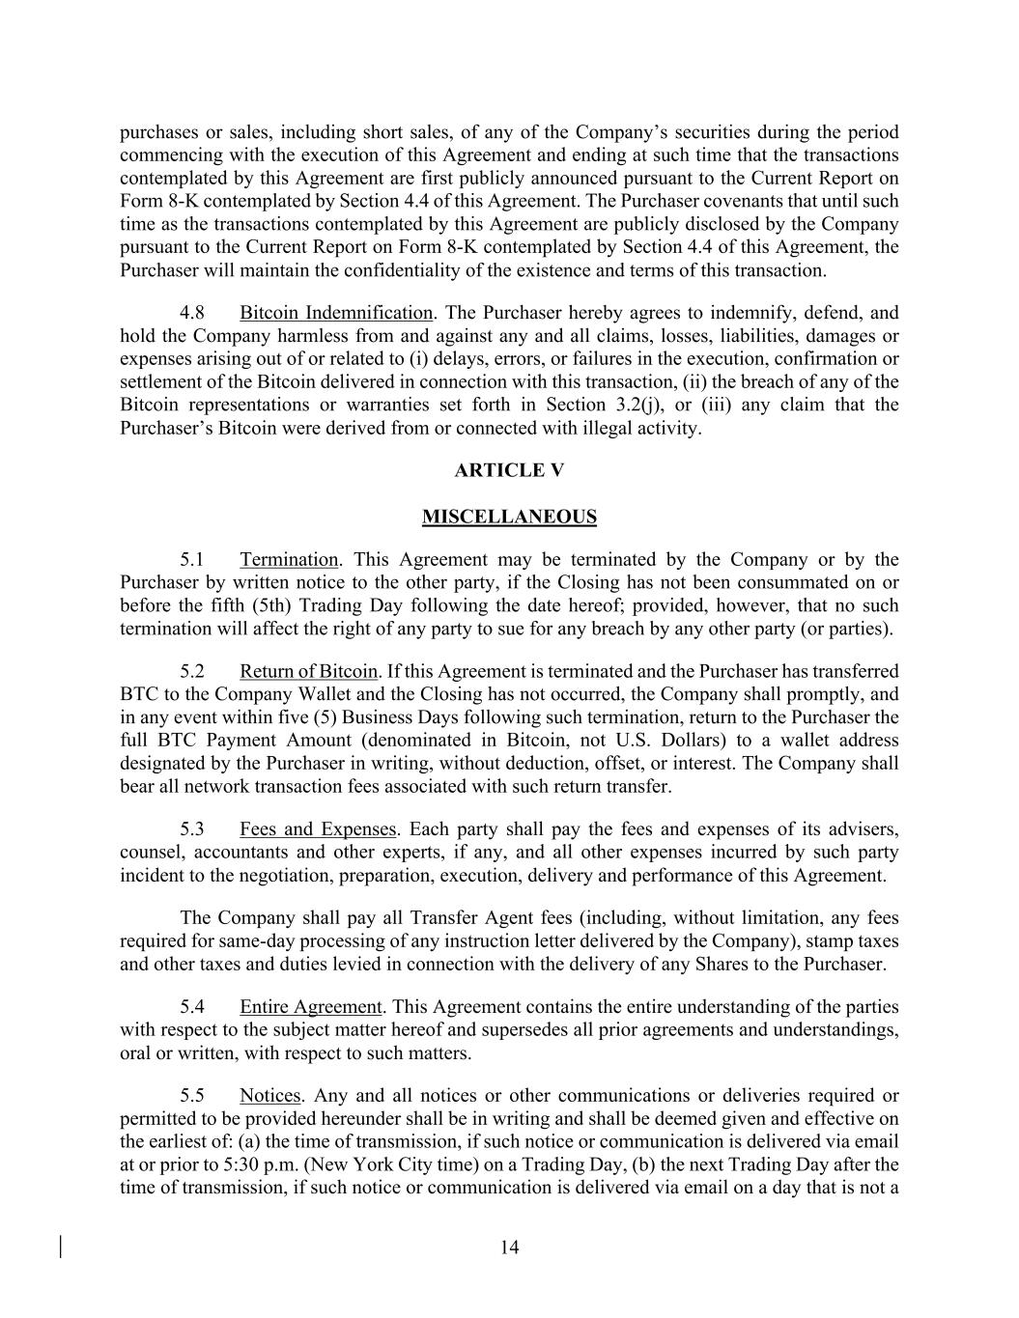
14 purchases or sales, including short sales, of any of the Company’s securities during the period commencing with the execution of this Agreement and ending at such time that the transactions contemplated by this Agreement are first publicly announced pursuant to the Current Report on Form 8-K contemplated by Section 4.4 of this Agreement. The Purchaser covenants that until such time as the transactions contemplated by this Agreement are publicly disclosed by the Company pursuant to the Current Report on Form 8-K contemplated by Section 4.4 of this Agreement, the Purchaser will maintain the confidentiality of the existence and terms of this transaction. 4.8 Bitcoin Indemnification. The Purchaser hereby agrees to indemnify, defend, and hold the Company harmless from and against any and all claims, losses, liabilities, damages or expenses arising out of or related to (i) delays, errors, or failures in the execution, confirmation or settlement of the Bitcoin delivered in connection with this transaction, (ii) the breach of any of the Bitcoin representations or warranties set forth in Section 3.2(j), or (iii) any claim that the Purchaser’s Bitcoin were derived from or connected with illegal activity. ARTICLE V MISCELLANEOUS 5.1 Termination. This Agreement may be terminated by the Company or by the Purchaser by written notice to the other party, if the Closing has not been consummated on or before the fifth (5th) Trading Day following the date hereof; provided, however, that no such termination will affect the right of any party to sue for any breach by any other party (or parties). 5.2 Return of Bitcoin. If this Agreement is terminated and the Purchaser has transferred BTC to the Company Wallet and the Closing has not occurred, the Company shall promptly, and in any event within five (5) Business Days following such termination, return to the Purchaser the full BTC Payment Amount (denominated in Bitcoin, not U.S. Dollars) to a wallet address designated by the Purchaser in writing, without deduction, offset, or interest. The Company shall bear all network transaction fees associated with such return transfer. 5.3 Fees and Expenses. Each party shall pay the fees and expenses of its advisers, counsel, accountants and other experts, if any, and all other expenses incurred by such party incident to the negotiation, preparation, execution, delivery and performance of this Agreement. The Company shall pay all Transfer Agent fees (including, without limitation, any fees required for same-day processing of any instruction letter delivered by the Company), stamp taxes and other taxes and duties levied in connection with the delivery of any Shares to the Purchaser. 5.4 Entire Agreement. This Agreement contains the entire understanding of the parties with respect to the subject matter hereof and supersedes all prior agreements and understandings, oral or written, with respect to such matters. 5.5 Notices. Any and all notices or other communications or deliveries required or permitted to be provided hereunder shall be in writing and shall be deemed given and effective on the earliest of: (a) the time of transmission, if such notice or communication is delivered via email at or prior to 5:30 p.m. (New York City time) on a Trading Day, (b) the next Trading Day after the time of transmission, if such notice or communication is delivered via email on a day that is not a

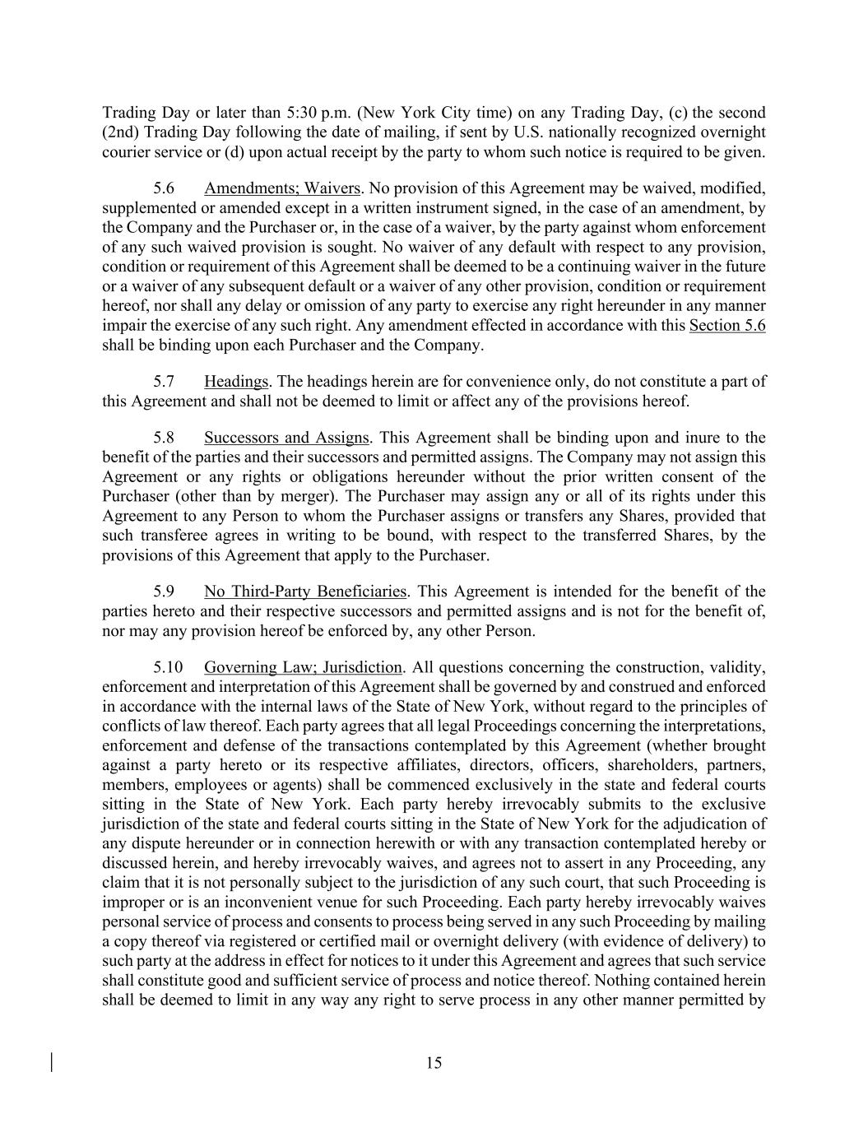
15 Trading Day or later than 5:30 p.m. (New York City time) on any Trading Day, (c) the second (2nd) Trading Day following the date of mailing, if sent by U.S. nationally recognized overnight courier service or (d) upon actual receipt by the party to whom such notice is required to be given. 5.6 Amendments; Waivers. No provision of this Agreement may be waived, modified, supplemented or amended except in a written instrument signed, in the case of an amendment, by the Company and the Purchaser or, in the case of a waiver, by the party against whom enforcement of any such waived provision is sought. No waiver of any default with respect to any provision, condition or requirement of this Agreement shall be deemed to be a continuing waiver in the future or a waiver of any subsequent default or a waiver of any other provision, condition or requirement hereof, nor shall any delay or omission of any party to exercise any right hereunder in any manner impair the exercise of any such right. Any amendment effected in accordance with this Section 5.6 shall be binding upon each Purchaser and the Company. 5.7 Headings. The headings herein are for convenience only, do not constitute a part of this Agreement and shall not be deemed to limit or affect any of the provisions hereof. 5.8 Successors and Assigns. This Agreement shall be binding upon and inure to the benefit of the parties and their successors and permitted assigns. The Company may not assign this Agreement or any rights or obligations hereunder without the prior written consent of the Purchaser (other than by merger). The Purchaser may assign any or all of its rights under this Agreement to any Person to whom the Purchaser assigns or transfers any Shares, provided that such transferee agrees in writing to be bound, with respect to the transferred Shares, by the provisions of this Agreement that apply to the Purchaser. 5.9 No Third-Party Beneficiaries. This Agreement is intended for the benefit of the parties hereto and their respective successors and permitted assigns and is not for the benefit of, nor may any provision hereof be enforced by, any other Person. 5.10 Governing Law; Jurisdiction. All questions concerning the construction, validity, enforcement and interpretation of this Agreement shall be governed by and construed and enforced in accordance with the internal laws of the State of New York, without regard to the principles of conflicts of law thereof. Each party agrees that all legal Proceedings concerning the interpretations, enforcement and defense of the transactions contemplated by this Agreement (whether brought against a party hereto or its respective affiliates, directors, officers, shareholders, partners, members, employees or agents) shall be commenced exclusively in the state and federal courts sitting in the State of New York. Each party hereby irrevocably submits to the exclusive jurisdiction of the state and federal courts sitting in the State of New York for the adjudication of any dispute hereunder or in connection herewith or with any transaction contemplated hereby or discussed herein, and hereby irrevocably waives, and agrees not to assert in any Proceeding, any claim that it is not personally subject to the jurisdiction of any such court, that such Proceeding is improper or is an inconvenient venue for such Proceeding. Each party hereby irrevocably waives personal service of process and consents to process being served in any such Proceeding by mailing a copy thereof via registered or certified mail or overnight delivery (with evidence of delivery) to such party at the address in effect for notices to it under this Agreement and agrees that such service shall constitute good and sufficient service of process and notice thereof. Nothing contained herein shall be deemed to limit in any way any right to serve process in any other manner permitted by

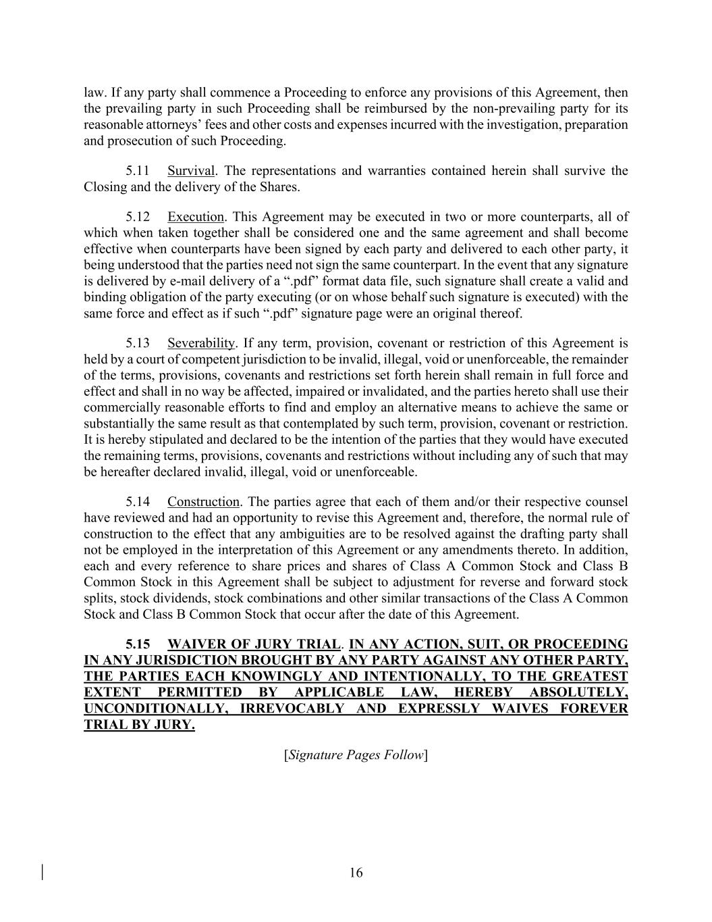
16 law. If any party shall commence a Proceeding to enforce any provisions of this Agreement, then the prevailing party in such Proceeding shall be reimbursed by the non-prevailing party for its reasonable attorneys’ fees and other costs and expenses incurred with the investigation, preparation and prosecution of such Proceeding. 5.11 Survival. The representations and warranties contained herein shall survive the Closing and the delivery of the Shares. 5.12 Execution. This Agreement may be executed in two or more counterparts, all of which when taken together shall be considered one and the same agreement and shall become effective when counterparts have been signed by each party and delivered to each other party, it being understood that the parties need not sign the same counterpart. In the event that any signature is delivered by e-mail delivery of a “.pdf” format data file, such signature shall create a valid and binding obligation of the party executing (or on whose behalf such signature is executed) with the same force and effect as if such “.pdf” signature page were an original thereof. 5.13 Severability. If any term, provision, covenant or restriction of this Agreement is held by a court of competent jurisdiction to be invalid, illegal, void or unenforceable, the remainder of the terms, provisions, covenants and restrictions set forth herein shall remain in full force and effect and shall in no way be affected, impaired or invalidated, and the parties hereto shall use their commercially reasonable efforts to find and employ an alternative means to achieve the same or substantially the same result as that contemplated by such term, provision, covenant or restriction. It is hereby stipulated and declared to be the intention of the parties that they would have executed the remaining terms, provisions, covenants and restrictions without including any of such that may be hereafter declared invalid, illegal, void or unenforceable. 5.14 Construction. The parties agree that each of them and/or their respective counsel have reviewed and had an opportunity to revise this Agreement and, therefore, the normal rule of construction to the effect that any ambiguities are to be resolved against the drafting party shall not be employed in the interpretation of this Agreement or any amendments thereto. In addition, each and every reference to share prices and shares of Class A Common Stock and Class B Common Stock in this Agreement shall be subject to adjustment for reverse and forward stock splits, stock dividends, stock combinations and other similar transactions of the Class A Common Stock and Class B Common Stock that occur after the date of this Agreement. 5.15 WAIVER OF JURY TRIAL. IN ANY ACTION, SUIT, OR PROCEEDING IN ANY JURISDICTION BROUGHT BY ANY PARTY AGAINST ANY OTHER PARTY, THE PARTIES EACH KNOWINGLY AND INTENTIONALLY, TO THE GREATEST EXTENT PERMITTED BY APPLICABLE LAW, HEREBY ABSOLUTELY, UNCONDITIONALLY, IRREVOCABLY AND EXPRESSLY WAIVES FOREVER TRIAL BY JURY. [Signature Pages Follow]

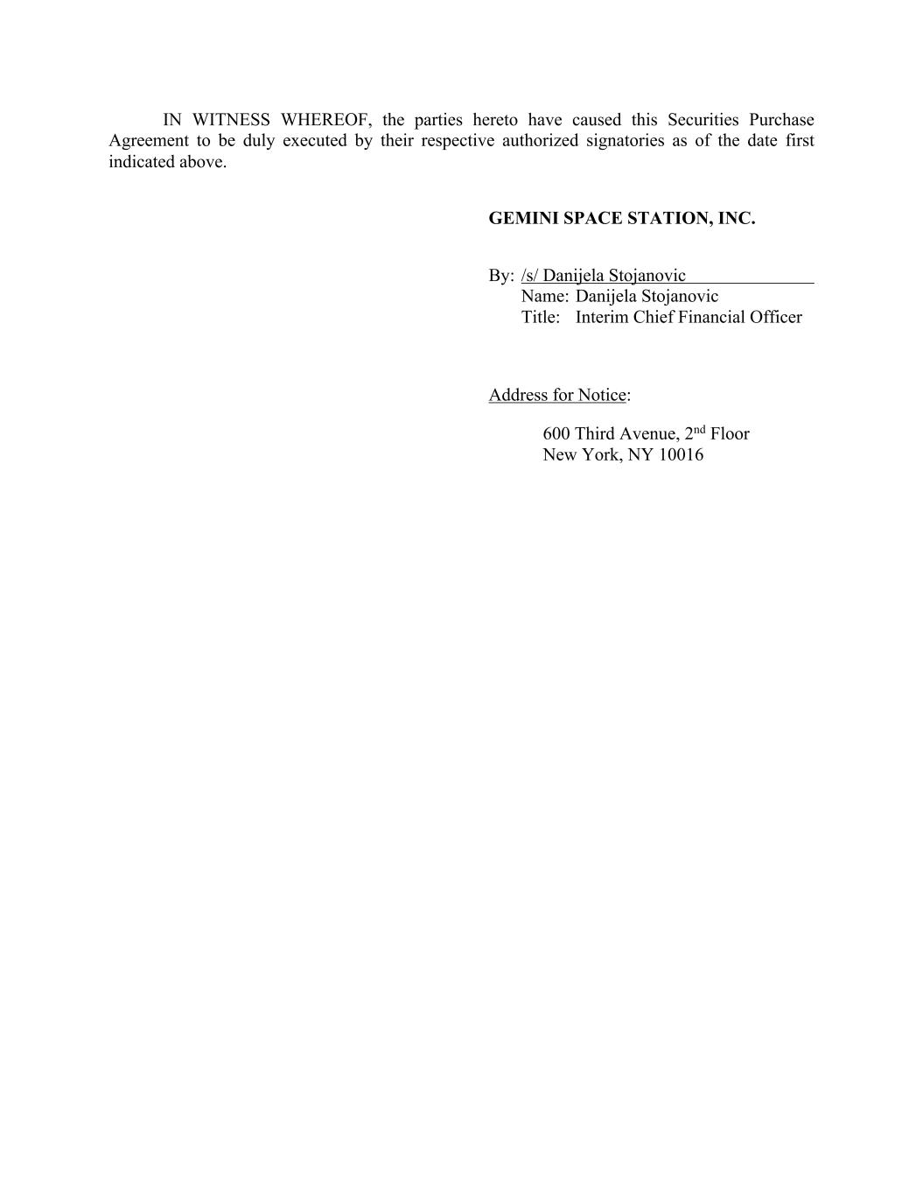
IN WITNESS WHEREOF, the parties hereto have caused this Securities Purchase Agreement to be duly executed by their respective authorized signatories as of the date first indicated above. GEMINI SPACE STATION, INC. By: /s/ Danijela Stojanovic Name: Danijela Stojanovic Title: Interim Chief Financial Officer Address for Notice: 600 Third Avenue, 2nd Floor New York, NY 10016

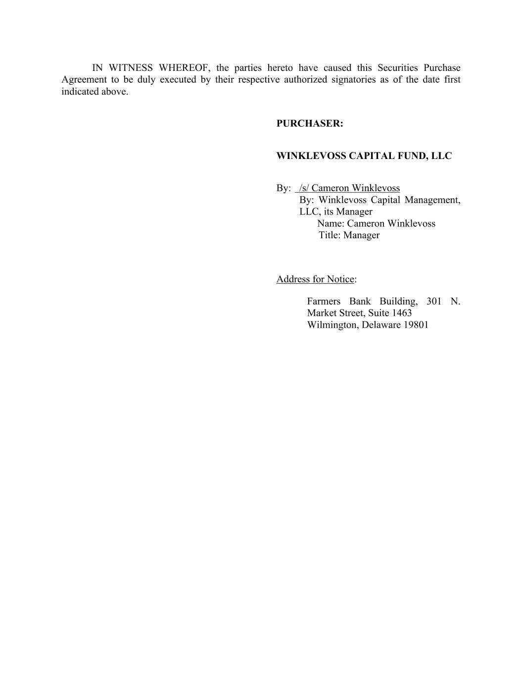
IN WITNESS WHEREOF, the parties hereto have caused this Securities Purchase Agreement to be duly executed by their respective authorized signatories as of the date first indicated above. PURCHASER: WINKLEVOSS CAPITAL FUND, LLC By: /s/ Cameron Winklevoss By: Winklevoss Capital Management, LLC, its Manager Name: Cameron Winklevoss Title: Manager Address for Notice: Farmers Bank Building, 301 N. Market Street, Suite 1463 Wilmington, Delaware 19801

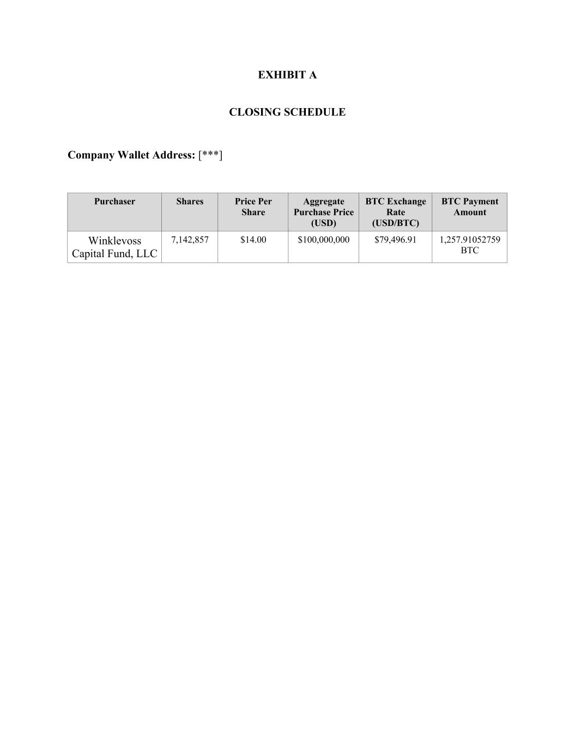
EXHIBIT A CLOSING SCHEDULE Company Wallet Address: [***] Purchaser Shares Price Per Share Aggregate Purchase Price (USD) BTC Exchange Rate (USD/BTC) BTC Payment Amount Winklevoss Capital Fund, LLC 7,142,857 $14.00 $100,000,000 $79,496.91 1,257.91052759 BTC

AMENDMENT NO. 1 TO REGISTRATION RIGHTS AGREEMENT
May 14, 2026
RECITALS
Parties
herein.

meanings ascribed to such terms in the Registration Rights Agreement unless otherwise defined

Company and the Holders party thereto. All capitalized terms used in this Amendment have the

”), by and among, the
Registration Rights Agreement
Agreement, dated September 12, 2025 (the “

”) and amends that certain Registration Rights
This Amendment No. 1 (the “
” and, together with WCF, the “
Company
“

”) and Gemini Space Station, Inc., a Nevada corporation (the
WCF
Winklevoss Capital Fund, LLC (“

”), dated May 14, 2026, is made by and between
Amendment
WHEREAS, WCF and the Company are parties to the Registration Rights Agreement;
WHEREAS, WCF holds more than 50% of Registrable Securities outstanding as of the date
hereof; and
2
removed; (c) such securities shall have been transferred in a transaction in which the

shares of Common Stock, or any stock dividend or stock distribution in respect of such shares

of Common Stock; provided, however, such securities shall cease to be Registrable Securities

on the earliest to occur of (a) a Registration Statement with respect to the sale of such

securities shall have become effective under the Securities Act and such securities shall have

been disposed of in accordance with such Registration Statement; (b) such securities shall

have been sold in accordance with Rule 144 and the restrictive legend shall have been

reclassification, recapitalization, stock split or combination, exchange or readjustment of such

transferor’s rights under this Agreement are not assigned to the transferee of the securities in

accordance with the terms hereof; (d) such securities shall have been otherwise transferred,

new certificates or book entry credits for such securities not bearing a legend restricting

further transfer shall have been delivered by PubCo and subsequent public distribution of

such securities shall not require registration under the Securities Act; or (e) such securities

have ceased to be outstanding.
Section (a)(xvii) of the Registration Rights Agreement is hereby amended and
, in accordance with Section (b)(xviii) of the Registration Rights Agreement, the

Parties wish to amend Sections (a)(xvii) and (b)(i)(2) of the Registration Rights Agreement as set

forth herein.

NOW, THEREFORE
, in consideration of the foregoing recitals and for other good and

valuable consideration, the adequacy and sufficiency of which are hereby acknowledged, the

undersigned hereby agrees as follows:
1.
WHEREAS

restated in its entirety as follows:
(a) “
Registrable Securities
” means any shares of Class A Common Stock (A) owned

by a Holder on the date hereof, (B) issued or issuable upon the conversion of shares of Class

B Common Stock, or (C) acquired by WCF on the date hereof and thereafter, including, in

each case of clauses (A), (B) and (C), any securities acquired as a result of any

[SIGNATURE PAGE TO FOLLOW]
This Amendment shall be governed by, and construed and enforced in accordance

herein, is the entire, final, and complete agreement and understanding of the Parties

This Amendment, together with the other documents and agreements referred to
6.
that would result in the application of the laws of another jurisdiction.

with, the laws of the State of Nevada, without regard to its rules of conflict of laws

hereto relating to the subject matter hereof and supersedes and replaces all prior and
5.
hereto.

force and effect as originally constituted and is ratified and affirmed by the Parties

Except as amended hereby, the Registration Rights Agreement shall continue in full
4.
make, deliver and perform this Agreement.

effective for all purposes.

delivered shall be deemed to have been duly and validly delivered and be valid and

e.g., www.docusign.com) or other transmission method and any counterpart so

pdf or any electronic signature complying with the U.S. federal ESIGN Act of 2000,

agreement. Counterparts may be delivered via facsimile, electronic mail (including
WCF hereby represents and warrants that it has the requisite power and authority to
be deemed an original, but all of which together shall constitute one and the same

This Amendment may be executed in two or more counterparts, each of which shall
7.
among the Parties or their representatives with respect thereto.

contemporaneous agreements and understandings, whether written and oral, by and

Securities then outstanding that PubCo file a Form S-3 registration statement with respect to

Notice to all Holders other than the Initiating Holders; and (ii) as soon as practicable, and in

PubCo shall (i) within ten (10) days after the date such request is given, give a Demand

proceeds, net of Selling Expenses, of at least fifty million US dollars ($50,000,000), then

outstanding Registrable Securities of such Holders having an anticipated aggregate offering

any event within forty-five (45) days after the date such request is given by the Initiating

PubCo receives a request from Holders of at least ten percent (10%) of the Registrable

. If at any time when it is eligible to use a Form S-3 registration statement,
Form S-3 Demand
in its entirety as follows:

Section (b)(i)(2) of the Registration Rights Agreement is hereby amended and restated

3.
also cover any other securities of PubCo and other Holders of PubCo’s securities.

of this Agreement. Such Form S-3 registration statement may
b(iii)
and
paragraphs b(i)(3)

of the date the Demand Notice is given, and in each case, subject to the limitations of
2.
Holders, as specified by notice given by each such Holder to PubCo within twenty (20) days

covering all Registrable Securities requested to be included in such registration by any other

amendment or prospectus supplement to an existing Form S-3 registration statement)

Holders, file a Form S-3 registration statement under the Securities Act (or a post-effective

3

IN WITNESS WHEREOF, the signatories hereto have caused this waiver to be
duly executed by their respective authorized officers as of the day and year first above written.
GEMINI SPACE STATION, INC.
[Signature page to Amendment No. 1 to Registration Rights Agreement]
4
Registration Rights Agreement Parties:
[Signature page to Amendment No. 1 to Registration Rights Agreement]
By:
Name:
Title:

Name of Shareholder:
WINKLEVOSS CAPITAL
FUND, LLC
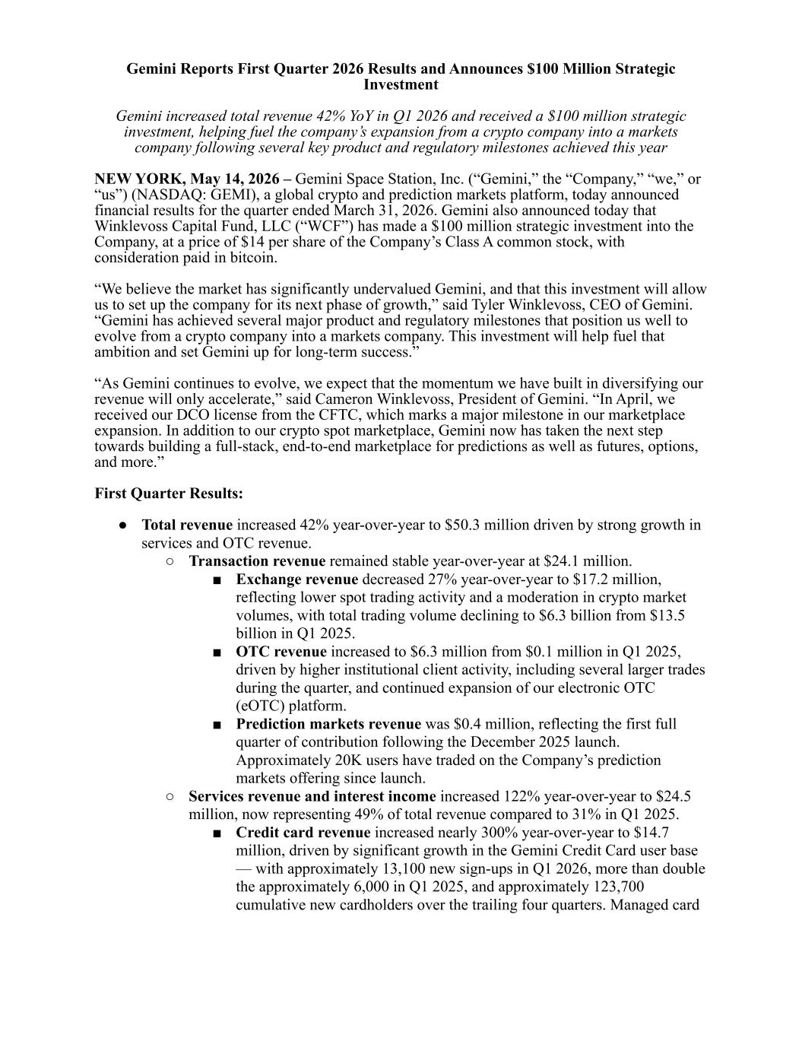
Gemini Reports First Quarter 2026 Results and Announces $100 Million Strategic Investment Gemini increased total revenue 42% YoY in Q1 2026 and received a $100 million strategic investment, helping fuel the company’s expansion from a crypto company into a markets company following several key product and regulatory milestones achieved this year NEW YORK, May 14, 2026 – Gemini Space Station, Inc. (“Gemini,” the “Company,” “we,” or “us”) (NASDAQ: GEMI), a global crypto and prediction markets platform, today announced financial results for the quarter ended March 31, 2026. Gemini also announced today that Winklevoss Capital Fund, LLC (“WCF”) has made a $100 million strategic investment into the Company, at a price of $14 per share of the Company’s Class A common stock, with consideration paid in bitcoin. “We believe the market has significantly undervalued Gemini, and that this investment will allow us to set up the company for its next phase of growth,” said Tyler Winklevoss, CEO of Gemini. “Gemini has achieved several major product and regulatory milestones that position us well to evolve from a crypto company into a markets company. This investment will help fuel that ambition and set Gemini up for long-term success.” “As Gemini continues to evolve, we expect that the momentum we have built in diversifying our revenue will only accelerate,” said Cameron Winklevoss, President of Gemini. “In April, we received our DCO license from the CFTC, which marks a major milestone in our marketplace expansion. In addition to our crypto spot marketplace, Gemini now has taken the next step towards building a full-stack, end-to-end marketplace for predictions as well as futures, options, and more.” First Quarter Results: ● Total revenue increased 42% year-over-year to $50.3 million driven by strong growth in services and OTC revenue. ○ Transaction revenue remained stable year-over-year at $24.1 million. ■ Exchange revenue decreased 27% year-over-year to $17.2 million, reflecting lower spot trading activity and a moderation in crypto market volumes, with total trading volume declining to $6.3 billion from $13.5 billion in Q1 2025. ■ OTC revenue increased to $6.3 million from $0.1 million in Q1 2025, driven by higher institutional client activity, including several larger trades during the quarter, and continued expansion of our electronic OTC (eOTC) platform. ■ Prediction markets revenue was $0.4 million, reflecting the first full quarter of contribution following the December 2025 launch. Approximately 20K users have traded on the Company’s prediction markets offering since launch. ○ Services revenue and interest income increased 122% year-over-year to $24.5 million, now representing 49% of total revenue compared to 31% in Q1 2025. ■ Credit card revenue increased nearly 300% year-over-year to $14.7 million, driven by significant growth in the Gemini Credit Card user base — with approximately 13,100 new sign-ups in Q1 2026, more than double the approximately 6,000 in Q1 2025, and approximately 123,700 cumulative new cardholders over the trailing four quarters. Managed card

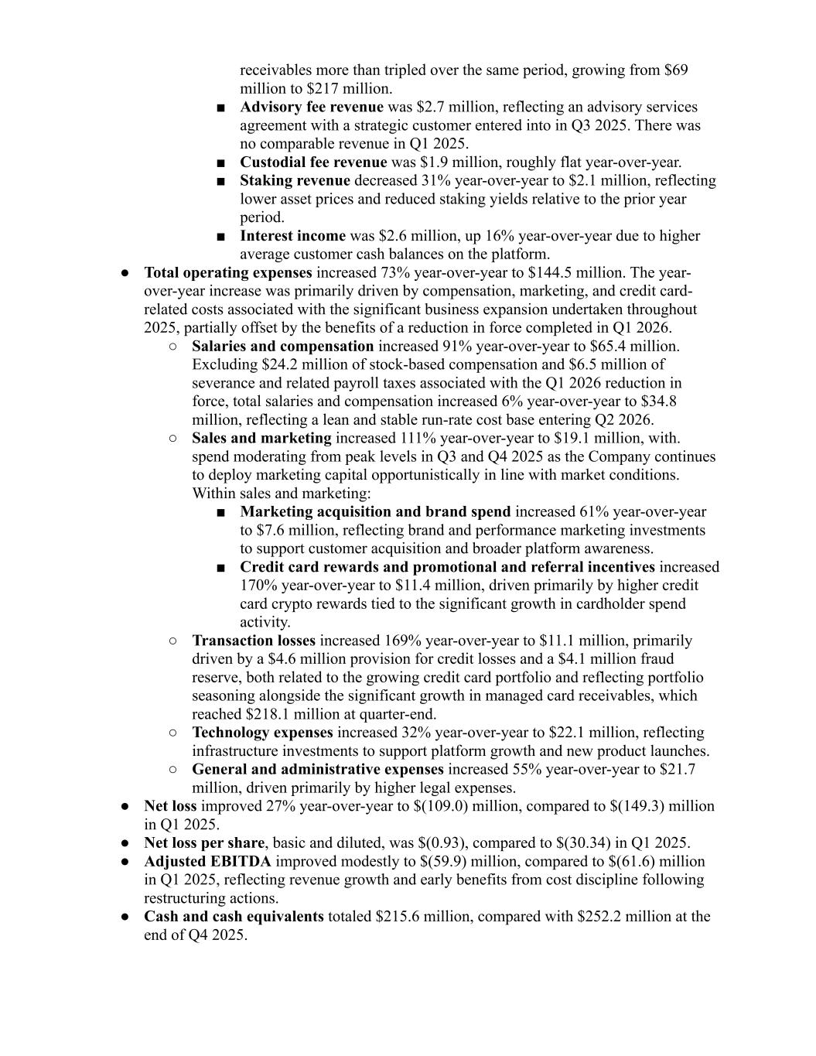
receivables more than tripled over the same period, growing from $69 million to $217 million. ■ Advisory fee revenue was $2.7 million, reflecting an advisory services agreement with a strategic customer entered into in Q3 2025. There was no comparable revenue in Q1 2025. ■ Custodial fee revenue was $1.9 million, roughly flat year-over-year. ■ Staking revenue decreased 31% year-over-year to $2.1 million, reflecting lower asset prices and reduced staking yields relative to the prior year period. ■ Interest income was $2.6 million, up 16% year-over-year due to higher average customer cash balances on the platform. ● Total operating expenses increased 73% year-over-year to $144.5 million. The year- over-year increase was primarily driven by compensation, marketing, and credit card- related costs associated with the significant business expansion undertaken throughout 2025, partially offset by the benefits of a reduction in force completed in Q1 2026. ○ Salaries and compensation increased 91% year-over-year to $65.4 million. Excluding $24.2 million of stock-based compensation and $6.5 million of severance and related payroll taxes associated with the Q1 2026 reduction in force, total salaries and compensation increased 6% year-over-year to $34.8 million, reflecting a lean and stable run-rate cost base entering Q2 2026. ○ Sales and marketing increased 111% year-over-year to $19.1 million, with. spend moderating from peak levels in Q3 and Q4 2025 as the Company continues to deploy marketing capital opportunistically in line with market conditions. Within sales and marketing: ■ Marketing acquisition and brand spend increased 61% year-over-year to $7.6 million, reflecting brand and performance marketing investments to support customer acquisition and broader platform awareness. ■ Credit card rewards and promotional and referral incentives increased 170% year-over-year to $11.4 million, driven primarily by higher credit card crypto rewards tied to the significant growth in cardholder spend activity. ○ Transaction losses increased 169% year-over-year to $11.1 million, primarily driven by a $4.6 million provision for credit losses and a $4.1 million fraud reserve, both related to the growing credit card portfolio and reflecting portfolio seasoning alongside the significant growth in managed card receivables, which reached $218.1 million at quarter-end. ○ Technology expenses increased 32% year-over-year to $22.1 million, reflecting infrastructure investments to support platform growth and new product launches. ○ General and administrative expenses increased 55% year-over-year to $21.7 million, driven primarily by higher legal expenses. ● Net loss improved 27% year-over-year to $(109.0) million, compared to $(149.3) million in Q1 2025. ● Net loss per share, basic and diluted, was $(0.93), compared to $(30.34) in Q1 2025. ● Adjusted EBITDA improved modestly to $(59.9) million, compared to $(61.6) million in Q1 2025, reflecting revenue growth and early benefits from cost discipline following restructuring actions. ● Cash and cash equivalents totaled $215.6 million, compared with $252.2 million at the end of Q4 2025.

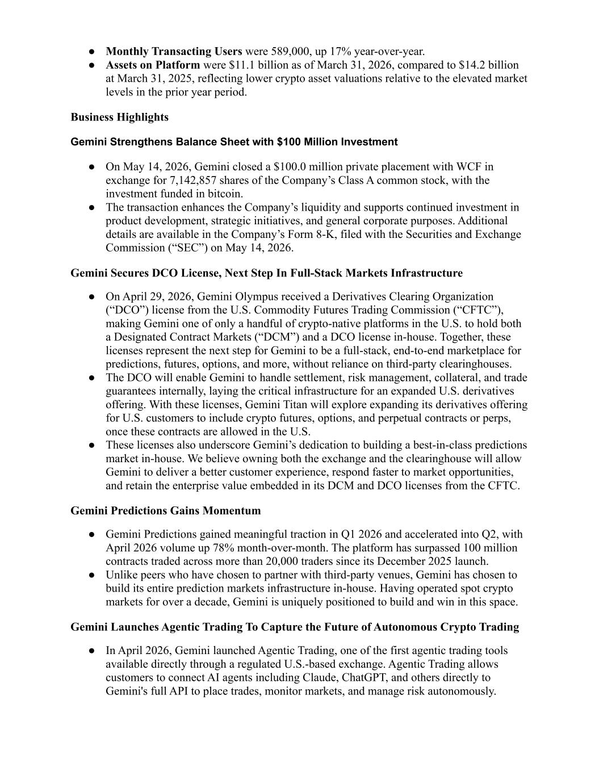
● Monthly Transacting Users were 589,000, up 17% year-over-year. ● Assets on Platform were $11.1 billion as of March 31, 2026, compared to $14.2 billion at March 31, 2025, reflecting lower crypto asset valuations relative to the elevated market levels in the prior year period. Business Highlights Gemini Strengthens Balance Sheet with $100 Million Investment ● On May 14, 2026, Gemini closed a $100.0 million private placement with WCF in exchange for 7,142,857 shares of the Company’s Class A common stock, with the investment funded in bitcoin. ● The transaction enhances the Company’s liquidity and supports continued investment in product development, strategic initiatives, and general corporate purposes. Additional details are available in the Company’s Form 8-K, filed with the Securities and Exchange Commission (“SEC”) on May 14, 2026. Gemini Secures DCO License, Next Step In Full-Stack Markets Infrastructure ● On April 29, 2026, Gemini Olympus received a Derivatives Clearing Organization (“DCO”) license from the U.S. Commodity Futures Trading Commission (“CFTC”), making Gemini one of only a handful of crypto-native platforms in the U.S. to hold both a Designated Contract Markets (“DCM”) and a DCO license in-house. Together, these licenses represent the next step for Gemini to be a full-stack, end-to-end marketplace for predictions, futures, options, and more, without reliance on third-party clearinghouses. ● The DCO will enable Gemini to handle settlement, risk management, collateral, and trade guarantees internally, laying the critical infrastructure for an expanded U.S. derivatives offering. With these licenses, Gemini Titan will explore expanding its derivatives offering for U.S. customers to include crypto futures, options, and perpetual contracts or perps, once these contracts are allowed in the U.S. ● These licenses also underscore Gemini’s dedication to building a best-in-class predictions market in-house. We believe owning both the exchange and the clearinghouse will allow Gemini to deliver a better customer experience, respond faster to market opportunities, and retain the enterprise value embedded in its DCM and DCO licenses from the CFTC. Gemini Predictions Gains Momentum ● Gemini Predictions gained meaningful traction in Q1 2026 and accelerated into Q2, with April 2026 volume up 78% month-over-month. The platform has surpassed 100 million contracts traded across more than 20,000 traders since its December 2025 launch. ● Unlike peers who have chosen to partner with third-party venues, Gemini has chosen to build its entire prediction markets infrastructure in-house. Having operated spot crypto markets for over a decade, Gemini is uniquely positioned to build and win in this space. Gemini Launches Agentic Trading To Capture the Future of Autonomous Crypto Trading ● In April 2026, Gemini launched Agentic Trading, one of the first agentic trading tools available directly through a regulated U.S.-based exchange. Agentic Trading allows customers to connect AI agents including Claude, ChatGPT, and others directly to Gemini's full API to place trades, monitor markets, and manage risk autonomously.

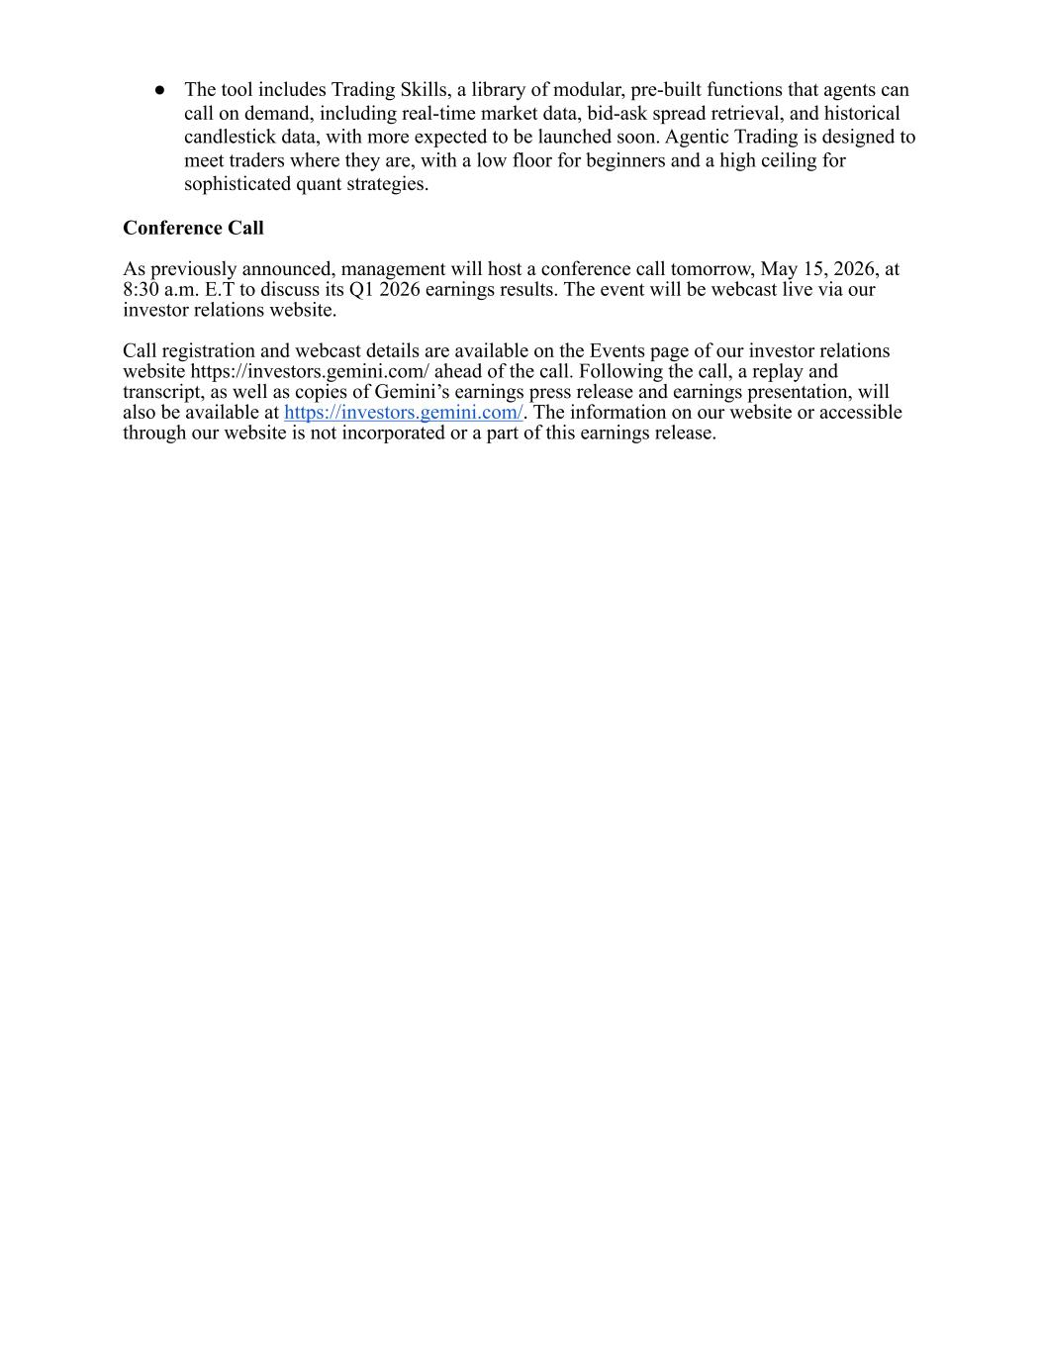
● The tool includes Trading Skills, a library of modular, pre-built functions that agents can call on demand, including real-time market data, bid-ask spread retrieval, and historical candlestick data, with more expected to be launched soon. Agentic Trading is designed to meet traders where they are, with a low floor for beginners and a high ceiling for sophisticated quant strategies. Conference Call As previously announced, management will host a conference call tomorrow, May 15, 2026, at 8:30 a.m. E.T to discuss its Q1 2026 earnings results. The event will be webcast live via our investor relations website. Call registration and webcast details are available on the Events page of our investor relations website https://investors.gemini.com/ ahead of the call. Following the call, a replay and transcript, as well as copies of Gemini’s earnings press release and earnings presentation, will also be available at https://investors.gemini.com/. The information on our website or accessible through our website is not incorporated or a part of this earnings release.

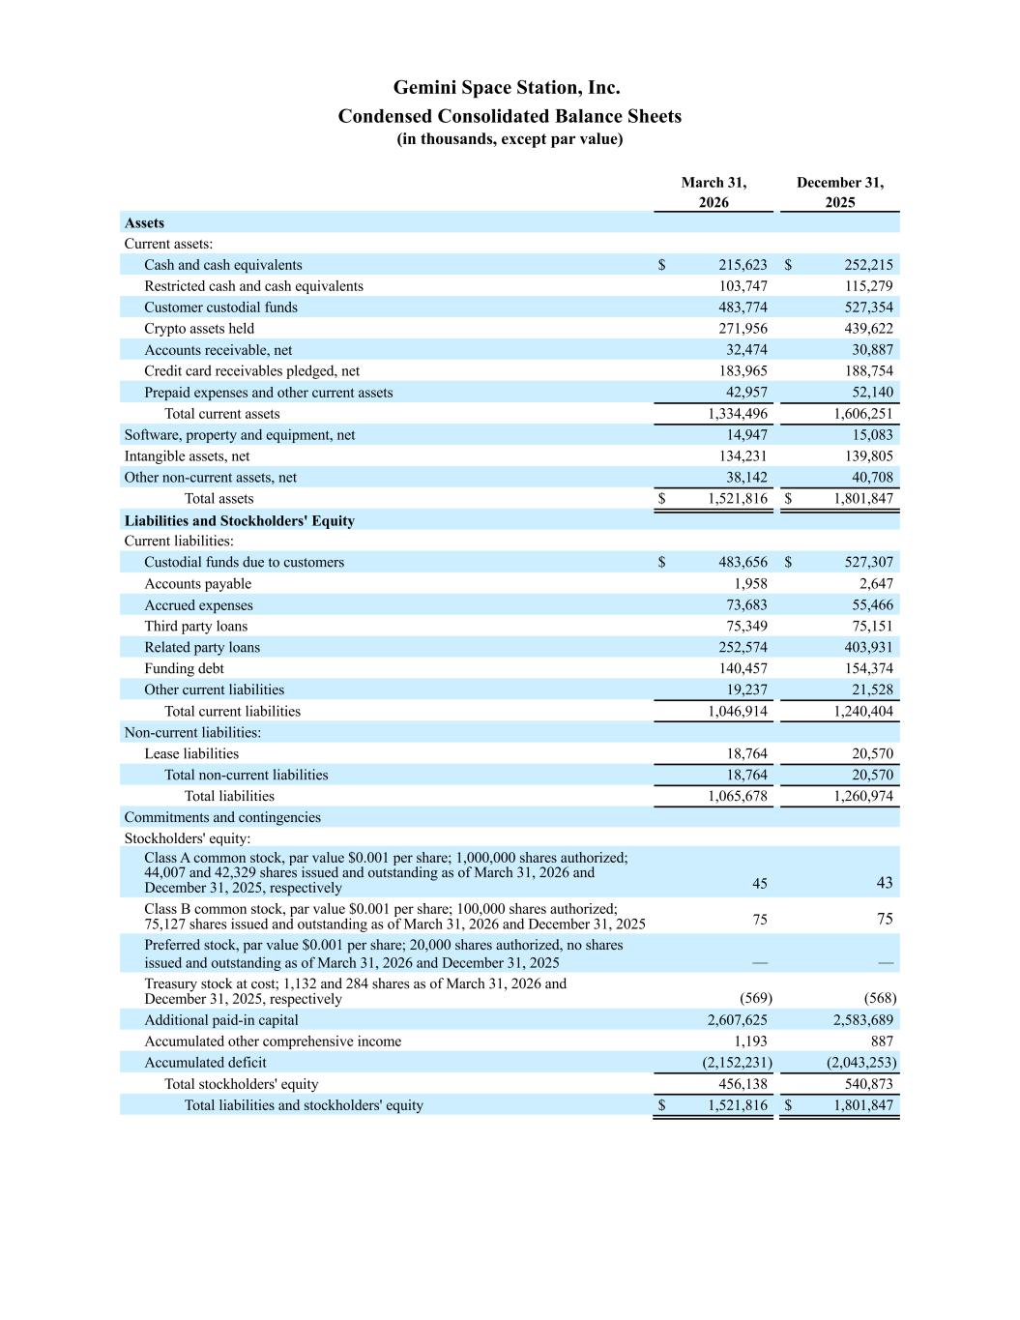
Gemini Space Station, Inc. Condensed Consolidated Balance Sheets (in thousands, except par value) March 31, December 31, 2026 2025 Assets Current assets: Cash and cash equivalents $ 215,623 $ 252,215 Restricted cash and cash equivalents 103,747 115,279 Customer custodial funds 483,774 527,354 Crypto assets held 271,956 439,622 Accounts receivable, net 32,474 30,887 Credit card receivables pledged, net 183,965 188,754 Prepaid expenses and other current assets 42,957 52,140 Total current assets 1,334,496 1,606,251 Software, property and equipment, net 14,947 15,083 Intangible assets, net 134,231 139,805 Other non-current assets, net 38,142 40,708 Total assets $ 1,521,816 $ 1,801,847 Liabilities and Stockholders' Equity Current liabilities: Custodial funds due to customers $ 483,656 $ 527,307 Accounts payable 1,958 2,647 Accrued expenses 73,683 55,466 Third party loans 75,349 75,151 Related party loans 252,574 403,931 Funding debt 140,457 154,374 Other current liabilities 19,237 21,528 Total current liabilities 1,046,914 1,240,404 Non-current liabilities: Lease liabilities 18,764 20,570 Total non-current liabilities 18,764 20,570 Total liabilities 1,065,678 1,260,974 Commitments and contingencies Stockholders' equity: Class A common stock, par value $0.001 per share; 1,000,000 shares authorized; 44,007 and 42,329 shares issued and outstanding as of March 31, 2026 and December 31, 2025, respectively 45 43 Class B common stock, par value $0.001 per share; 100,000 shares authorized; 75,127 shares issued and outstanding as of March 31, 2026 and December 31, 2025 75 75 Preferred stock, par value $0.001 per share; 20,000 shares authorized, no shares issued and outstanding as of March 31, 2026 and December 31, 2025 — — Treasury stock at cost; 1,132 and 284 shares as of March 31, 2026 and December 31, 2025, respectively (569) (568) Additional paid-in capital 2,607,625 2,583,689 Accumulated other comprehensive income 1,193 887 Accumulated deficit (2,152,231) (2,043,253) Total stockholders' equity 456,138 540,873 Total liabilities and stockholders' equity $ 1,521,816 $ 1,801,847

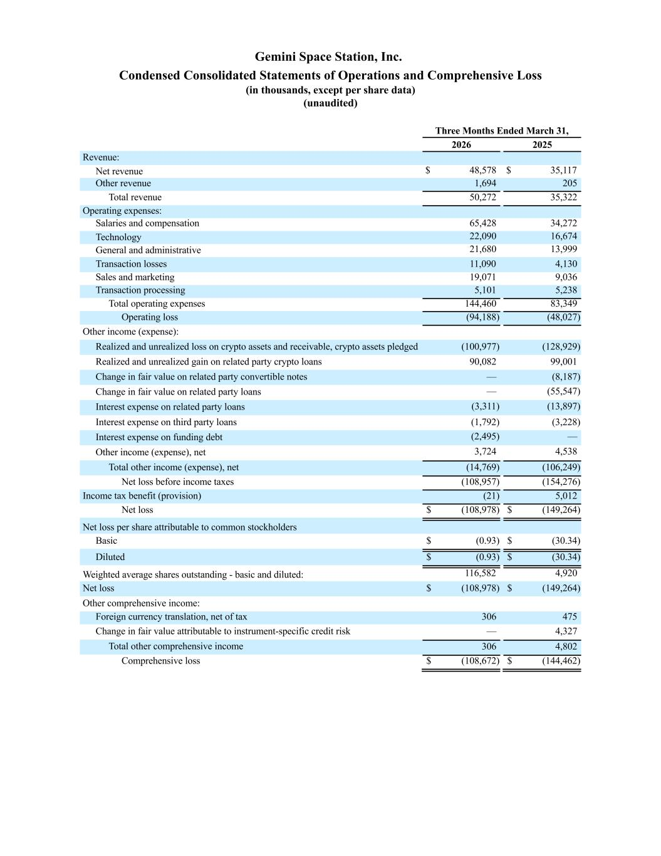
Gemini Space Station, Inc. Condensed Consolidated Statements of Operations and Comprehensive Loss (in thousands, except per share data) (unaudited) Three Months Ended March 31, 2026 2025 Revenue: Net revenue $ 48,578 $ 35,117 Other revenue 1,694 205 Total revenue 50,272 35,322 Operating expenses: Salaries and compensation 65,428 34,272 Technology 22,090 16,674 General and administrative 21,680 13,999 Transaction losses 11,090 4,130 Sales and marketing 19,071 9,036 Transaction processing 5,101 5,238 Total operating expenses 144,460 83,349 Operating loss (94,188) (48,027) Other income (expense): Realized and unrealized loss on crypto assets and receivable, crypto assets pledged (100,977) (128,929) Realized and unrealized gain on related party crypto loans 90,082 99,001 Change in fair value on related party convertible notes — (8,187) Change in fair value on related party loans — (55,547) Interest expense on related party loans (3,311) (13,897) Interest expense on third party loans (1,792) (3,228) Interest expense on funding debt (2,495) — Other income (expense), net 3,724 4,538 Total other income (expense), net (14,769) (106,249) Net loss before income taxes (108,957) (154,276) Income tax benefit (provision) (21) 5,012 Net loss $ (108,978) $ (149,264) Net loss per share attributable to common stockholders Basic $ (0.93) $ (30.34) Diluted $ (0.93) $ (30.34) Weighted average shares outstanding - basic and diluted: 116,582 4,920 Net loss $ (108,978) $ (149,264) Other comprehensive income: Foreign currency translation, net of tax 306 475 Change in fair value attributable to instrument-specific credit risk — 4,327 Total other comprehensive income 306 4,802 Comprehensive loss $ (108,672) $ (144,462)

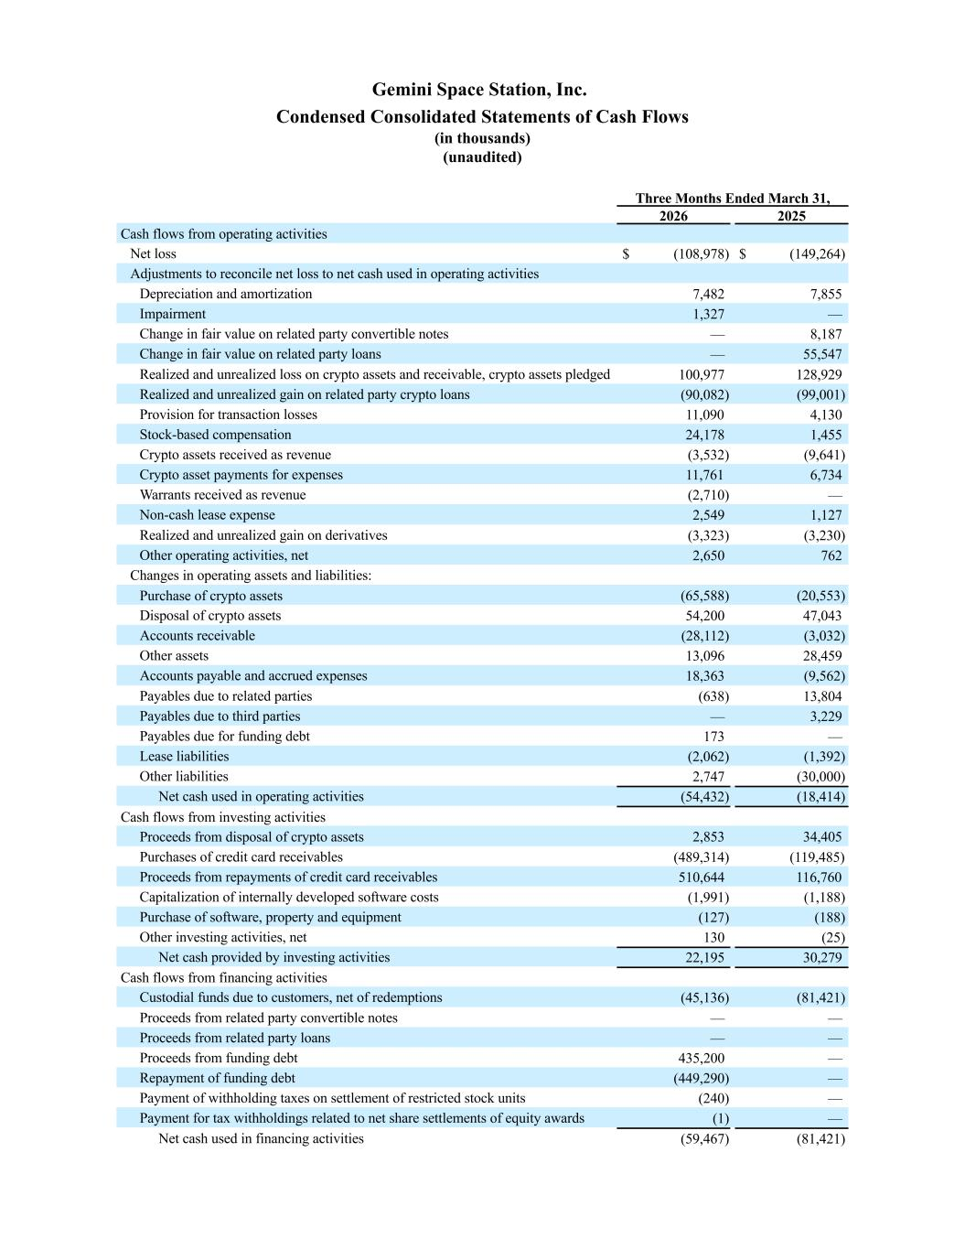
Gemini Space Station, Inc. Condensed Consolidated Statements of Cash Flows (in thousands) (unaudited) Three Months Ended March 31, 2026 2025 Cash flows from operating activities Net loss $ (108,978) $ (149,264) Adjustments to reconcile net loss to net cash used in operating activities Depreciation and amortization 7,482 7,855 Impairment 1,327 — Change in fair value on related party convertible notes — 8,187 Change in fair value on related party loans — 55,547 Realized and unrealized loss on crypto assets and receivable, crypto assets pledged 100,977 128,929 Realized and unrealized gain on related party crypto loans (90,082) (99,001) Provision for transaction losses 11,090 4,130 Stock-based compensation 24,178 1,455 Crypto assets received as revenue (3,532) (9,641) Crypto asset payments for expenses 11,761 6,734 Warrants received as revenue (2,710) — Non-cash lease expense 2,549 1,127 Realized and unrealized gain on derivatives (3,323) (3,230) Other operating activities, net 2,650 762 Changes in operating assets and liabilities: Purchase of crypto assets (65,588) (20,553) Disposal of crypto assets 54,200 47,043 Accounts receivable (28,112) (3,032) Other assets 13,096 28,459 Accounts payable and accrued expenses 18,363 (9,562) Payables due to related parties (638) 13,804 Payables due to third parties — 3,229 Payables due for funding debt 173 — Lease liabilities (2,062) (1,392) Other liabilities 2,747 (30,000) Net cash used in operating activities (54,432) (18,414) Cash flows from investing activities Proceeds from disposal of crypto assets 2,853 34,405 Purchases of credit card receivables (489,314) (119,485) Proceeds from repayments of credit card receivables 510,644 116,760 Capitalization of internally developed software costs (1,991) (1,188) Purchase of software, property and equipment (127) (188) Other investing activities, net 130 (25) Net cash provided by investing activities 22,195 30,279 Cash flows from financing activities Custodial funds due to customers, net of redemptions (45,136) (81,421) Proceeds from related party convertible notes — — Proceeds from related party loans — — Proceeds from funding debt 435,200 — Repayment of funding debt (449,290) — Payment of withholding taxes on settlement of restricted stock units (240) — Payment for tax withholdings related to net share settlements of equity awards (1) — Net cash used in financing activities (59,467) (81,421)

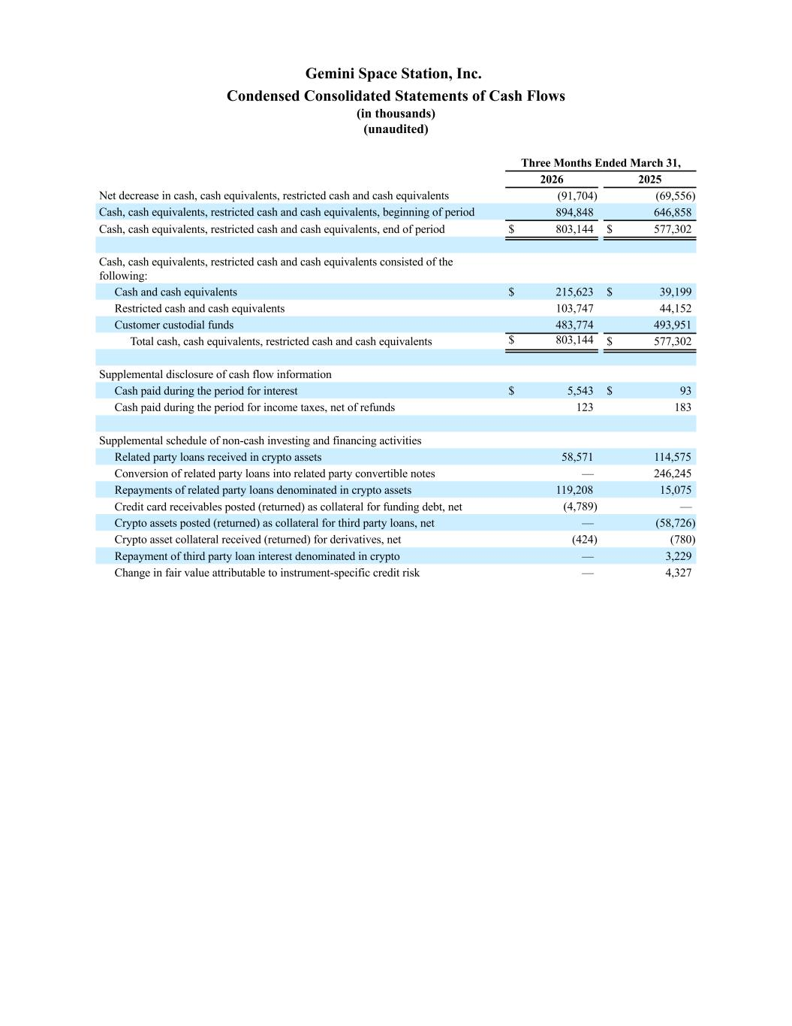
Gemini Space Station, Inc. Condensed Consolidated Statements of Cash Flows (in thousands) (unaudited) Three Months Ended March 31, 2026 2025 Net decrease in cash, cash equivalents, restricted cash and cash equivalents (91,704) (69,556) Cash, cash equivalents, restricted cash and cash equivalents, beginning of period 894,848 646,858 Cash, cash equivalents, restricted cash and cash equivalents, end of period $ 803,144 $ 577,302 Cash, cash equivalents, restricted cash and cash equivalents consisted of the following: Cash and cash equivalents $ 215,623 $ 39,199 Restricted cash and cash equivalents 103,747 44,152 Customer custodial funds 483,774 493,951 Total cash, cash equivalents, restricted cash and cash equivalents $ 803,144 $ 577,302 Supplemental disclosure of cash flow information Cash paid during the period for interest $ 5,543 $ 93 Cash paid during the period for income taxes, net of refunds 123 183 Supplemental schedule of non-cash investing and financing activities Related party loans received in crypto assets 58,571 114,575 Conversion of related party loans into related party convertible notes — 246,245 Repayments of related party loans denominated in crypto assets 119,208 15,075 Credit card receivables posted (returned) as collateral for funding debt, net (4,789) — Crypto assets posted (returned) as collateral for third party loans, net — (58,726) Crypto asset collateral received (returned) for derivatives, net (424) (780) Repayment of third party loan interest denominated in crypto — 3,229 Change in fair value attributable to instrument-specific credit risk — 4,327

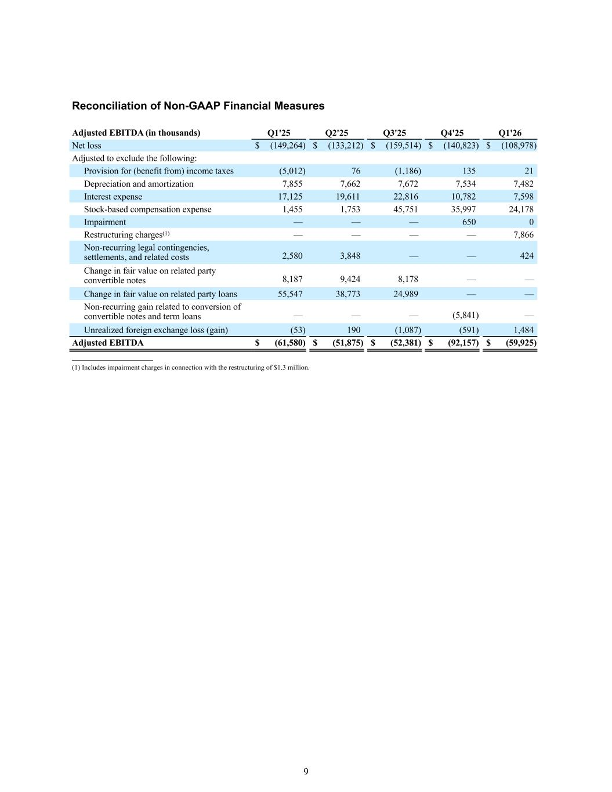
9 Reconciliation of Non-GAAP Financial Measures Adjusted EBITDA (in thousands) Q1'25 Q2'25 Q3'25 Q4'25 Q1'26 Net loss $ (149,264) $ (133,212) $ (159,514) $ (140,823) $ (108,978) Adjusted to exclude the following: Provision for (benefit from) income taxes (5,012) 76 (1,186) 135 21 Depreciation and amortization 7,855 7,662 7,672 7,534 7,482 Interest expense 17,125 19,611 22,816 10,782 7,598 Stock-based compensation expense 1,455 1,753 45,751 35,997 24,178 Impairment — — — 650 0 Restructuring charges(1) — — — — 7,866 Non-recurring legal contingencies, settlements, and related costs 2,580 3,848 — — 424 Change in fair value on related party convertible notes 8,187 9,424 8,178 — — Change in fair value on related party loans 55,547 38,773 24,989 — — Non-recurring gain related to conversion of convertible notes and term loans — — — (5,841) — Unrealized foreign exchange loss (gain) (53) 190 (1,087) (591) 1,484 Adjusted EBITDA $ (61,580) $ (51,875) $ (52,381) $ (92,157) $ (59,925) __________________ (1) Includes impairment charges in connection with the restructuring of $1.3 million.

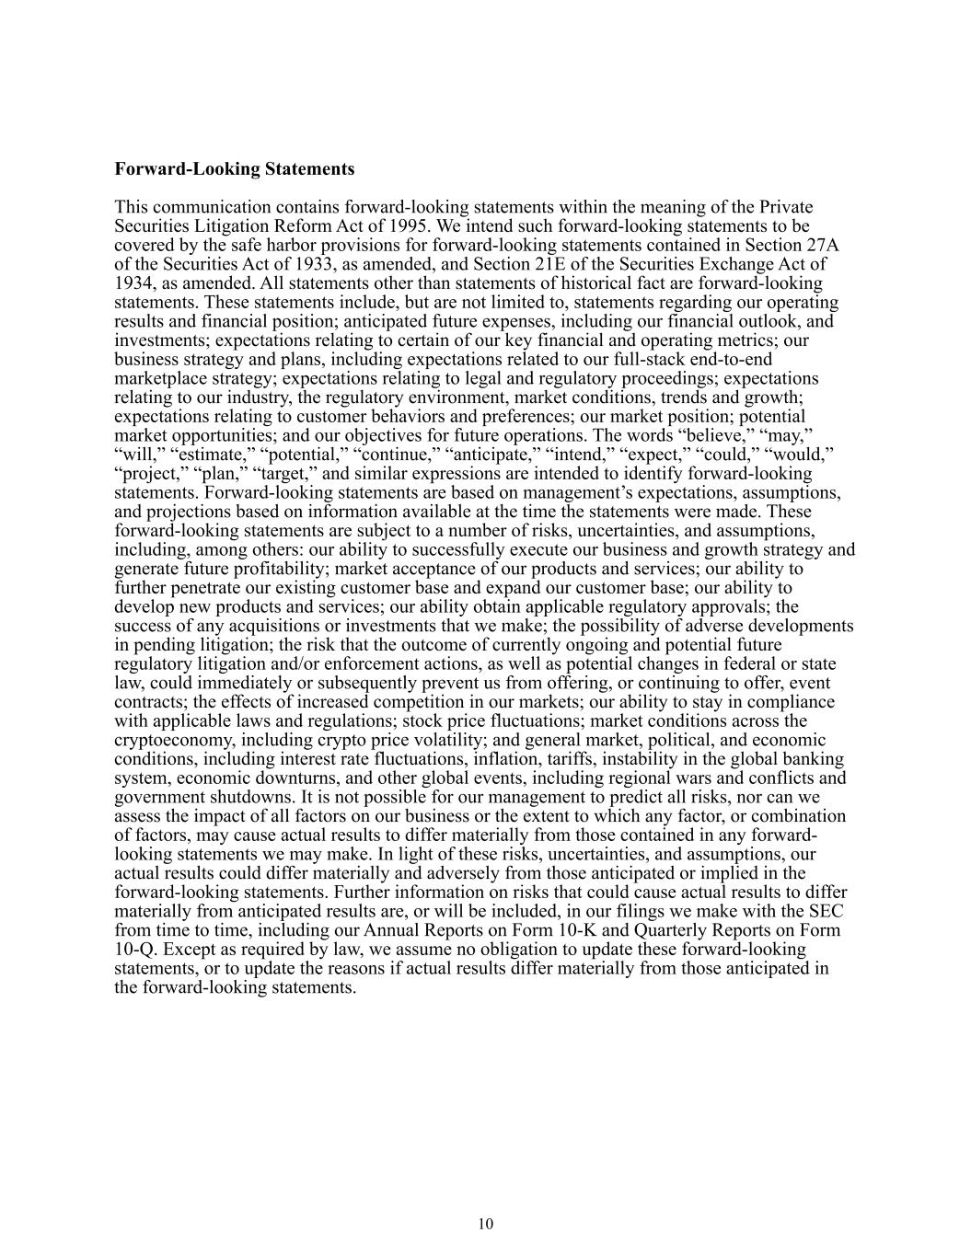
10 Forward-Looking Statements This communication contains forward-looking statements within the meaning of the Private Securities Litigation Reform Act of 1995. We intend such forward-looking statements to be covered by the safe harbor provisions for forward-looking statements contained in Section 27A of the Securities Act of 1933, as amended, and Section 21E of the Securities Exchange Act of 1934, as amended. All statements other than statements of historical fact are forward-looking statements. These statements include, but are not limited to, statements regarding our operating results and financial position; anticipated future expenses, including our financial outlook, and investments; expectations relating to certain of our key financial and operating metrics; our business strategy and plans, including expectations related to our full-stack end-to-end marketplace strategy; expectations relating to legal and regulatory proceedings; expectations relating to our industry, the regulatory environment, market conditions, trends and growth; expectations relating to customer behaviors and preferences; our market position; potential market opportunities; and our objectives for future operations. The words “believe,” “may,” “will,” “estimate,” “potential,” “continue,” “anticipate,” “intend,” “expect,” “could,” “would,” “project,” “plan,” “target,” and similar expressions are intended to identify forward-looking statements. Forward-looking statements are based on management’s expectations, assumptions, and projections based on information available at the time the statements were made. These forward-looking statements are subject to a number of risks, uncertainties, and assumptions, including, among others: our ability to successfully execute our business and growth strategy and generate future profitability; market acceptance of our products and services; our ability to further penetrate our existing customer base and expand our customer base; our ability to develop new products and services; our ability obtain applicable regulatory approvals; the success of any acquisitions or investments that we make; the possibility of adverse developments in pending litigation; the risk that the outcome of currently ongoing and potential future regulatory litigation and/or enforcement actions, as well as potential changes in federal or state law, could immediately or subsequently prevent us from offering, or continuing to offer, event contracts; the effects of increased competition in our markets; our ability to stay in compliance with applicable laws and regulations; stock price fluctuations; market conditions across the cryptoeconomy, including crypto price volatility; and general market, political, and economic conditions, including interest rate fluctuations, inflation, tariffs, instability in the global banking system, economic downturns, and other global events, including regional wars and conflicts and government shutdowns. It is not possible for our management to predict all risks, nor can we assess the impact of all factors on our business or the extent to which any factor, or combination of factors, may cause actual results to differ materially from those contained in any forward- looking statements we may make. In light of these risks, uncertainties, and assumptions, our actual results could differ materially and adversely from those anticipated or implied in the forward-looking statements. Further information on risks that could cause actual results to differ materially from anticipated results are, or will be included, in our filings we make with the SEC from time to time, including our Annual Reports on Form 10-K and Quarterly Reports on Form 10-Q. Except as required by law, we assume no obligation to update these forward-looking statements, or to update the reasons if actual results differ materially from those anticipated in the forward-looking statements.

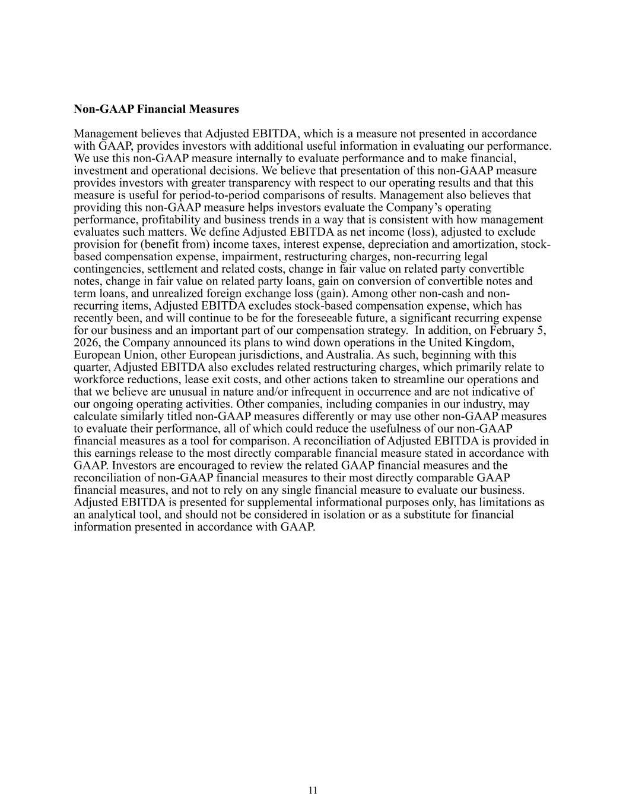
11 Non-GAAP Financial Measures Management believes that Adjusted EBITDA, which is a measure not presented in accordance with GAAP, provides investors with additional useful information in evaluating our performance. We use this non-GAAP measure internally to evaluate performance and to make financial, investment and operational decisions. We believe that presentation of this non-GAAP measure provides investors with greater transparency with respect to our operating results and that this measure is useful for period-to-period comparisons of results. Management also believes that providing this non-GAAP measure helps investors evaluate the Company’s operating performance, profitability and business trends in a way that is consistent with how management evaluates such matters. We define Adjusted EBITDA as net income (loss), adjusted to exclude provision for (benefit from) income taxes, interest expense, depreciation and amortization, stock- based compensation expense, impairment, restructuring charges, non-recurring legal contingencies, settlement and related costs, change in fair value on related party convertible notes, change in fair value on related party loans, gain on conversion of convertible notes and term loans, and unrealized foreign exchange loss (gain). Among other non-cash and non- recurring items, Adjusted EBITDA excludes stock-based compensation expense, which has recently been, and will continue to be for the foreseeable future, a significant recurring expense for our business and an important part of our compensation strategy. In addition, on February 5, 2026, the Company announced its plans to wind down operations in the United Kingdom, European Union, other European jurisdictions, and Australia. As such, beginning with this quarter, Adjusted EBITDA also excludes related restructuring charges, which primarily relate to workforce reductions, lease exit costs, and other actions taken to streamline our operations and that we believe are unusual in nature and/or infrequent in occurrence and are not indicative of our ongoing operating activities. Other companies, including companies in our industry, may calculate similarly titled non-GAAP measures differently or may use other non-GAAP measures to evaluate their performance, all of which could reduce the usefulness of our non-GAAP financial measures as a tool for comparison. A reconciliation of Adjusted EBITDA is provided in this earnings release to the most directly comparable financial measure stated in accordance with GAAP. Investors are encouraged to review the related GAAP financial measures and the reconciliation of non-GAAP financial measures to their most directly comparable GAAP financial measures, and not to rely on any single financial measure to evaluate our business. Adjusted EBITDA is presented for supplemental informational purposes only, has limitations as an analytical tool, and should not be considered in isolation or as a substitute for financial information presented in accordance with GAAP.

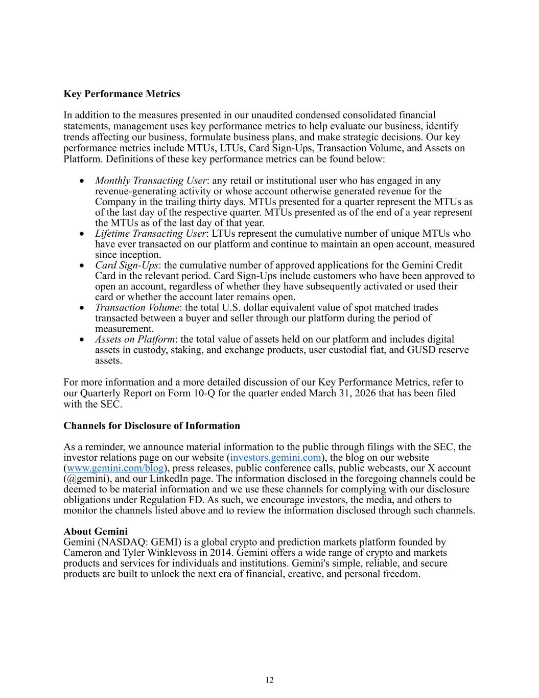
12 Key Performance Metrics In addition to the measures presented in our unaudited condensed consolidated financial statements, management uses key performance metrics to help evaluate our business, identify trends affecting our business, formulate business plans, and make strategic decisions. Our key performance metrics include MTUs, LTUs, Card Sign-Ups, Transaction Volume, and Assets on Platform. Definitions of these key performance metrics can be found below: • Monthly Transacting User: any retail or institutional user who has engaged in any revenue-generating activity or whose account otherwise generated revenue for the Company in the trailing thirty days. MTUs presented for a quarter represent the MTUs as of the last day of the respective quarter. MTUs presented as of the end of a year represent the MTUs as of the last day of that year. • Lifetime Transacting User: LTUs represent the cumulative number of unique MTUs who have ever transacted on our platform and continue to maintain an open account, measured since inception. • Card Sign-Ups: the cumulative number of approved applications for the Gemini Credit Card in the relevant period. Card Sign-Ups include customers who have been approved to open an account, regardless of whether they have subsequently activated or used their card or whether the account later remains open. • Transaction Volume: the total U.S. dollar equivalent value of spot matched trades transacted between a buyer and seller through our platform during the period of measurement. • Assets on Platform: the total value of assets held on our platform and includes digital assets in custody, staking, and exchange products, user custodial fiat, and GUSD reserve assets. For more information and a more detailed discussion of our Key Performance Metrics, refer to our Quarterly Report on Form 10-Q for the quarter ended March 31, 2026 that has been filed with the SEC. Channels for Disclosure of Information As a reminder, we announce material information to the public through filings with the SEC, the investor relations page on our website (investors.gemini.com), the blog on our website (www.gemini.com/blog), press releases, public conference calls, public webcasts, our X account (@gemini), and our LinkedIn page. The information disclosed in the foregoing channels could be deemed to be material information and we use these channels for complying with our disclosure obligations under Regulation FD. As such, we encourage investors, the media, and others to monitor the channels listed above and to review the information disclosed through such channels. About Gemini Gemini (NASDAQ: GEMI) is a global crypto and prediction markets platform founded by Cameron and Tyler Winklevoss in 2014. Gemini offers a wide range of crypto and markets products and services for individuals and institutions. Gemini's simple, reliable, and secure products are built to unlock the next era of financial, creative, and personal freedom.


13 Contact Investors Gemini Investor Relations Email: investors@gemini.com Press Natalie Johnson Email: press@gemini.com


First Quarter 2026 Results May 2026 Earnings Presentation

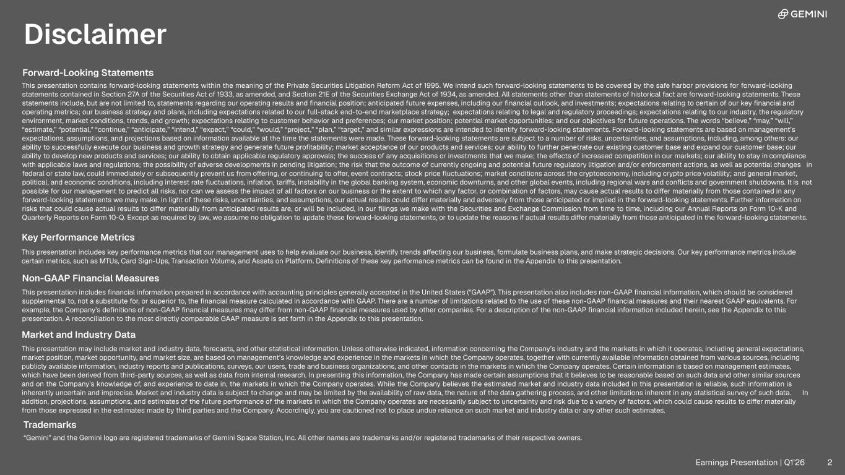
Disclaimer Forward-Looking Statements This presentation contains forward-looking statements within the meaning of the Private Securities Litigation Reform Act of 1995. We intend such forward-looking statements to be covered by the safe harbor provisions for forward-looking statements contained in Section 27A of the Securities Act of 1933, as amended, and Section 21E of the Securities Exchange Act of 1934, as amended. All statements other than statements of historical fact are forward-looking statements. These statements include, but are not limited to, statements regarding our operating results and financial position; anticipated future expenses, including our financial outlook, and investments; expectations relating to certain of our key financial and operating metrics; our business strategy and plans, including expectations related to our full-stack end-to-end marketplace strategy; expectations relating to legal and regulatory proceedings; expectations relating to our industry, the regulatory environment, market conditions, trends, and growth; expectations relating to customer behavior and preferences; our market position; potential market opportunities; and our objectives for future operations. The words “believe,” “may,” “will,” “estimate,” “potential,” “continue,” “anticipate,” “intend,” “expect,” “could,” “would,” “project,” “plan,” “target,” and similar expressions are intended to identify forward-looking statements. Forward-looking statements are based on management’s expectations, assumptions, and projections based on information available at the time the statements were made. These forward-looking statements are subject to a number of risks, uncertainties, and assumptions, including, among others: our ability to successfully execute our business and growth strategy and generate future profitability; market acceptance of our products and services; our ability to further penetrate our existing customer base and expand our customer base; our ability to develop new products and services; our ability to obtain applicable regulatory approvals; the success of any acquisitions or investments that we make; the effects of increased competition in our markets; our ability to stay in compliance with applicable laws and regulations; the possibility of adverse developments in pending litigation; the risk that the outcome of currently ongoing and potential future regulatory litigation and/or enforcement actions, as well as potential changes in federal or state law, could immediately or subsequently prevent us from offering, or continuing to offer, event contracts; stock price fluctuations; market conditions across the cryptoeconomy, including crypto price volatility; and general market, political, and economic conditions, including interest rate fluctuations, inflation, tariffs, instability in the global banking system, economic downturns, and other global events, including regional wars and conflicts and government shutdowns. It is not possible for our management to predict all risks, nor can we assess the impact of all factors on our business or the extent to which any factor, or combination of factors, may cause actual results to differ materially from those contained in any forward-looking statements we may make. In light of these risks, uncertainties, and assumptions, our actual results could differ materially and adversely from those anticipated or implied in the forward-looking statements. Further information on risks that could cause actual results to differ materially from anticipated results are, or will be included, in our filings we make with the Securities and Exchange Commission from time to time, including our Annual Reports on Form 10-K and Quarterly Reports on Form 10-Q. Except as required by law, we assume no obligation to update these forward-looking statements, or to update the reasons if actual results differ materially from those anticipated in the forward-looking statements. Key Performance Metrics This presentation includes key performance metrics that our management uses to help evaluate our business, identify trends affecting our business, formulate business plans, and make strategic decisions. Our key performance metrics include certain metrics, such as MTUs, Card Sign-Ups, Transaction Volume, and Assets on Platform. Definitions of these key performance metrics can be found in the Appendix to this presentation. Market and Industry Data This presentation may include market and industry data, forecasts, and other statistical information. Unless otherwise indicated, information concerning the Company’s industry and the markets in which it operates, including general expectations, market position, market opportunity, and market size, are based on management’s knowledge and experience in the markets in which the Company operates, together with currently available information obtained from various sources, including publicly available information, industry reports and publications, surveys, our users, trade and business organizations, and other contacts in the markets in which the Company operates. Certain information is based on management estimates, which have been derived from third-party sources, as well as data from internal research. In presenting this information, the Company has made certain assumptions that it believes to be reasonable based on such data and other similar sources and on the Company’s knowledge of, and experience to date in, the markets in which the Company operates. While the Company believes the estimated market and industry data included in this presentation is reliable, such information is inherently uncertain and imprecise. Market and industry data is subject to change and may be limited by the availability of raw data, the nature of the data gathering process, and other limitations inherent in any statistical survey of such data. In addition, projections, assumptions, and estimates of the future performance of the markets in which the Company operates are necessarily subject to uncertainty and risk due to a variety of factors, which could cause results to differ materially from those expressed in the estimates made by third parties and the Company. Accordingly, you are cautioned not to place undue reliance on such market and industry data or any other such estimates. Trademarks “Gemini” and the Gemini logo are registered trademarks of Gemini Space Station, Inc. All other names are trademarks and/or registered trademarks of their respective owners. This presentation includes financial information prepared in accordance with accounting principles generally accepted in the United States (“GAAP”). This presentation also includes non-GAAP financial information, which should be considered supplemental to, not a substitute for, or superior to, the financial measure calculated in accordance with GAAP. There are a number of limitations related to the use of these non-GAAP financial measures and their nearest GAAP equivalents. For example, the Company’s definitions of non-GAAP financial measures may differ from non-GAAP financial measures used by other companies. For a description of the non-GAAP financial information included herein, see the Appendix to this presentation. A reconciliation to the most directly comparable GAAP measure is set forth in the Appendix to this presentation. Non-GAAP Financial Measures Earnings Presentation | Q1’26 2

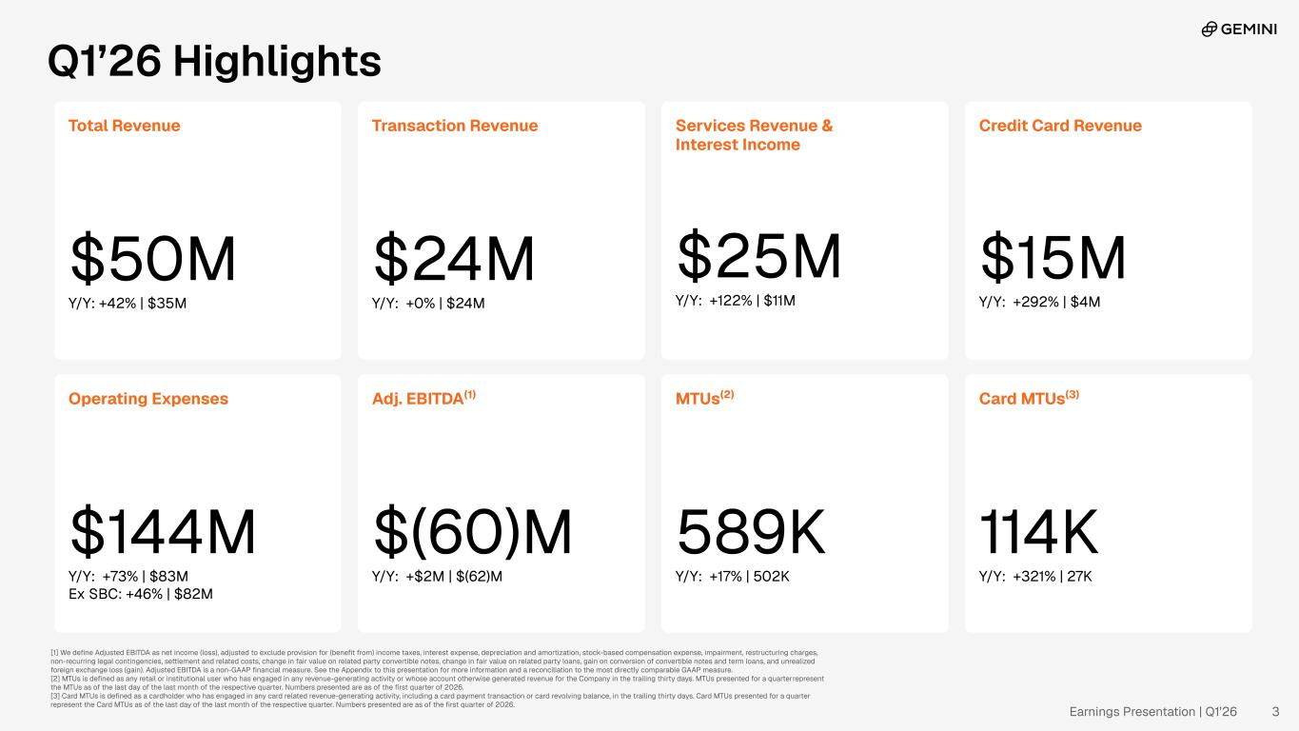
Q1’26 Highlights Total Revenue $50M Y/Y: +42% | $35M Transaction Revenue $24M Y/Y: +0% | $24M Services Revenue & Interest Income $25M Y/Y: +122% | $11M Operating Expenses $144M Y/Y: +73% | $83M Ex SBC: +46% | $82M Adj. EBITDA(1) $(60)M Y/Y: +$2M | $(62)M MTUs(2) 589K Y/Y: +17% | 502K [1] We define Adjusted EBITDA as net income (loss), adjusted to exclude provision for (benefit from) income taxes, interest expense, depreciation and amortization, stock-based compensation expense, impairment, restructuring charges, non-recurring legal contingencies, settlement and related costs, change in fair value on related party convertible notes, change in fair value on related party loans, gain on conversion of convertible notes and term loans, and unrealized foreign exchange loss (gain). Adjusted EBITDA is a non-GAAP financial measure. See the Appendix to this presentation for more information and a reconciliation to the most directly comparable GAAP measure. [2] MTUs is defined as any retail or institutional user who has engaged in any revenue-generating activity or whose account otherwise generated revenue for the Company in the trailing thirty days. MTUs presented for a quarter represent the MTUs as of the last day of the last month of the respective quarter. Numbers presented are as of the first quarter of 2026. [3] Card MTUs is defined as a cardholder who has engaged in any card related revenue-generating activity, including a card payment transaction or card revolving balance, in the trailing thirty days. Card MTUs presented for a quarter represent the Card MTUs as of the last day of the last month of the respective quarter. Numbers presented are as of the first quarter of 2026. Credit Card Revenue $15M Y/Y: +292% | $4M Card MTUs(3) 114K Y/Y: +321% | 27K Earnings Presentation | Q1’26 3

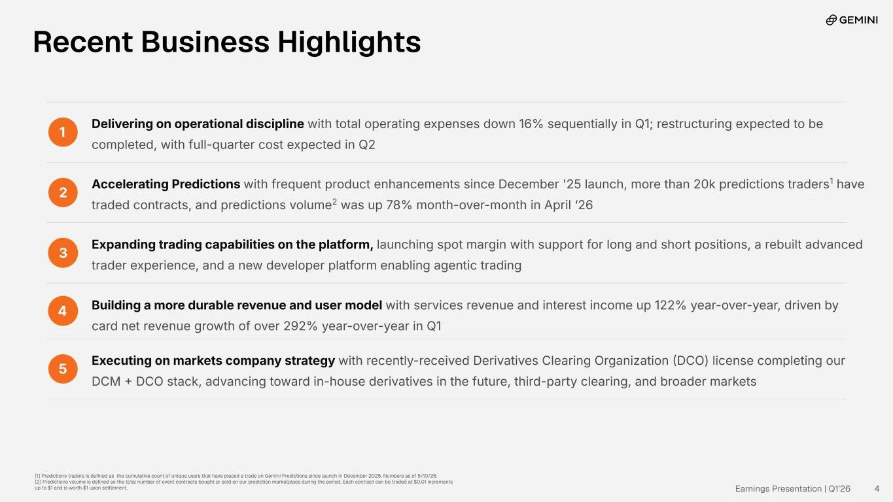
1 Delivering on operational discipline with total operating expenses down 16% sequentially in Q1; restructuring expected to be completed, with full-quarter cost expected in Q2 2 Accelerating Predictions with frequent product enhancements since December '25 launch, more than 20k predictions traders1 have traded contracts, and predictions volume2 was up 78% month-over-month in April ‘26 3 Expanding trading capabilities on the platform, launching spot margin with support for long and short positions, a rebuilt advanced trader experience, and a new developer platform enabling agentic trading 4 Building a more durable revenue and user model with services revenue and interest income up 122% year-over-year, driven by card net revenue growth of over 292% year-over-year in Q1 5 Executing on markets company strategy with recently-received Derivatives Clearing Organization DCO) license completing our DCM  DCO stack, advancing toward in-house derivatives in the future, third-party clearing, and broader markets Recent Business Highlights [1] Predictions traders is defined as the cumulative count of unique users that have placed a trade on Gemini Predictions since launch in December 2025. Numbers as of 5/10/26. [2] Predictions volume is defined as the total number of event contracts bought or sold on our prediction marketplace during the period. Each contract can be traded at $0.01 increments up to $1 and is worth $1 upon settlement. Earnings Presentation | Q1’26 4

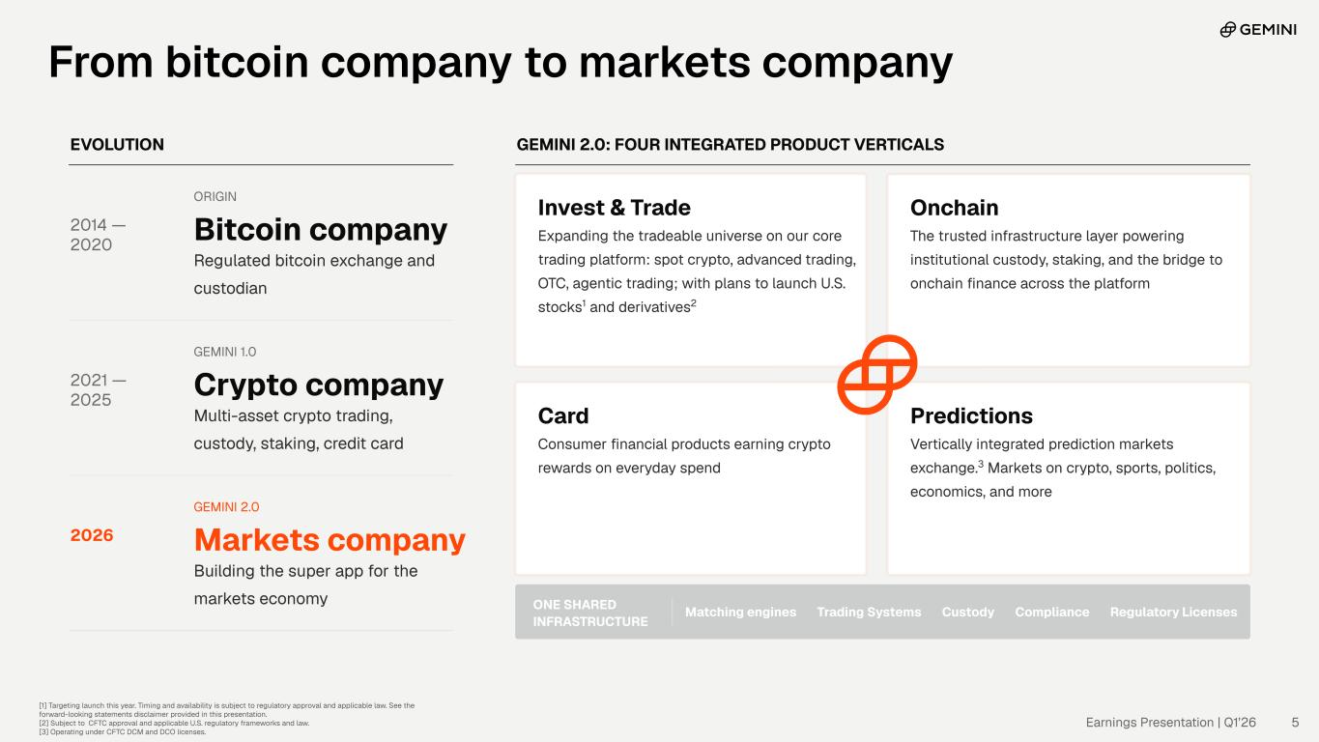
EVOLUTION 2014 — 2020 ORIGIN Bitcoin company Regulated bitcoin exchange and custodian 2021 — 2025 GEMINI 1.0 Crypto company Multi-asset crypto trading, custody, staking, credit card 2026 GEMINI 2.0 Markets company Building the super app for the markets economy GEMINI 2.0: FOUR INTEGRATED PRODUCT VERTICALS Invest & Trade Expanding the tradeable universe on our core trading platform: spot crypto, advanced trading, OTC, agentic trading; with plans to launch U.S. stocks1 and derivatives2 Onchain The trusted infrastructure layer powering institutional custody, staking, and the bridge to onchain finance across the platform Card Consumer financial products earning crypto rewards on everyday spend Predictions Vertically integrated prediction markets exchange.3 Markets on crypto, sports, politics, economics, and more ONE SHARED INFRASTRUCTURE Matching engines Trading Systems Custody Compliance Regulatory Licenses [1] Targeting launch this year. Timing and availability is subject to regulatory approval and applicable law. See the forward-looking statements disclaimer provided in this presentation. [2] Subject to CFTC approval and applicable U.S. regulatory frameworks and law. [3] Operating under CFTC DCM and DCO licenses. Earnings Presentation | Q1’26 5 From bitcoin company to markets company

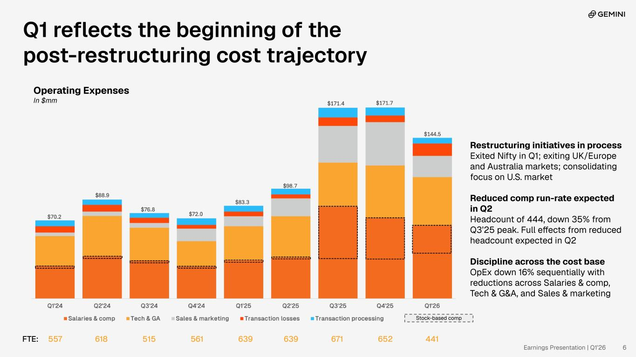
Earnings Presentation | Q1’26 6 Q1 reflects the beginning of the post-restructuring cost trajectory Operating Expenses In $mm FTE: 557 618 515 561 639 639 671 652 441 Restructuring initiatives in process Exited Nifty in Q1; exiting UK/Europe and Australia markets; consolidating focus on U.S. market Reduced comp run-rate expected in Q2 Headcount of 444, down 35% from Q3’25 peak. Full effects from reduced headcount expected in Q2 Discipline across the cost base OpEx down 16% sequentially with reductions across Salaries & comp, Tech & G&A, and Sales & marketing Stock-based comp

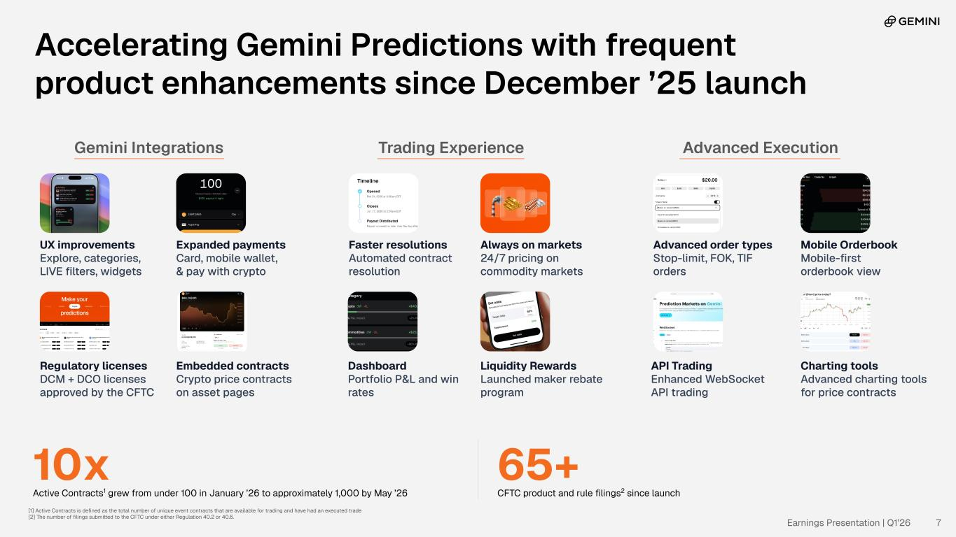
Advanced ExecutionGemini Integrations UX improvements Explore, categories, LIVE filters, widgets Expanded payments Card, mobile wallet, & pay with crypto Faster resolutions Automated contract resolution Always on markets 24/7 pricing on commodity markets Mobile Orderbook Mobile-first orderbook view Regulatory licenses DCM + DCO licenses approved by the CFTC Liquidity Rewards Launched maker rebate program Dashboard Portfolio P&L and win rates Charting tools Advanced charting tools for price contracts Trading Experience Embedded contracts Crypto price contracts on asset pages Advanced order types Stop-limit, FOK, TIF orders API Trading Enhanced WebSocket API trading Accelerating Gemini Predictions with frequent product enhancements since December ’25 launch 10x Active Contracts1 grew from under 100 in January ’26 to approximately 1,000 by May ’26 65+ CFTC product and rule filings2 since launch Earnings Presentation | Q1’26 7 [1] Active Contracts is defined as the total number of unique event contracts that are available for trading and have had an executed trade [2] The number of filings submitted to the CFTC under either Regulation 40.2 or 40.6.

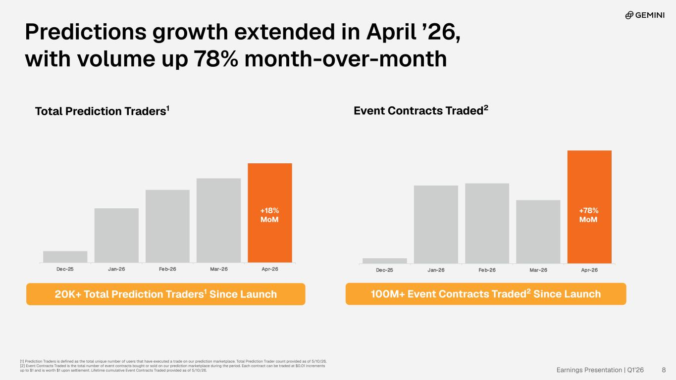
100M+ Event Contracts Traded2 Since Launch20K+ Total Prediction Traders1 Since Launch Event Contracts Traded2Total Prediction Traders1 +78% MoM Earnings Presentation | Q1’26 8 Predictions growth extended in April ’26, with volume up 78% month-over-month [1] Prediction Traders is defined as the total unique number of users that have executed a trade on our prediction marketplace. Total Prediction Trader count provided as of 5/10/26. [2] Event Contracts Traded is the total number of event contracts bought or sold on our prediction marketplace during the period. Each contract can be traded at $0.01 increments up to $1 and is worth $1 upon settlement. Lifetime cumulative Event Contracts Traded provided as of 5/10/26. +18% MoM

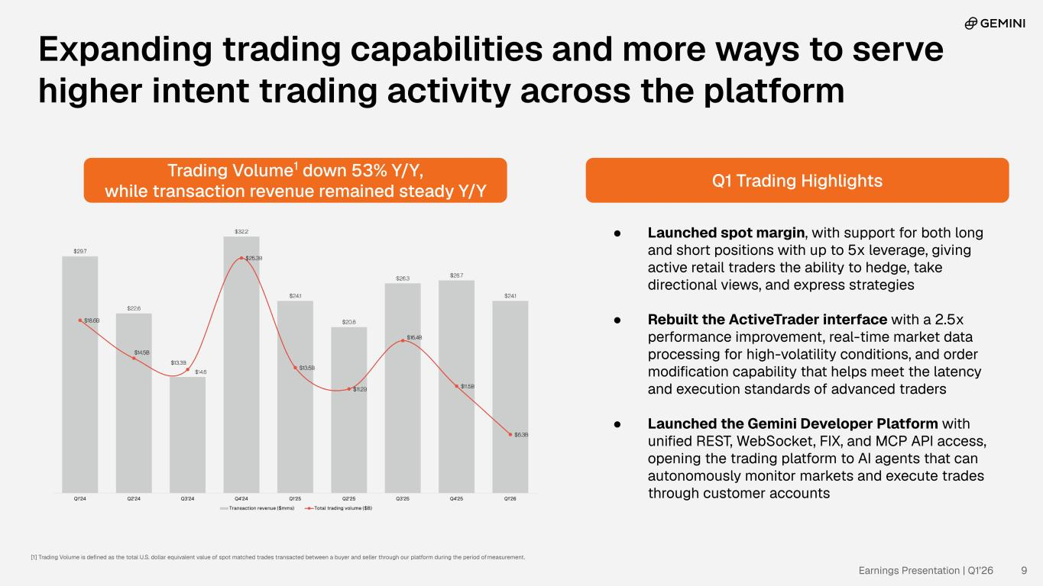
● Launched spot margin, with support for both long and short positions with up to 5x leverage, giving active retail traders the ability to hedge, take directional views, and express strategies ● Rebuilt the ActiveTrader interface with a 2.5x performance improvement, real-time market data processing for high-volatility conditions, and order modification capability that helps meet the latency and execution standards of advanced traders ● Launched the Gemini Developer Platform with unified REST, WebSocket, FIX, and MCP API access, opening the trading platform to AI agents that can autonomously monitor markets and execute trades through customer accounts Trading Volume1 down 53% Y/Y, while transaction revenue remained steady Y/Y Q1 Trading Highlights Earnings Presentation | Q1’26 9 [1] Trading Volume is defined as the total U.S. dollar equivalent value of spot matched trades transacted between a buyer and seller through our platform during the period of measurement. Expanding trading capabilities and more ways to serve higher intent trading activity across the platform

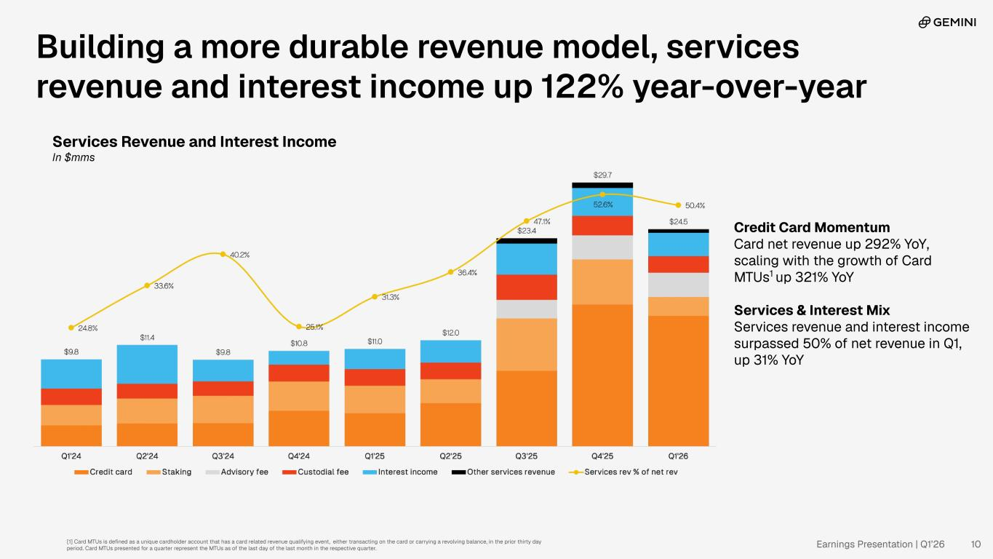
Credit Card Momentum Card net revenue up 292% YoY, scaling with the growth of Card MTUs1 up 321% YoY Services & Interest Mix Services revenue and interest income surpassed 50% of net revenue in Q1, up 31% YoY Building a more durable revenue model, services revenue and interest income up 122% year-over-year Services Revenue and Interest Income In $mms [1] Card MTUs is defined as a unique cardholder account that has a card related revenue qualifying event, either transacting on the card or carrying a revolving balance, in the prior thirty day period. Card MTUs presented for a quarter represent the MTUs as of the last day of the last month in the respective quarter. Earnings Presentation | Q1’26 10

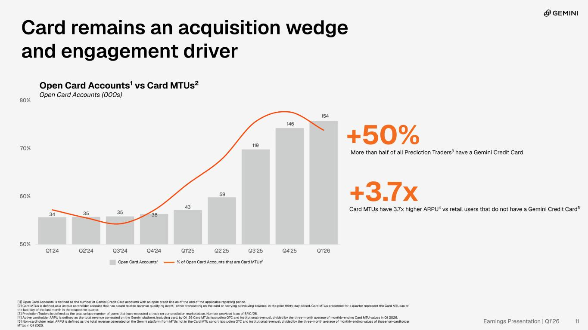
Card remains an acquisition wedge and engagement driver +50% More than half of all Prediction Traders3 have a Gemini Credit Card +3.7x Card MTUs have 3.7x higher ARPU4 vs retail users that do not have a Gemini Credit Card5 [1]] Open Card Accounts is defined as the number of Gemini Credit Card accounts with an open credit line as of the end of the applicable reporting period. [2] Card MTUs is defined as a unique cardholder account that has a card related revenue qualifying event, either transacting on the card or carrying a revolving balance, in the prior thirty-day period. Card MTUs presented for a quarter represent the Card MTUs as of the last day of the last month in the respective quarter. [3] Prediction Traders is defined as the total unique number of users that have executed a trade on our prediction marketplace. Number provided is as of 5/10/26. [4] Active cardholder ARPU is defined as the total revenue generated on the Gemini platform, including card, by Q1 ‘26 Card MTUs (excluding OTC and institutional revenue), divided by the three-month average of monthly-ending Card MTU values in Q1 2026. [5] Non-cardholder retail ARPU is defined as the total revenue generated on the Gemini platform from MTUs not in the Card MTU cohort (excluding OTC and institutional revenue), divided by the three-month average of monthly ending values of those non-cardholder MTUs in Q1 2026. Open Card Accounts1 vs Card MTUs2 Open Card Accounts (000s) Open Card Accounts1 % of Open Card Accounts that are Card MTUs2 Earnings Presentation | Q1’26 11

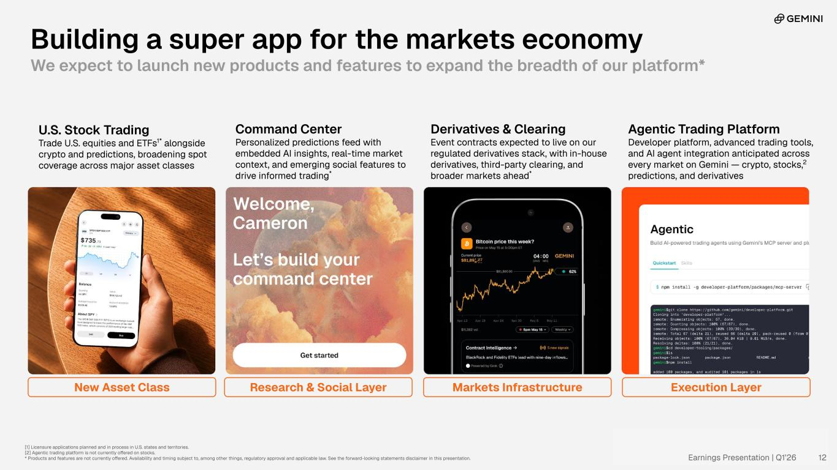
Building a super app for the markets economy We expect to launch new products and features to expand the breadth of our platform* New Asset Class Research & Social Layer Markets Infrastructure Execution Layer [1] Licensure applications planned and in process in U.S. states and territories. [2] Agentic trading platform is not currently offered on stocks. * Products and features are not currently offered. Availability and timing subject to, among other things, regulatory approval and applicable law. See the forward-looking statements disclaimer in this presentation. U.S. Stock Trading Trade U.S. equities and ETFs1* alongside crypto and predictions, broadening spot coverage across major asset classes Command Center Personalized predictions feed with embedded AI insights, real-time market context, and emerging social features to drive informed trading* Derivatives & Clearing Event contracts expected to live on our regulated derivatives stack, with in-house derivatives, third-party clearing, and broader markets ahead* Agentic Trading Platform Developer platform, advanced trading tools, and AI agent integration anticipated across every market on Gemini — crypto, stocks,2 predictions, and derivatives Earnings Presentation | Q1’26 12

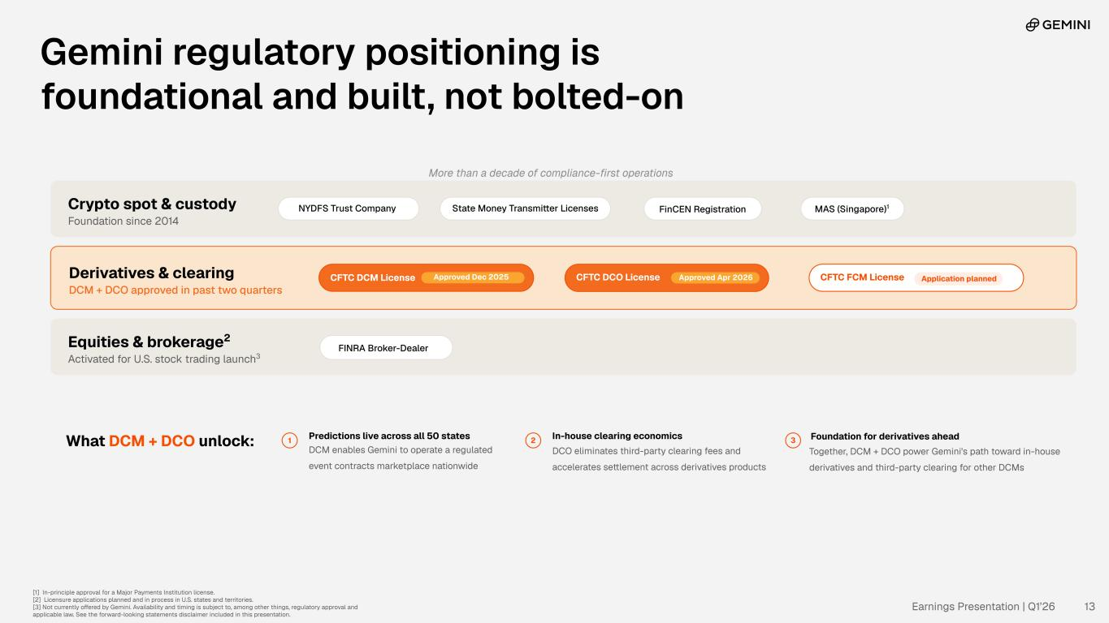
Gemini regulatory positioning is foundational and built, not bolted-on Crypto spot & custody Foundation since 2014 NYDFS Trust Company State Money Transmitter Licenses FinCEN Registration MAS (Singapore)1 Derivatives & clearing DCM + DCO approved in past two quarters CFTC DCM License Approved Dec 2025 CFTC DCO License Approved Apr 2026 CFTC FCM License Application planned Equities & brokerage2 Activated for U.S. stock trading launch3 FINRA Broker-Dealer What DCM + DCO unlock: 1 Predictions live across all 50 states DCM enables Gemini to operate a regulated event contracts marketplace nationwide 2 In-house clearing economics DCO eliminates third-party clearing fees and accelerates settlement across derivatives products 3 Foundation for derivatives ahead Together, DCM + DCO power Gemini's path toward in-house derivatives and third-party clearing for other DCMs More than a decade of compliance-first operations [1] In-principle approval for a Major Payments Institution license. [2] Licensure applications planned and in process in U.S. states and territories. [3] Not currently offered by Gemini. Availability and timing is subject to, among other things, regulatory approval and applicable law. See the forward-looking statements disclaimer included in this presentation. Earnings Presentation | Q1’26 13


Appendix Earnings Presentation | Q1’26 14

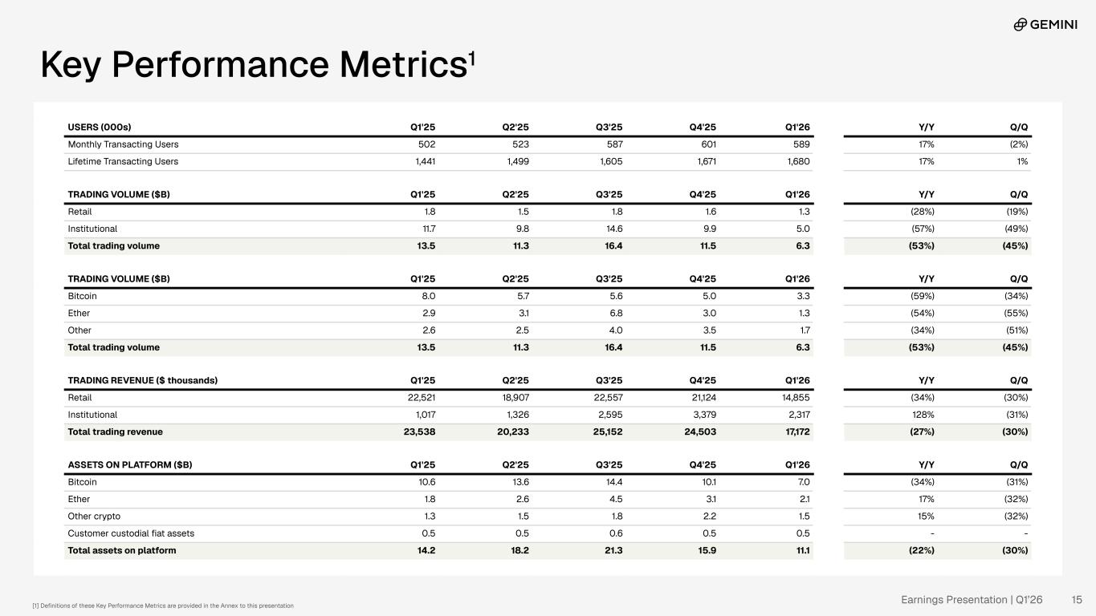
Key Performance Metrics1 USERS (000s) Q1'25 Q2'25 Q3'25 Q4'25 Q1'26 Y/Y Q/Q Monthly Transacting Users 502 523 587 601 589 17% (2%) Lifetime Transacting Users 1,441 1,499 1,605 1,671 1,680 17% 1% TRADING VOLUME ($B) Q1'25 Q2'25 Q3'25 Q4'25 Q1'26 Y/Y Q/Q Retail 1.8 1.5 1.8 1.6 1.3 (28%) (19%) Institutional 11.7 9.8 14.6 9.9 5.0 (57%) (49%) Total trading volume 13.5 11.3 16.4 11.5 6.3 (53%) (45%) TRADING VOLUME ($B) Q1'25 Q2'25 Q3'25 Q4'25 Q1'26 Y/Y Q/Q Bitcoin 8.0 5.7 5.6 5.0 3.3 (59%) (34%) Ether 2.9 3.1 6.8 3.0 1.3 (54%) (55%) Other 2.6 2.5 4.0 3.5 1.7 (34%) (51%) Total trading volume 13.5 11.3 16.4 11.5 6.3 (53%) (45%) TRADING REVENUE ($ thousands) Q1'25 Q2'25 Q3'25 Q4'25 Q1'26 Y/Y Q/Q Retail 22,521 18,907 22,557 21,124 14,855 (34%) (30%) Institutional 1,017 1,326 2,595 3,379 2,317 128% (31%) Total trading revenue 23,538 20,233 25,152 24,503 17,172 (27%) (30%) ASSETS ON PLATFORM ($B) Q1'25 Q2'25 Q3'25 Q4'25 Q1'26 Y/Y Q/Q Bitcoin 10.6 13.6 14.4 10.1 7.0 (34%) (31%) Ether 1.8 2.6 4.5 3.1 2.1 17% (32%) Other crypto 1.3 1.5 1.8 2.2 1.5 15% (32%) Customer custodial fiat assets 0.5 0.5 0.6 0.5 0.5 - - Total assets on platform 14.2 18.2 21.3 15.9 11.1 (22%) (30%) [1] Definitions of these Key Performance Metrics are provided in the Annex to this presentation Earnings Presentation | Q1’26 15

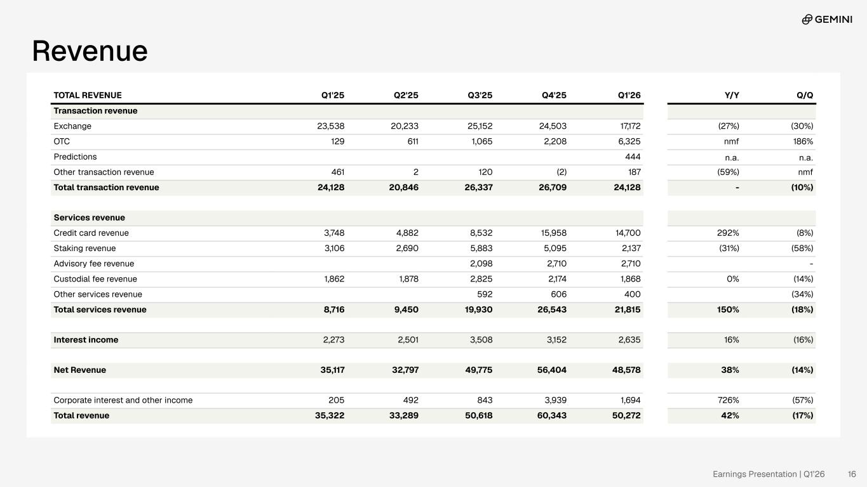
Revenue TOTAL REVENUE Q1'25 Q2'25 Q3'25 Q4'25 Q1'26 Y/Y Q/Q Transaction revenue Exchange 23,538 20,233 25,152 24,503 17,172 (27%) (30%) OTC 129 611 1,065 2,208 6,325 nmf 186% Predictions 444 n.a. n.a. Other transaction revenue 461 2 120 (2) 187 (59%) nmf Total transaction revenue 24,128 20,846 26,337 26,709 24,128 - (10%) Services revenue Credit card revenue 3,748 4,882 8,532 15,958 14,700 292% (8%) Staking revenue 3,106 2,690 5,883 5,095 2,137 (31%) (58%) Advisory fee revenue 2,098 2,710 2,710 - Custodial fee revenue 1,862 1,878 2,825 2,174 1,868 0% (14%) Other services revenue 592 606 400 (34%) Total services revenue 8,716 9,450 19,930 26,543 21,815 150% (18%) Interest income 2,273 2,501 3,508 3,152 2,635 16% (16%) Net Revenue 35,117 32,797 49,775 56,404 48,578 38% (14%) Corporate interest and other income 205 492 843 3,939 1,694 726% (57%) Total revenue 35,322 33,289 50,618 60,343 50,272 42% (17%) Earnings Presentation | Q1’26 16

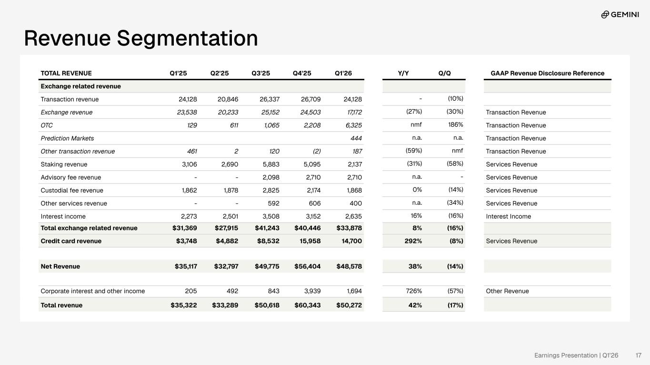
TOTAL REVENUE Q1'25 Q2'25 Q3'25 Q4'25 Q1'26 Y/Y Q/Q GAAP Revenue Disclosure Reference Exchange related revenue Transaction revenue 24,128 20,846 26,337 26,709 24,128 - (10%) Exchange revenue 23,538 20,233 25,152 24,503 17,172 (27%) (30%) Transaction Revenue OTC 129 611 1,065 2,208 6,325 nmf 186% Transaction Revenue Prediction Markets 444 n.a. n.a. Transaction Revenue Other transaction revenue 461 2 120 (2) 187 (59%) nmf Transaction Revenue Staking revenue 3,106 2,690 5,883 5,095 2,137 (31%) (58%) Services Revenue Advisory fee revenue - - 2,098 2,710 2,710 n.a. - Services Revenue Custodial fee revenue 1,862 1,878 2,825 2,174 1,868 0% (14%) Services Revenue Other services revenue - - 592 606 400 n.a. (34%) Services Revenue Interest income 2,273 2,501 3,508 3,152 2,635 16% (16%) Interest Income Total exchange related revenue $31,369 $27,915 $41,243 $40,446 $33,878 8% (16%) Credit card revenue $3,748 $4,882 $8,532 15,958 14,700 292% (8%) Services Revenue Net Revenue $35,117 $32,797 $49,775 $56,404 $48,578 38% (14%) Corporate interest and other income 205 492 843 3,939 1,694 726% (57%) Other Revenue Total revenue $35,322 $33,289 $50,618 $60,343 $50,272 42% (17%) Revenue Segmentation Earnings Presentation | Q1’26 17

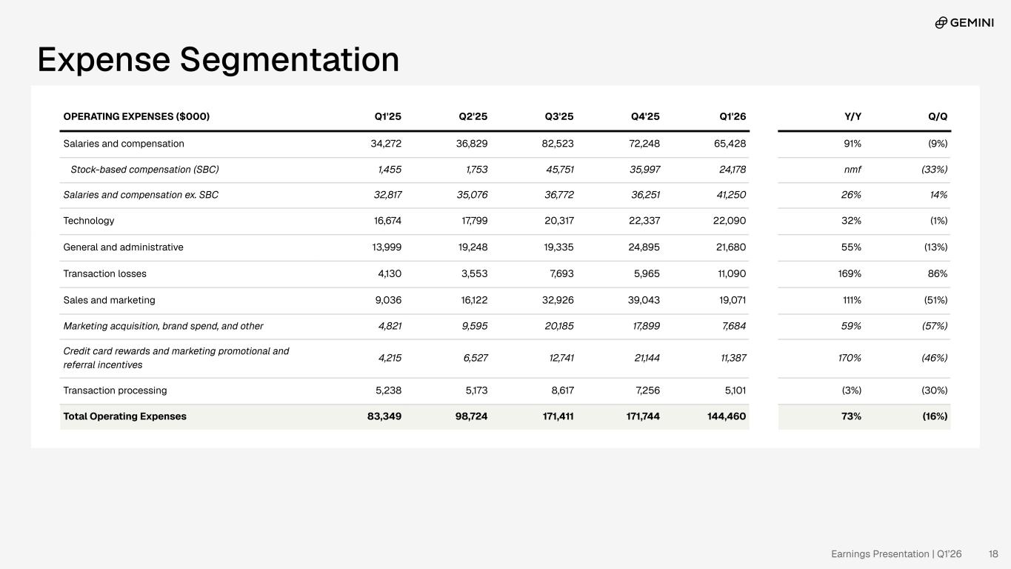
OPERATING EXPENSES 4Q'24 1Q'25 2Q'25 3Q'25 4Q'25 Salaries and compensation 28,830 34,272 36,829 82,523 72,752 Technology 16,203 16,674 17,799 20,317 22,336 General and administrative 6,519 13,999 19,248 19,335 22,050 Transaction losses 3,311 4,130 3,553 7,693 6,551 Sales and marketing 11,306 9,036 16,122 32,926 37,361 Transaction processing 5,871 5,238 5,173 8,617 7,102 Total Operating Expenses 72,040 83,349 98,724 171,411 168,152 Expense Segmentation Break out SBC from Comp Break out crypto rewards, promos, referrals, etc from marketing OPERATING EXPENSES ($000) Q1'25 Q2'25 Q3'25 Q4'25 Q1'26 Y/Y Q/Q Salaries and compensation 34,272 36,829 82,523 72,248 65,428 91% (9%) Stock-based compensation (SBC) 1,455 1,753 45,751 35,997 24,178 nmf (33%) Salaries and compensation ex. SBC 32,817 35,076 36,772 36,251 41,250 26% 14% Technology 16,674 17,799 20,317 22,337 22,090 32% (1%) General and administrative 13,999 19,248 19,335 24,895 21,680 55% (13%) Transaction losses 4,130 3,553 7,693 5,965 11,090 169% 86% Sales and marketing 9,036 16,122 32,926 39,043 19,071 111% (51%) Marketing acquisition, brand spend, and other 4,821 9,595 20,185 17,899 7,684 59% (57%) Credit card rewards and marketing promotional and referral incentives 4,215 6,527 12,741 21,144 11,387 170% (46%) Transaction processing 5,238 5,173 8,617 7,256 5,101 (3%) (30%) Total Operating Expenses 83,349 98,724 171,411 171,744 144,460 73% (16%) Earnings Presentation | Q1’26 18

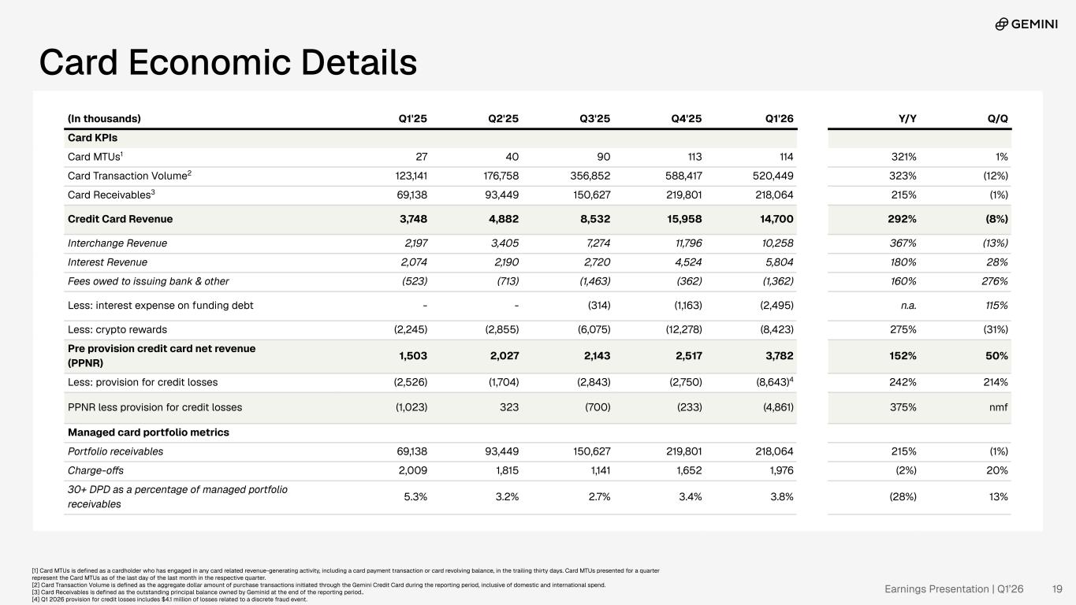
Card Economic Details (In thousands) Q1'25 Q2'25 Q3'25 Q4'25 Q1'26 Y/Y Q/Q Card KPIs Card MTUs1 27 40 90 113 114 321% 1% Card Transaction Volume2 123,141 176,758 356,852 588,417 520,449 323% (12%) Card Receivables3 69,138 93,449 150,627 219,801 218,064 215% (1%) Credit Card Revenue 3,748 4,882 8,532 15,958 14,700 292% (8%) Interchange Revenue 2,197 3,405 7,274 11,796 10,258 367% (13%) Interest Revenue 2,074 2,190 2,720 4,524 5,804 180% 28% Fees owed to issuing bank & other (523) (713) (1,463) (362) (1,362) 160% 276% Less: interest expense on funding debt - - (314) (1,163) (2,495) n.a. 115% Less: crypto rewards (2,245) (2,855) (6,075) (12,278) (8,423) 275% (31%) Pre provision credit card net revenue (PPNR) 1,503 2,027 2,143 2,517 3,782 152% 50% Less: provision for credit losses (2,526) (1,704) (2,843) (2,750) (8,643)4 242% 214% PPNR less provision for credit losses (1,023) 323 (700) (233) (4,861) 375% nmf Managed card portfolio metrics Portfolio receivables 69,138 93,449 150,627 219,801 218,064 215% (1%) Charge-offs 2,009 1,815 1,141 1,652 1,976 (2%) 20% 30+ DPD as a percentage of managed portfolio receivables 5.3% 3.2% 2.7% 3.4% 3.8% (28%) 13% [1] Card MTUs is defined as a cardholder who has engaged in any card related revenue-generating activity, including a card payment transaction or card revolving balance, in the trailing thirty days. Card MTUs presented for a quarter represent the Card MTUs as of the last day of the last month in the respective quarter. [2] Card Transaction Volume is defined as the aggregate dollar amount of purchase transactions initiated through the Gemini Credit Card during the reporting period, inclusive of domestic and international spend. [3] Card Receivables is defined as the outstanding principal balance owned by Geminid at the end of the reporting period.. [4] Q1 2026 provision for credit losses includes $4.1 million of losses related to a discrete fraud event. Earnings Presentation | Q1’26 19

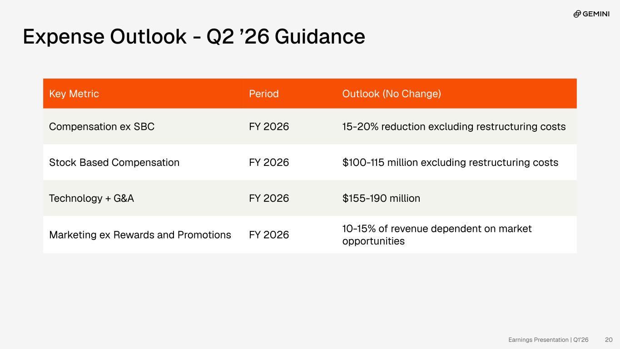
Expense Outlook - Q2 ’26 Guidance Key Metric Period Outlook (No Change) Compensation ex SBC FY 2026 15-20% reduction excluding restructuring costs Stock Based Compensation FY 2026 $100-115 million excluding restructuring costs Technology + G&A FY 2026 $155-190 million Marketing ex Rewards and Promotions FY 2026 10-15% of revenue dependent on market opportunities Earnings Presentation | Q1’26 20

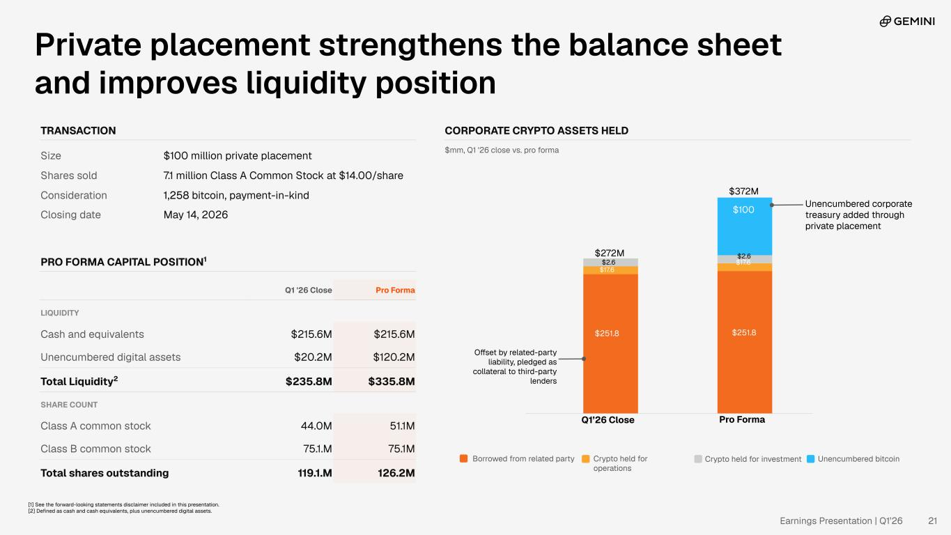
Private placement strengthens the balance sheet and improves liquidity position TRANSACTION Size $100 million private placement Shares sold 7.1 million Class A Common Stock at $14.00/share Consideration 1,258 bitcoin, payment-in-kind Closing date May 14, 2026 PRO FORMA CAPITAL POSITION1 Q1 '26 Close Pro Forma LIQUIDITY Cash and equivalents $215.6M $215.6M Unencumbered digital assets $20.2M $120.2M Total Liquidity2 $235.8M $335.8M SHARE COUNT Class A common stock 44.0M 51.1M Class B common stock 75.1.M 75.1M Total shares outstanding 119.1.M 126.2M CORPORATE CRYPTO ASSETS HELD $mm, Q1 '26 close vs. pro forma Borrowed from related party Crypto held for operations Crypto held for investment Unencumbered bitcoin Q1’26 Close Pro Forma $251.8 $17.6 $100 Unencumbered corporate treasury added through private placement Offset by related-party liability, pledged as collateral to third-party lenders $2.6 $372M $251.8 $272M $2.6 $17.6 [1] See the forward-looking statements disclaimer included in this presentation. [2] Defined as cash and cash equivalents, plus unencumbered digital assets. Earnings Presentation | Q1’26 21

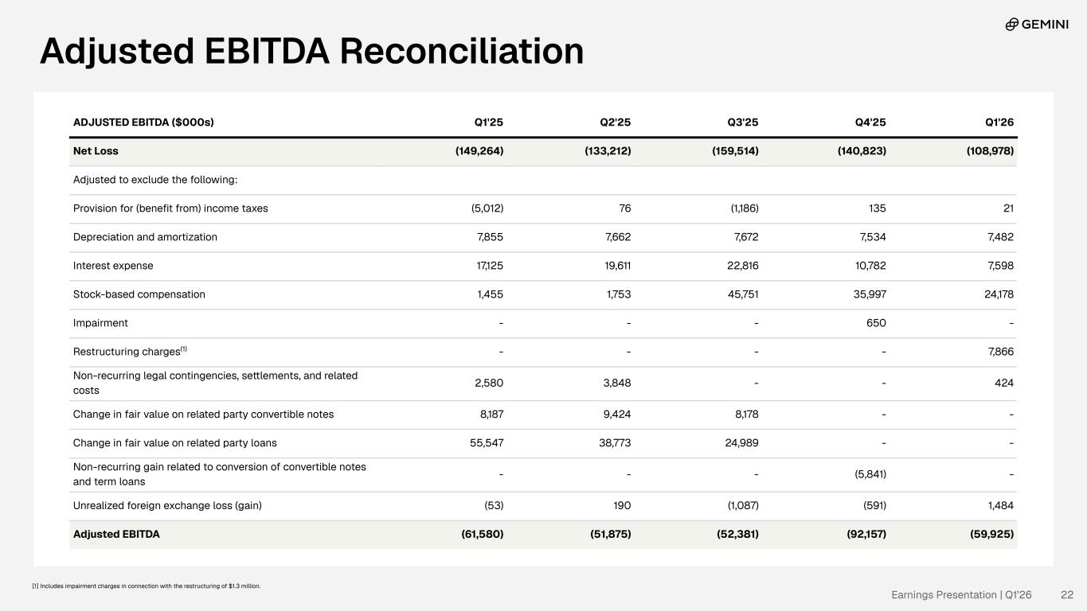
Adjusted EBITDA Reconciliation ADJUSTED EBITDA ($000s) Q1'25 Q2'25 Q3'25 Q4'25 Q1'26 Net Loss (149,264) (133,212) (159,514) (140,823) (108,978) Adjusted to exclude the following: Provision for (benefit from) income taxes (5,012) 76 (1,186) 135 21 Depreciation and amortization 7,855 7,662 7,672 7,534 7,482 Interest expense 17,125 19,611 22,816 10,782 7,598 Stock-based compensation 1,455 1,753 45,751 35,997 24,178 Impairment - - - 650 - Restructuring charges(1) - - - - 7,866 Non-recurring legal contingencies, settlements, and related costs 2,580 3,848 - - 424 Change in fair value on related party convertible notes 8,187 9,424 8,178 - - Change in fair value on related party loans 55,547 38,773 24,989 - - Non-recurring gain related to conversion of convertible notes and term loans - - - (5,841) - Unrealized foreign exchange loss (gain) (53) 190 (1,087) (591) 1,484 Adjusted EBITDA (61,580) (51,875) (52,381) (92,157) (59,925) Earnings Presentation | Q1’26 22 [1] Includes impairment charges in connection with the restructuring of $1.3 million.

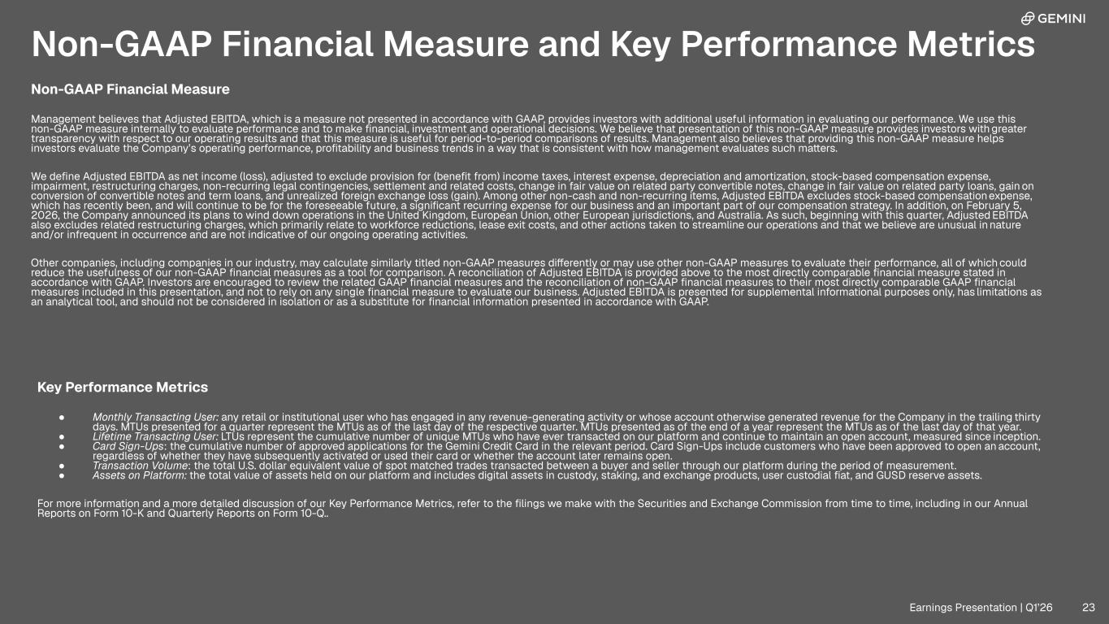
Non-GAAP Financial Measure Management believes that Adjusted EBITDA, which is a measure not presented in accordance with GAAP, provides investors with additional useful information in evaluating our performance. We use this non-GAAP measure internally to evaluate performance and to make financial, investment and operational decisions. We believe that presentation of this non-GAAP measure provides investors with greater transparency with respect to our operating results and that this measure is useful for period-to-period comparisons of results. Management also believes that providing this non-GAAP measure helps investors evaluate the Company’s operating performance, profitability and business trends in a way that is consistent with how management evaluates such matters. We define Adjusted EBITDA as net income (loss), adjusted to exclude provision for (benefit from) income taxes, interest expense, depreciation and amortization, stock-based compensation expense, impairment, restructuring charges, non-recurring legal contingencies, settlement and related costs, change in fair value on related party convertible notes, change in fair value on related party loans, gain on conversion of convertible notes and term loans, and unrealized foreign exchange loss (gain). Among other non-cash and non-recurring items, Adjusted EBITDA excludes stock-based compensation expense, which has recently been, and will continue to be for the foreseeable future, a significant recurring expense for our business and an important part of our compensation strategy. In addition, on February 5, 2026, the Company announced its plans to wind down operations in the United Kingdom, European Union, other European jurisdictions, and Australia. As such, beginning with this quarter, Adjusted EBITDA also excludes related restructuring charges, which primarily relate to workforce reductions, lease exit costs, and other actions taken to streamline our operations and that we believe are unusual in nature and/or infrequent in occurrence and are not indicative of our ongoing operating activities. Other companies, including companies in our industry, may calculate similarly titled non-GAAP measures differently or may use other non-GAAP measures to evaluate their performance, all of which could reduce the usefulness of our non-GAAP financial measures as a tool for comparison. A reconciliation of Adjusted EBITDA is provided above to the most directly comparable financial measure stated in accordance with GAAP. Investors are encouraged to review the related GAAP financial measures and the reconciliation of non-GAAP financial measures to their most directly comparable GAAP financial measures included in this presentation, and not to rely on any single financial measure to evaluate our business. Adjusted EBITDA is presented for supplemental informational purposes only, has limitations as an analytical tool, and should not be considered in isolation or as a substitute for financial information presented in accordance with GAAP. Key Performance Metrics ● Monthly Transacting User: any retail or institutional user who has engaged in any revenue-generating activity or whose account otherwise generated revenue for the Company in the trailing thirty days. MTUs presented for a quarter represent the MTUs as of the last day of the respective quarter. MTUs presented as of the end of a year represent the MTUs as of the last day of that year. ● Lifetime Transacting User: LTUs represent the cumulative number of unique MTUs who have ever transacted on our platform and continue to maintain an open account, measured since inception. ● Card Sign-Ups: the cumulative number of approved applications for the Gemini Credit Card in the relevant period. Card Sign-Ups include customers who have been approved to open an account, regardless of whether they have subsequently activated or used their card or whether the account later remains open. ● Transaction Volume: the total U.S. dollar equivalent value of spot matched trades transacted between a buyer and seller through our platform during the period of measurement. ● Assets on Platform: the total value of assets held on our platform and includes digital assets in custody, staking, and exchange products, user custodial fiat, and GUSD reserve assets. For more information and a more detailed discussion of our Key Performance Metrics, refer to the filings we make with the Securities and Exchange Commission from time to time, including in our Annual Reports on Form 10-K and Quarterly Reports on Form 10-Q.. Non-GAAP Financial Measure and Key Performance Metrics Earnings Presentation | Q1’26 23




Earnings Presentation | Q1’26

